**Houston Vertical Systems**



4800 Calhoun Rd

Houston, TX 77004

**Individual Database Report**

* Randy Nguyen
* Kristy Hoang
* Celesta Monsivaiz
* Jason Ngo
* Brandon Nguyen
* Muktar Abubakar
* Brady Acevedo
* Samuel Ekpe

Table of Contents

Individual SQL Scripts 1

Randy Nguyen 1

Create Scripts 1

Alter Scripts 2

Bulk Insert Scripts 3

Data Records for Tables 4

SQL Report Queries 19

SQL Insert, Update, and Delete Scripts 28

GUI User Views 31

Kristy Hoang 33

Create Scripts 33

Alter Scripts 34

Bulk Insert Scripts 35

Data Records for Tables 36

SQL Report Queries 47

SQL Insert, Update, and Delete Scripts 55

GUI User Views 58

Celesta Monsivaiz 60

Create Table Scripts 60

Alter Scripts 61

Bulk insert Scripts 62

Data Records for Tables 63

SQL Report Queries 78

SQL insert, update, & delete scripts 85

GUI User View 91

Jason Ngo 92

Create Script 92

Alter Scripts 93

Bulk Inserts 94

Data Records 95

SQL Report Queries 113

SQL Insert, Delete, Update Scripts 119

GUI User Views 125

Brandon Nguyen 127

Create Script 127

Alter Scripts 128

Bulk Inserts 129

Data Records 130

SQL Report Queries 145

SQL Insert, Delete, Update Scripts 150

GUI User Views 153

Muktar Abubakar 154

Created Scripts 154

Alter Scripts 155

Bulk Insert Scripts 156

Data Records for Tables 157

SQL Query 172

SQL Insert, Update, and Delete Scripts 177

GUI User View 181

Brady Acevedo 182

Created Scripts 182

Alter Scripts 184

Bulk Insert Scripts 184

Data Records for Tables 185

SQL Report Queries 198

SQL Insert, Update, and Delete Scripts 203

GUI User Views 209

Samuel Ekpe 210

Create Scripts 210

Alter Scripts 211

Bulk Inserts 211

Data Records 213

SQL Report Queries 227

SQL Insert, Delete, Update Scripts 232

GUI User Views 235

# Individual SQL Scripts

## Randy Nguyen

### Create Scripts

#### Location Table

create table Locations

(

   Location_ID int not null identity(1,1),

   Street_Address varchar(25) not null,

   City varchar(25) not null,

   State varchar(2) not null,

   Postal varchar(10) not null,

   Country varchar(25) not null,

   constraint Locations_pk

       primary key (Location_ID)

);

#### Music Table

create table Music

(

   Song_ID int not null identity(1,1),

   Song_Name varchar(25) not null,

   Artist_Name varchar(25) not null,

   Album_Name varchar(25),

   Genre_Type varchar(25) not null,

   constraint Music_pk

       primary key (Song_ID)

);

#### Phone Numbers

create table Phone_Number

(

   Phone_ID int not null identity(1,1),

   First_Name varchar(25) not null,

   Last_Name varchar(25) not null,

   Phone_Number varchar(15) not null,

   constraint Phone_Number_pk

       primary key (Phone_ID)

);

### Alter Scripts

Alter table Event_Type

 Add constraint Fk_Event_Type

   Foreign key(Event_ID) references Event(Event_ID);

Alter table Service_Request

 Add constraint Fk_Service_Request

   Foreign key(Event_ID) references Event(Event_ID);

Alter table Event_Expenses

 Add constraint Fk_Event_Expenses

   Foreign key(Event_ID) references Event(Event_ID);

Alter table Event_Status

 Add constraint Fk_Event_Status

   Foreign key(Event_ID) references Event(Event_ID);

Alter table Client

Add Location_ID int not null;

Alter table Employee

Add Location_ID int not null;

Alter table Client

Add constraint Fk_Client_Location

foreign key(Location_ID) references Locations(Location_ID);

Alter table Employee

Add constraint Fk_Employee_Location

foreign key(Location_ID) references Locations(Location_ID);

### Bulk Insert Scripts

#### Client Table Insert

bulk insert Client

from 'C:\Users\rtnguye9\Downloads\Clients.csv'

with

(

rowterminator='\n',

fieldterminator=','

)

#### Music Table Insert

bulk insert Music

from 'C:\Users\rtnguye9\Downloads\Song_records.csv'

with

(

rowterminator='\n',

fieldterminator=','

)

#### Locations Table Insert

bulk insert Locations

from 'C:\Users\rtnguye9\Downloads\Company_Location.csv'

with

(

rowterminator='\n',

fieldterminator=','

)

### Data Records for Tables

#### Client Data

1,Avis,Moroz,Avis.Moroz@gmail.com  ,(325) 372-8992,7811 E. Hamilton,Abbott,TX,No Comment,1

2,Floyd,Paek,Floyd.Paek@gmail.com  ,(706) 578-8078,409 N. Paris Hill St,Abernathy,TX,No Comment,1

3,Marjory,Gisi,Marjory.Gisi@gmail.com  ,(405) 676-2234,968 W. Lakeshore St.,Abilene,TX,No Comment,1

4,Lance,Garnett,Lance.Garnett@gmail.com  ,(338) 466-1980,863 N. Walt Whitman,Ackerly,TX,No Comment,1

5,Georgene,Bach,Georgene.Bach@gmail.com  ,(629) 397-4936,47 Lyme Ave,Addison,TX,No Comment,1

6,Evonne,Seales,Evonne.Seales@gmail.com  ,(553) 650-0503,35 N. Indian Summer,Adrian,TX,No Comment,1

7,Jeanette,Allinder,Jeanette.Allinder@gmail.com  ,(414) 383-1439,41 Carson St.,Agua Dulce,TX,No Comment,1

8,Anh,Currier,Anh.Currier@gmail.com  ,(503) 246-2251,80 North Pulaski Dr.,Alamo,TX,No Comment,1

9,Major,Fuller,Major.Fuller@gmail.com  ,(691) 946-7716,40 Roehampton Rd,Alamo Heights,TX,No Comment,1

10,Eldon,Mccolley,Eldon.Mccolley@gmail.com  ,(973) 836-1042,397 Randall Mill St.,Albany,TX,No Comment,1

11,Rudolf,Reza,Rudolf.Reza@gmail.com  ,(246) 581-8261,7293 Goldfield St,Aledo,TX,No Comment,1

12,Norma,Flemister,Norma.Flemister@gmail.com  ,(610) 503-6106,674 Del Monte St,Alice,TX,No Comment,1

13,Carman,Turco,Carman.Turco@gmail.com  ,(716) 346-8068,15 Oakland ,Allen,TX,No Comment,1

14,Lovella,Jennette,Lovella.Jennette@gmail.com  ,(817) 768-7173,468 Santa Clara St,Alpine,TX,No Comment,1

15,Rutha,Widman,Rutha.Widman@gmail.com  ,(447) 410-5693,44 Swanson St,Alon,TX,No Comment,1

16,Annamarie,Alpers,Annamarie.Alpers@gmail.com  ,(286) 468-4490,33 E. Piper Ave.,Alvarado,TX,No Comment,1

17,Kit,Blasko,Kit.Blasko@gmail.com  ,(393) 238-9026,7758 Manor St.,Alvin,TX,No Comment,1

18,Jeanice,Grennan,Jeanice.Grennan@gmail.com  ,(324) 772-6334,748 Brandywine Rd,Amarillo,TX,No Comment,1

19,Janice,Son,Janice.Son@gmail.com  ,(774) 850-5891,814 Trenton Lane,Ames,TX,No Comment,1

20,Alica,Alt,Alica.Alt@gmail.com  ,(992) 985-5684,8697 Oak Meadow St,Amherst,TX,No Comment,1

21,Etsuko,Canter,Etsuko.Canter@gmail.com  ,(615) 773-6740,601 Peg Shop,Anahuac,TX,No Comment,1

22,Ruby,Dube,Ruby.Dube@gmail.com  ,(250) 999-5792,432 Durham St.,Anderson,TX,No Comment,1

23,Laronda,Willcox,Laronda.Willcox@gmail.com  ,(938) 806-3607,73 Ridge Dr,Andrews,TX,No Comment,1

24,Clifford,Theis,Clifford.Theis@gmail.com  ,(828) 634-2499,92 Eagle Lane,Angelton,TX,No Comment,1

25,Mozella,Elmendorf,Mozella.Elmendorf@gmail.com  ,(289) 496-8187,61 E. Illinois St,Angus,TX,No Comment,1

26,Zofia,Speas,Zofia.Speas@gmail.com  ,(811) 257-0197,12 E. Atlantic St,Anna,TX,No Comment,1

27,Marco,Wiest,Marco.Wiest@gmail.com  ,(945) 376-6023,9020 Wintergreen St,Anson,TX,No Comment,1

28,Flavia,Blay,Flavia.Blay@gmail.com  ,(508) 217-8448,8900 N. Essex St,Anton,TX,No Comment,1

29,Tomoko,Gruber,Tomoko.Gruber@gmail.com  ,(277) 613-0285,67 Country Dr,Appleby,TX,No Comment,1

30,Maryanna,Tyer,Maryanna.Tyer@gmail.com  ,(572) 676-0400,381 N. Addison St,Aquilla,TX,No Comment,1

31,Lona,Muir,Lona.Muir@gmail.com  ,(781) 902-2575,49 New Lane,Aransas,TX,No Comment,1

32,Magdalen,Manges,Magdalen.Manges@gmail.com  ,(303) 514-2251,308 W. Edgewater Dr,Archer City,TX,No Comment,1

33,Ignacia,Hieber,Ignacia.Hieber@outlook.com  ,(242) 739-2009,5 Nicolls Dr,Arcola,TX,No Comment,1

34,Marty,Townes,Marty.Townes@outlook.com  ,(542) 786-3607,9712 Pawnee Lane,Argyle,TX,No Comment,1

35,Lyndon,Giffen,Lyndon.Giffen@outlook.com  ,(263) 388-6261,658 Fulton Ave,Arlington,TX,No Comment,1

36,Evelin,Trujillo,Evelin.Trujillo@outlook.com  ,(816) 891-5184,9438 2nd St,Arp,TX,No Comment,1

37,Yuri,Shasteen,Yuri.Shasteen@outlook.com  ,(406) 427-9084,40 Applegate St,Asherton,TX,No Comment,1

38,Carmel,Troyer,Carmel.Troyer@outlook.com  ,(457) 675-3209,131 Shirley St,Athens,TX,No Comment,1

39,Velma,Matthies,Velma.Matthies@outlook.com  ,(657) 822-9986,8748 Peachtree Dr,Atlanta,TX,No Comment,1

40,Lorna,Riker,Lorna.Riker@outlook.com  ,(873) 745-8698,5 Logan Ave,Aubrey,TX,No Comment,1

41,Jesenia,Sylvia,Jesenia.Sylvia@outlook.com  ,(452) 565-2100,596 Windsor St,Aurora,TX,No Comment,1

42,Marceline,Strayer,Marceline.Strayer@outlook.com  ,(511) 484-9118,1 Philmont Dr,Austin,TX,No Comment,1

43,Garth,Gilbert,Garth.Gilbert@outlook.com  ,(269) 965-6236,555 Tallwood St,Austwell,TX,No Comment,1

44,India,Marse,India.Marse@outlook.com  ,(406) 620-8984,7275 Schoolhouse st,Avery,TX,No Comment,1

45,Mayme,Dahle,Mayme.Dahle@outlook.com  ,(515) 748-9554,472 Williams st,Azel,TX,No Comment,1

46,Karena,Mangano,Karena.Mangano@outlook.com  ,(548) 589-5419,266 Wintergreen ave,Bailey,TX,No Comment,1

47,Rheba,Mcqueary,Rheba.Mcqueary@outlook.com  ,(429) 796-4991,8750 Sussex st,Baird,TX,No Comment,1

48,Echo,Kimbell,Echo.Kimbell@outlook.com  ,(385) 317-5465,477 Cemetery ave,Balch Springs,TX,No Comment,1

49,Richard,Maillet,Richard.Maillet@outlook.com  ,(889) 756-5131,8412 W. Oak dr,Balcones Heights,TX,No Comment,1

50,Flor,Gattis,Flor.Gattis@outlook.com  ,(773) 453-9843,65 Glenridge st,Ballinger,TX,No Comment,1

51,Cyndi,Whitmer,Cyndi.Whitemer@outlook.com,(463) 904-9541,7176 Carpenter ave,Balmorhea,TX,No Comment,1

52,Janett,Willey,Janett.Willey@outlook.com,(200) 977-9228,277 High Point st,Bandera,TX,No Comment,1

53,Meridith,Lyford,Meridith.Lyford@yahoo.com  ,(416) 824-8766,42 Border dr,Bangs,TX,No Comment,1

54,Malorie,Drost,Malorie.Drost@yahoo.com  ,(928) 999-1681,9250 Prairie dr,Bardwell,TX,No Comment,1

55,Belinda,Raber,Belinda.Raber@yahoo.com  ,(436) 214-7641,46 Harrison st,Barry,TX,No Comment,1

56,Rubie,Worthley,Rubie.Worthley@yahoo.com  ,(388) 548-8993,15 Mayfield st,Bellaire,TX,No Comment,1

57,Julissa,Mulero,Julissa.Mulero@yahoo.com  ,(743) 672-0562,8 Cleveland lan,Bellevue,TX,No Comment,1

58,Geoffrey,Mauk,Geoffrey.Mauk@yahoo.com  ,(398) 973-1290,806 Rock Creek st,Bellmead,TX,No Comment,1

59,Bailey,Hall,Bailey.Hall@yahoo.com  ,(541) 355-0783,992 S. Indian Summer,Bellville,TX,No Comment,1

60,Margert,Mahood,Margert.Mahood@yahoo.com  ,(791) 676-2053,7058 Kingston st,Belton,TX,No Comment,1

61,Linnie,Kizer,Linnie.Kizer@yahoo.com  ,(623) 893-0090,9347 Pin Oak dr,Benavides,TX,No Comment,1

62,Keneth,Drewes,Keneth.Drewes@yahoo.com  ,(625) 363-8483,938 Fifth rd,Benbrook,TX,No Comment,1

63,Damian,Vanmeter,Damian.Vanmeter@yahoo.com  ,(855) 580-2806,9299 Fieldstone ave,Benjamin,TX,No Comment,1

64,Jaclyn,Paden,Jaclyn.Paden@yahoo.com  ,(721) 434-6317,79 Old Tower ave,Bertram,TX,No Comment,1

65,Terrell,Craft,Terrell.Craft@yahoo.com  ,(282) 451-4984,9810 Bay Meadows ave,Beverly Hills,TX,No Comment,1

66,Kira,Oropeza,Kira.Oropeza@yahoo.com  ,(268) 395-5934,9421 Vernon st,Bevil Oaks,TX,No Comment,1

67,Cathy,Sowards,Cathy.Sowards@yahoo.com  ,(430) 304-3519,9643 E. Vine rd,Big Lake,TX,No Comment,1

68,Darlena,Meas,Darlena.Meas@yahoo.com  ,(854) 576-3606,7973 N. El Dorado,Big Spring,TX,No Comment,1

69,Albertha,Vogus,Albertha.Vogus@yahoo.com  ,(886) 476-7224,980 Canterbury st,Big Wells,TX,No Comment,1

70,Estrella,Mees,Estrella.Mees@yahoo.com  ,(614) 708-1396,9266 Rockville ave,Bishop,TX,No Comment,1

71,Latonia,Line,Latonia.Line@yahoo.com  ,(251) 751-9095,4 Poplar st,Blackwell,TX,No Comment,1

72,Cathern,Blackmer,Cathern.Blackmer@yahoo.com  ,(726) 601-3299,82 W. Hill Field,Blanco,TX,No Comment,1

73,Jonelle,Willman,Jonelle.Willman@yahoo.com  ,(925) 586-2806,680 River ave,Blessing,TX,No Comment,1

74,Mandy,Duke,Mandy.Duke@yahoo.com  ,(500) 202-3230,44 Laurel ave,Blossom,TX,No Comment,1

75,Yung,Capron,Yung.Capron@yahoo.com  ,(565) 938-2204,4 W. Cobblestone rd,Blue Mound,TX,No Comment,1

76,Mistie,Dorado,Mistie.Dorado@yahoo.com  ,(523) 526-7241,8571 Mayfair st,Blue Ridge,TX,No Comment,1

77,Jed,Powe,Jed.Powe@yahoo.com  ,(766) 421-1498,8109 Lafayette ave,Boerne,TX,No Comment,1

78,Gidget,Griffis,Gidget.Griffis@yahoo.com  ,(931) 638-8812,350 College rd,Bogata,TX,No Comment,1

79,Yvonne,Mcarthur,Yvonne.Mcarthur@live.com  ,(761) 796-2737,688 W. Kingston ave,Bonham,TX,No Comment,1

80,Mel,Godwin,Mel.Godwin@live.com  ,(894) 465-1154,594 Glendale dr,Borger,TX,No Comment,1

81,Cheryl,Webber,Cheryl.Webber@live.com  ,(443) 213-8770,490 Walk Whitman,Bovina,TX,No Comment,1

82,Frank,Sawyer,Frank.Sawyer@live.com  ,(620) 669-2992,9535 W. Ivy st,Bowie,TX,No Comment,1

83,Clarissa,Sugg,Clarissa.Sugg@live.com  ,(513) 439-8673,31 Shub Farm ave,Brackettville,TX,No Comment,1

84,Daniell,Bluford,Daniell.Bluford@live.com  ,(393) 525-9620,162 Manchester ave,Brady,TX,No Comment,1

85,Louann,Helget,Louann.Helget@live.com  ,(689) 772-8073,7723 Fairfield ave,Brazoria,TX,No Comment,1

86,Nathalie,Toms,Nathalie.Toms@live.com  ,(968) 687-3830,7722 N. Sunset ave,Brazos Country,TX,No Comment,1

87,Oretha,Duval,Oretha.Duval@live.com  ,(905) 590-3845,2 W. Bridge st,Bremond,TX,No Comment,1

88,Melony,Silberman,Melony.Silberman@live.com  ,(556) 692-7841,122 High Ridge rd,Brookshire,TX,No Comment,1

89,Ghislaine,Zaldivar,Ghislaine.Zaldivar@live.com  ,(250) 549-5157,80 S. Ivy st.,Houston,TX,No Comment,1

90,Haywood,Alward,Haywood.Alward@live.com  ,(762) 974-6699,102 Bay Meadows,Buda,TX,No Comment,1

91,Tillie,Mengel,Tillie.Mengel@live.com  ,(785) 890-8483,31 William st,Buffalo,TX,No Comment,1

92,Catharine,Thomason,Catharine.Thomason@live.com  ,(333) 251-2442,596 Penn st,Burke,TX,No Comment,1

93,Catrina,Coward,Catrina.Coward@live.com  ,(651) 876-4460,254 Princess st,Byers,TX,No Comment,1

94,Roman,Molitor,Roman.Molitor@live.com  ,(666) 859-2154,441 Old York st,Cactus,TX,No Comment,1

95,Mamie,Tennyson,Mamie.Tennyson@live.com  ,(210) 973-4467,9464 Baker dr,Cisco,TX,No Comment,1

96,Dulce,Vallee,Dulce.Vallee@live.com  ,(444) 220-6692,91 W. Boston rd,Celina,TX,No Comment,1

97,Tyrell,Downing,Tyrell.Downing@live.com  ,(580) 289-2019,418 E. Winchester ct,Chandler,TX,No Comment,1

98,Lang,Arthurs,Lang.Arthurs@live.com  ,(794) 395-6456,7615 Atlantic dr,Cleaveland,TX,No Comment,1

99,Rosie,Wallis,Rosie.Wallis@live.com  ,(921) 899-7329,915 San Carlos st,Coleman,TX,No Comment,1

100,Kiesha,Buendia,Kiesha.Buendia@live.com  ,(211) 835-9522,701 Rocky River st,Dayton,TX,No Comment,1

#### Music Data

1,Old Town Road ,Lil Nas X,,Hip Hop

2,Paranoid,Post Malone,BeerBongs&Bentleys,Hip Hop

3,Spoil my night,Post Malone,BeerBongs&Bentleys,Hip Hop

4,Rich & Sad,Post Malone,BeerBongs&Bentleys,Hip Hop

5,Zack and Codeine,Post Malone,BeerBongs&Bentleys,Hip Hop

6,Takin Shots,Post Malone,BeerBongs&Bentleys,Hip Hop

7,rockstar,Post Malone,BeerBongs&Bentleys,Hip Hop

8,over now,Post Malone,BeerBongs&Bentleys,Hip Hop

9,psycho,Post Malone,BeerBongs&Bentleys,Hip Hop

10,better now,Post Malone,BeerBongs&Bentleys,Hip Hop

11,ball for me,Post Malone,BeerBongs&Bentleys,Hip Hop

12,otherside,Post Malone,BeerBongs&Bentleys,Hip Hop

13,stay,Post Malone,BeerBongs&Bentleys,Hip Hop

14,blame it on me,Post Malone,BeerBongs&Bentleys,Hip Hop

15,same bitches,Post Malone,BeerBongs&Bentleys,Hip Hop

16,jonestown,Post Malone,BeerBongs&Bentleys,Hip Hop

17,92 explorer,Post Malone,BeerBongs&Bentleys,Hip Hop

18,candy paint,Post Malone,BeerBongs&Bentleys,Hip Hop

19,sugar wraith,Post Malone,BeerBongs&Bentleys,Hip Hop

20,Dark Sky,Big Sean,Dark Sky Paradise,Hip Hop

21,Blessings,Big Sean,Dark Sky Paradise,Hip Hop

22,All Your Fault,Big Sean,Dark Sky Paradise,Hip Hop

23,I Don't Fuck With You,Big Sean,Dark Sky Paradise,Hip Hop

24,Play No Games,Big Sean,Dark Sky Paradise,Hip Hop

25,Paradise,Big Sean,Dark Sky Paradise,Hip Hop

26,"Win Some, Lose Some",Big Sean,Dark Sky Paradise,Hip Hop

27,Stay Down,Big Sean,Dark Sky Paradise,Hip Hop

28,I Know,Big Sean,Dark Sky Paradise,Hip Hop

29,Deep,Big Sean,Dark Sky Paradise,Hip Hop

30,One Man,Big Sean,Dark Sky Paradise,Hip Hop

31,Outro,Big Sean,Dark Sky Paradise,Hip Hop

32,Deserve It,Big Sean,Dark Sky Paradise,Hip Hop

33,Research ,Big Sean,Dark Sky Paradise,Hip Hop

34,Platnium And Wood,Big Sean,Dark Sky Paradise,Hip Hop

35,Stargazing,Travis Scott,AstroWorld,Hip Hop

36,Carousel,Travis Scott,AstroWorld,Hip Hop

37,Sicko Mode,Travis Scott,AstroWorld,Hip Hop

38,Stop Trying To Be God,Travis Scott,AstroWorld,Hip Hop

39,No Bystanders,Travis Scott,AstroWorld,Hip Hop

40,Skeletons,Travis Scott,AstroWorld,Hip Hop

41,Wake Up,Travis Scott,AstroWorld,Hip Hop

42,5% Tint,Travis Scott,AstroWorld,Hip Hop

43,NC-17,Travis Scott,AstroWorld,Hip Hop

44,Astrothunder,Travis Scott,AstroWorld,Hip Hop

45,Yosemite,Travis Scott,AstroWorld,Hip Hop

46,Can't Say,Travis Scott,AstroWorld,Hip Hop

47,Who? What?,Travis Scott,AstroWorld,Hip Hop

48,Butterfly Effect,Travis Scott,AstroWorld,Hip Hop

49,Houstonfornication,Travis Scott,AstroWorld,Hip Hop

50,Coffee Bean,Travis Scott,AstroWorld,Hip Hop

51,Middle Child,J. Cole,,Hip Hop

52,Intro,J. Cole,Forest Hills Drive,Hip Hop

53,January,J. Cole,Forest Hills Drive,Hip Hop

54,Wet Dreamz,J. Cole,Forest Hills Drive,Hip Hop

55,03' Adolescence,J. Cole,Forest Hills Drive,Hip Hop

56,A Tale of 2 Citiez,J. Cole,Forest Hills Drive,Hip Hop

57,Fire Squad,J. Cole,Forest Hills Drive,Hip Hop

58,St. Tropez,J. Cole,Forest Hills Drive,Hip Hop

59,Intermission,J. Cole,Forest Hills Drive,Hip Hop

60,G.O.M.D.,J. Cole,Forest Hills Drive,Hip Hop

61,No Role Modelz,J. Cole,Forest Hills Drive,Hip Hop

62,Hello,J. Cole,Forest Hills Drive,Hip Hop

63,Apparently,J. Cole,Forest Hills Drive,Hip Hop

64,Love Yourz,J. Cole,Forest Hills Drive,Hip Hop

65,Bad Luck,Khalid,Free Spirit,Hip Hop

66,My Bad,Khalid,Free Spirit,Hip Hop

67,Better,Khalid,Free Spirit,Hip Hop

68,Talk,Khalid,Free Spirit,Hip Hop

69,Right Back,Khalid,Free Spirit,Hip Hop

70,Don't Pretend,Khalid,Free Spirit,Hip Hop

71,Paradise,Khalid,Free Spirit,Hip Hop

72,Hundred,Khalid,Free Spirit,Hip Hop

73,Outta My Head,Khalid,Free Spirit,Hip Hop

74,Free Spirit,Khalid,Free Spirit,Hip Hop

75,Twenty One,Khalid,Free Spirit,Hip Hop

76,Bluffin',Khalid,Free Spirit,Hip Hop

77,Self,Khalid,Free Spirit,Hip Hop

78,Alive,Khalid,Free Spirit,Hip Hop

79,Heaven,Khalid,Free Spirit,Hip Hop

80,Saturday Nights,Khalid,Free Spirit,Hip Hop

81,Imagine,Ariana Grande,"Thank u, next",Pop

82,Needy,Ariana Grande,"Thank u, next",Pop

83,NASA,Ariana Grande,"Thank u, next",Pop

84,Bloodline,Ariana Grande,"Thank u, next",Pop

85,Fake Smile,Ariana Grande,"Thank u, next",Pop

86,Bad Idea,Ariana Grande,"Thank u, next",Pop

87,Make Up,Ariana Grande,"Thank u, next",Pop

88,Ghostin,Ariana Grande,"Thank u, next",Pop

89,In My Head,Ariana Grande,"Thank u, next",Pop

90,7 Rings,Ariana Grande,"Thank u, next",Pop

91,"thank u, next",Ariana Grande,"Thank u, next",Pop

92,Break up with your gf,Ariana Grande,"Thank u, next",Pop

93,The Ringer,Ariana Grande,"Thank u, next",Pop

94,Lucky You,Eminem,Kamikaze,Hip Hop

95,Not Alike,Eminem,Kamikaze,Hip Hop

96,Fall,Eminem,Kamikaze,Hip Hop

97,Greatest,Eminem,Kamikaze,Hip Hop

98,Normal,Eminem,Kamikaze,Hip Hop

99,Stepping Stone,Eminem,Kamikaze,Hip Hop

100,Kill Shot,Eminem,,Hip Hop

#### Locations Data

1,9585 S. Main Blvd,Houston,TX,77025,United States

2,2727 Murworth Dr.,Houston,TX,77054,United States

3,219 Veltri Drive,Anchorage,AK,99503,United States

4,1221 Lonely Oak Drive,Mobile,AL,36602,United States

5,1513 Fittro Street,Lockesburg,AR,71846,United States

6,1145 Crowfield Road,Phoenix,AZ,85034,United States

7,8 Ashcraft Court,San Diego,CA,92111,United States

8,2007 Clover Drive,Pueblo,CO,81003,United States

9,3803 Whitman Court,New Haven,CT,06511,United States

10,4806 Massachusetts Ave,Washington,DC,20011,United States

11,2559 Argonne St,New Castle,DE,19720,United States

12,3671 Mapleview Dr.,Moon Lake,FL,33568,United States

13,3782 Edington Dr.,Decatur,GA,30030,United States

14,3396 Stratford Dr.,Honolulu,HI,96813,United States

15,1740 Pyramid Valley Rd,Ft. Madison,IA,52627,United States

16,4492 Science Center,Ririe,ID,83443,United States

17,4834 College View,Palestine,IL,62451,United States

18,1889 Capitol Ave.,Delphi,IN,46923,United States

19,2586 Better St.,Kansas City,KS,66215,United States

20,1332 Harper St.,Custer,KY,40115,United States

21,2260 Sherwood Cr.,Lafayette,LA,70501,United States

22,3915 C Street,E. Bridgewater,MA,02333,United States

23,2221 Five Points,Bel Air,MD,21014,United States

24,1207 Fantages Way,Westbrook,ME,04092,United States

25,2097 Robinson Ct.,Saginaw,MI,48607,United States

26,3968 Brighton Circle,Saint Cloud,MN,56303,United States

27,4562 chandler Dr.,Fairview,MO,64842,United States

28,1941 Gorby Ln.,Tylertown,MS,39667,United States

29,4595 Tibbs Ave.,Thompson Falls,MT,59873,United States

30,620 Hannah St.,Charlotte,NC,28273,United States

31,80 Catherine Dr.,Minot,ND,58701,United States

32,1808 Poling Farm Rd.,La Vista,NE,68128,United States

33,1256 Milford St.,Manchester,NH,03103,United States

34,3537 Watson St.,Laurel Springs,NJ,08021,United States

35,2037 Reel Ave.,Farmington,NM,87401,United States

36,4636 Martha Ellen Drive,Reno,NV,89501,United States

37,644 Redbud Dr.,New York,NY,10013,United States

38,1554 Carriage Lane,Toledo,OH,43609,United States

39,2325 Henry Ford,Broken Arrow,OK,74012,United States

40,1826 Mattson St,Portland,OR,97205,United States

41,277 Tipple Rd.,Philadelphia,PA,19115,United States

42,717 Winding Way,Providence ,RI,02903,United States

43,90 Wexford Way,Lancaster,SC,29720,United States

44,3540 Andy St.,Oldham,SD,57051,United States

45,4779 Point Dr.,Memphis,TN,38110,United States

46,2659 Whispering Pines,Lewisville,TX,75067,United States

47,450 Buck Dr.,Salt Lake City,UT,84119,United States

48,1972 Worley Ave.,Lynchburg,VA,24501,United States

49,590 Duff Ave.,South Burlington,VT,05403,United States

50,2929 Conifer Dr.,Tukwila,WA,98168,United States

51,1558 Irish Lane,Mt. Vernon,WI,53572,United States

52,1204 Froe St.,Lawford,WV,26409,United States

53,1548 Arbor Ct.,Casper,WY,82601,United States

54,2765 Acton Ave.,Toronto ,ON,M3H 4J1,Canada

55,1847 Scarth St.,Montreal,QC,S4P 3Y2,Canada

56,Ziegelstr. 80,Dietersburg,FB,84378,United Kingdom

57,638 W. Edgemont,Hartford,CT,06106,United States

58,99 S. Wellington Dr.,Middleburg,FL,32068,United States

59,9225 Union Lane,Maryvile,TN,37803,United States

60,36 Windsor St.,Mableton ,GA,30126,United States

61,183 Sulphur Springs,Lincoln Park,MI,48146,United States

62,9 3rd St.,Virginia Beach,VA,23451,United States

63,5 King Street,Noblesville,IN,46060,United States

64,946 State Court,Butler,PA,16001,United States

65,40 E. Baker St.,Greenwood,SC,29646,United States

66,9207 Hilldale St.,La Crosse ,WI,54601,United States

67,9424 W. Valley Lane,Ellicott City,MD,21042,United States

68,52 Pineknoll Ave.,Woodside,NY,11377,United States

69,8027 N. Spruce Lane,Jenison,MI,49428,United States

70,8015 East Dr.,Anchorage ,AK,99504,United States

71,298 Fordham St.,Hinesville,GA,31313,United States

72,9146 W. Railroad Dr.,Altoona,PA,16601,United States

73,153 Crescent St.,Hicksville,NY,11801,United States

74,877 Vane Dyke St.,Toledo,OH,43612,United States

75,79 Glen Creek St.,Supperior,WI,54880,United States

76,9584 Randall Mill,Sterling,VA,20164,United States

77,388 Lake View St,Wasilla ,AK,99654,United States

78,9356 Hanover,Hanover,PA,17331,United States

79,78 Woodside Dr.,Fairport,NY,14450,United States

80,32 Logan Circle,Winter Springs,FL,32708,United States

81,7896 W. Princeton St.,Jacksonville,FL,32250,United States

82,62 W. Arlington St.,Bethlehem,PA,18015,United States

83,7707 Constitution,Wantagh,NY,11793,United States

84,39 Old Euclid Ave.,Winona,MN,55987,United States

85,9 Rosewood Rd,Windsor Mill,MD,21244,United States

86,7563 N. Swanson St.,Mt. Vernon,NT,10550,United States

87,65 S. Somerset St.,Waterford,MI,48329,United States

88,8499 Plumb Branch,Fall River,MA,02720,United States

89,4 Pacific St.,Methuen,MA,01844,United States

90,8127 Lake Dr.,Coraopolis,PA,15108,United States

91,329 Whitemarsh St.,Birmingham,AL,35209,United States

92,528 Kent Street,Raleigh,NC,27603,United States

93,8222 E. Tallwood St,Raeford,NC,28376,United States

94,314 Riverside St.,Roseville,MI,48066,United States

95,9620 E. Pacific St.,Manassas ,VA,20109,United States

96,493 Leeton Ridge ,Graham,NV,27253,United States

97,9869 Arcadia Ave.,Temple Hills,MD,20748,United States

98,207 White Street,Bemidji,MN,56601,United States

99,484 Cemetery Rd,Knoxville,TN,37918,United States

100,23 Rockwell Court,Clearwater,FL,33756,United States

### SQL Report Queries

#### Query 1

Select loc.Location_ID, cl.Client_First, cl.Client_Last, ev.Event_ID, ev.Service_Requested, evl.Street_Address, evl.City

from Locations as loc inner join Client as cl

on loc.Location_ID = cl.Location_ID

inner join Event ev

on ev.Client_ID = cl.Client_ID

inner join Event_Location evl

on evl.Event_ID = ev.Event_ID

* This report query combines the following tables:
  + Location
  + Client
  + Event
  + Service Requested
* Using the location table, we find which company location that the client has requested his event from.
* The client table pulls the clients information such as the first and last name.
* The event table allows us to see which event the client requested for and where the event will be at.
* The service requested table will allow us to see what type of service the client requested for their event.

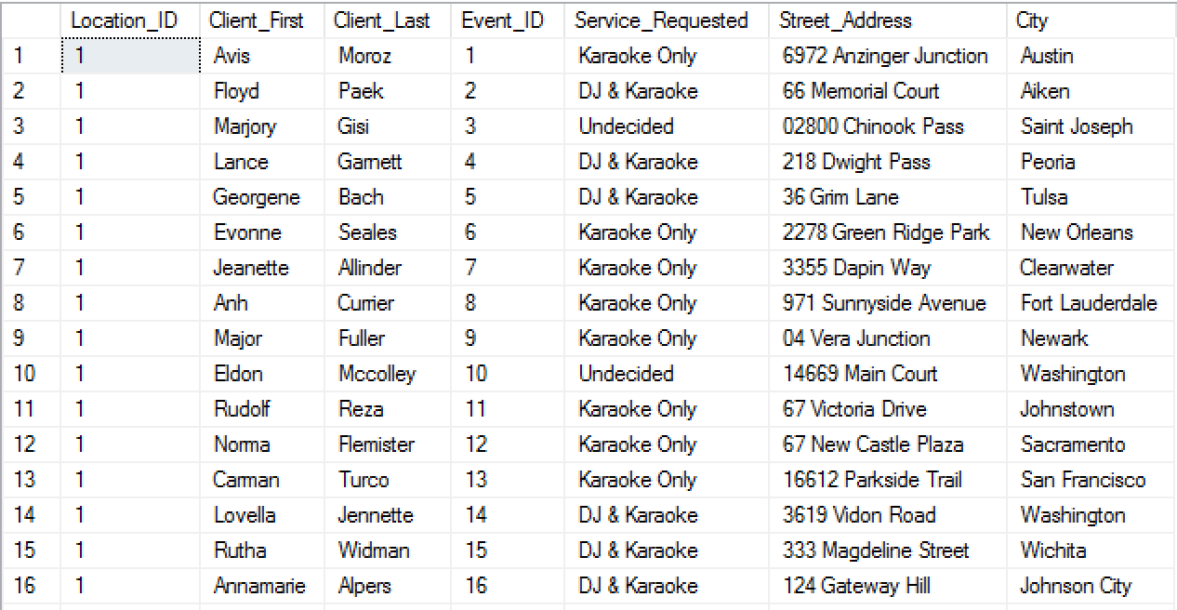

#### Query 2

Select loc.Location_ID, cl.Client_First, cl.Client_Last, ev.Event_ID, evs.Status

from Locations as loc inner join Client as cl

on loc.Location_ID = cl.Location_ID

inner join Event ev

on ev.Client_ID = cl.Client_ID

inner join Event_Status evs

on evs.Event_ID = ev.Event_ID

* This report query combines the following tables:
  + Location
  + Client
  + Event
  + Event Status
* Using the location table, we find which company location that the client has requested his event from.
* The client table pulls the clients information such as the first and last name.
* The event table allows us to see which event the client requested and its ID.
* The status table allows us to see whether or not the request has been completed.

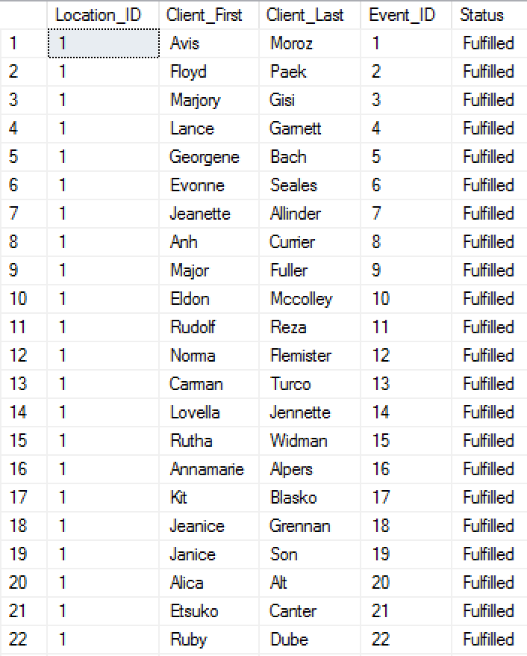

#### Query 3

Select loc.Location_ID, cl.Client_First, cl.Client_Last, ev.Event_ID, serv.Service_Requested

from Locations as loc inner join Client as cl

on loc.Location_ID = cl.Location_ID

inner join Event ev

on ev.Client_ID = cl.Client_ID

inner join Service_Request serv

on serv.Event_ID = ev.Event_ID

* This report query combines the following tables:
  + Location
  + Client
  + Event
  + Service Requested
* Using the location table, we find which company location that the client has requested his event from.
* The client table pulls the clients information such as the first and last name.
* The event table allows us to see which event the client requested and its ID.
* The service requested table allows us to see what service the client wanted.

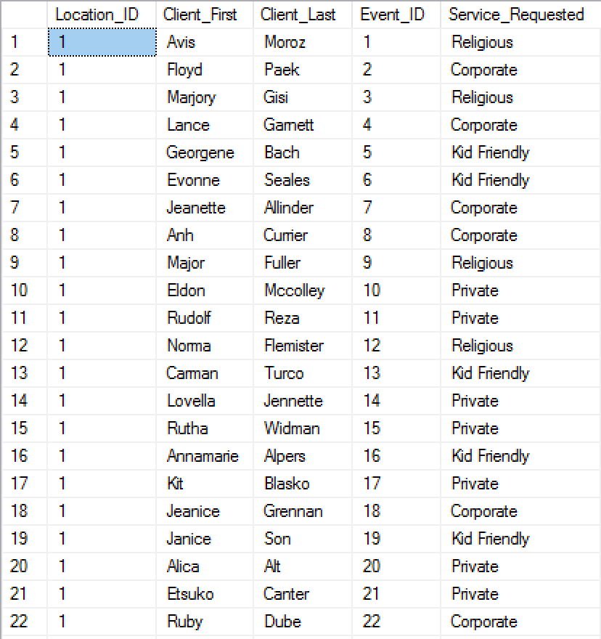

#### Query 4

Select loc.Location_ID, cl.Client_First, cl.Client_Last, ev.Event_ID, ev.Service_Requested, evd.Event_Date

from Locations as loc inner join Client as cl

on loc.Location_ID = cl.Location_ID

inner join Event ev

on ev.Client_ID = cl.Client_ID

inner join Event_Date evd

on evd.Event_ID = ev.Event_ID

* This report query combines the following tables:
  + Location
  + Client
  + Event
  + Event_Date
* Using the location table, we find which company location that the client has requested his event from.
* The client table pulls the clients information such as the first and last name.
* The event table allows us to see which event the client requested and its information.
* The event date table allows us to see what day the event will begin.

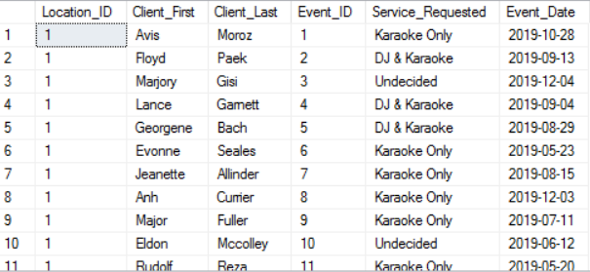

#### Query 5

Select loc.Location_ID, cl.Client_First, cl.Client_Last, ev.Event_ID, ev.Service_Requested, evd.Event_Date, evd.Event_Start, evd.Event_End

from Locations as loc inner join Client as cl

on loc.Location_ID = cl.Location_ID

inner join Event ev

on ev.Client_ID = cl.Client_ID

inner join Event_Date evd

on evd.Event_ID = ev.Event_ID

* This report query combines the following tables:
  + Location
  + Client
  + Event
  + Event_Date
* Using the location table, we find which company location that the client has requested his event from.
* The client table pulls the clients information such as the first and last name.
* The event table allows us to see which event the client requested and its information.
* The event date table allows us to see what day the event will begin and the time the event ends and begins.

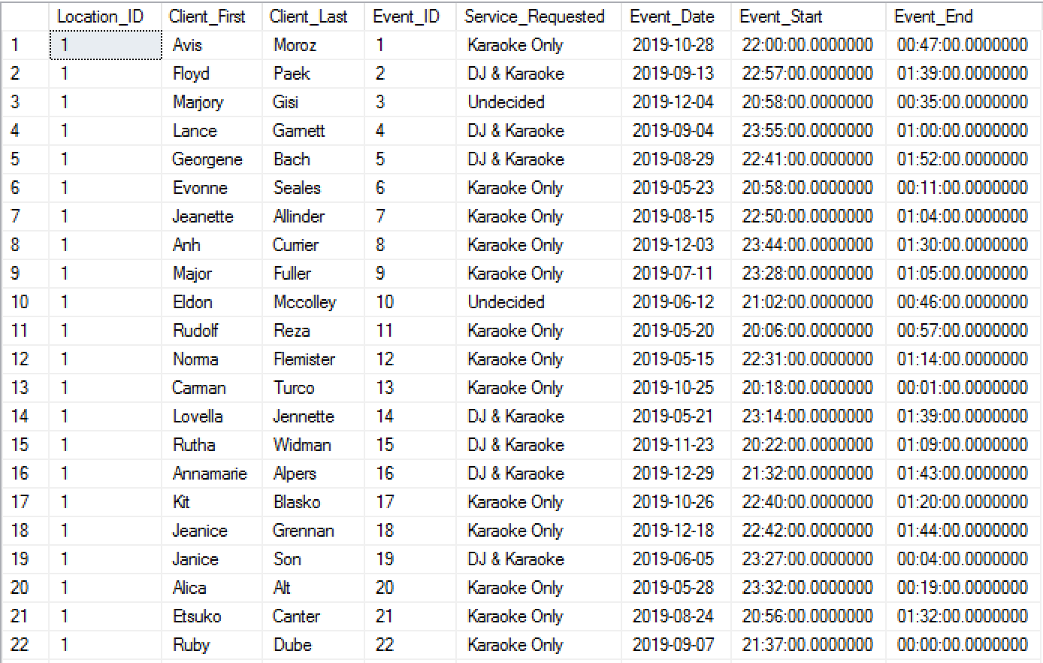

### SQL Insert, Update, and Delete Scripts

#### Insert Script 1

Insert into Music(Song_ID, Song_Name, Artist_Name, Album_Name, Genre_Type)

Values(‘101’, ‘1-800-273-8255’, ‘Logic’, ‘Everybody’, ‘Hip-Hop’);

Figure 1. *Before insert*



Figure 2. *After insert*



#### Insert Script 2

bulk insert Music

from ‘C:\Users\rtnguye9\Downloads\Song_records.csv’

with

(

rowterminator=’\n’,

fieldterminator=’,’

)

Figure 3. *Before bulk insert*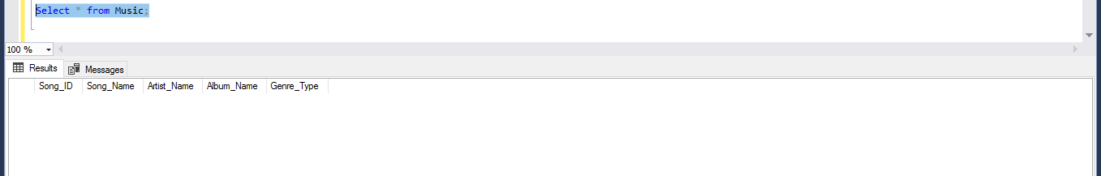Figure 4. *After bulk insert*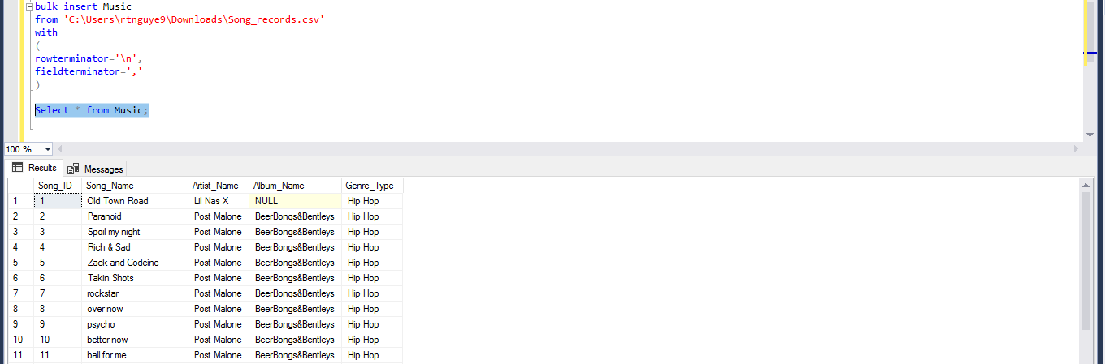

#### Update Script 1

Update Music

set Album_Name = ‘Old Town Road’

where Song_ID = 1;

Figure 5. *Before update script 1*

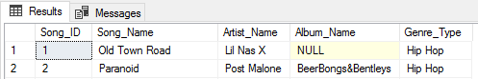

Figure 6. *After update script 1*

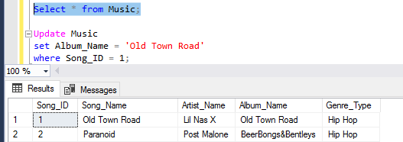

#### Update Script 2

Update Music

set Album_Name = ‘Kamikaze’

where Song_ID = 100;

Figure 7. *Before update script 2*



Figure 8. *After update script 2*



#### Delete Script 1

Delete from Music;

Figure 9. *Before delete* 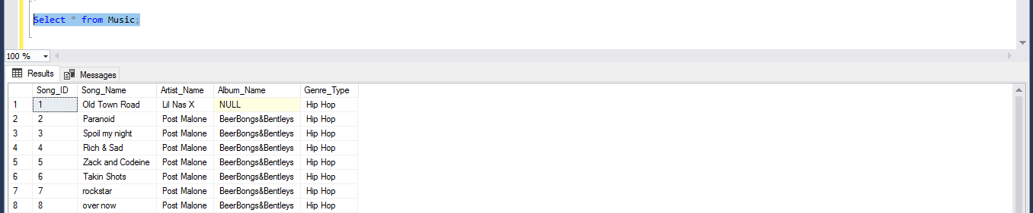

Figure 10. *After delete; all rows deleted because nothing was specified*

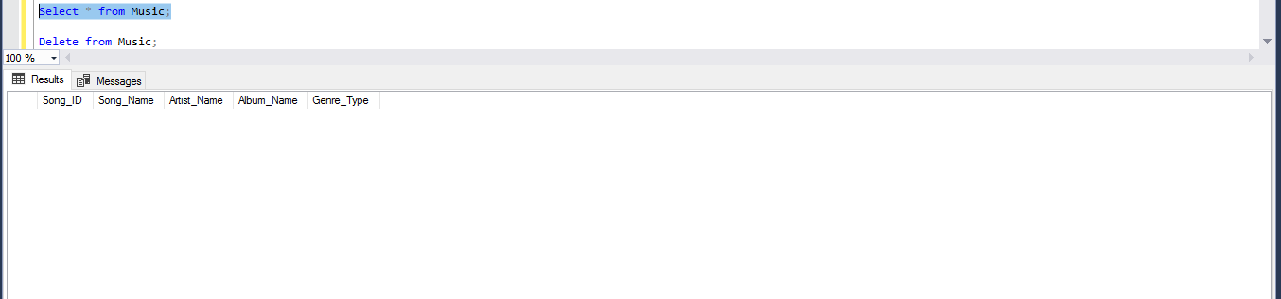

#### Delete Script 2

Delete from Music

where Song_ID = 93;

Figure 11. *Before specified delete*

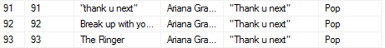

Figure 12. *After delete for Song_ID = 93*

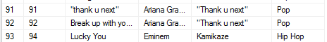

### GUI User Views

#### Login Screen

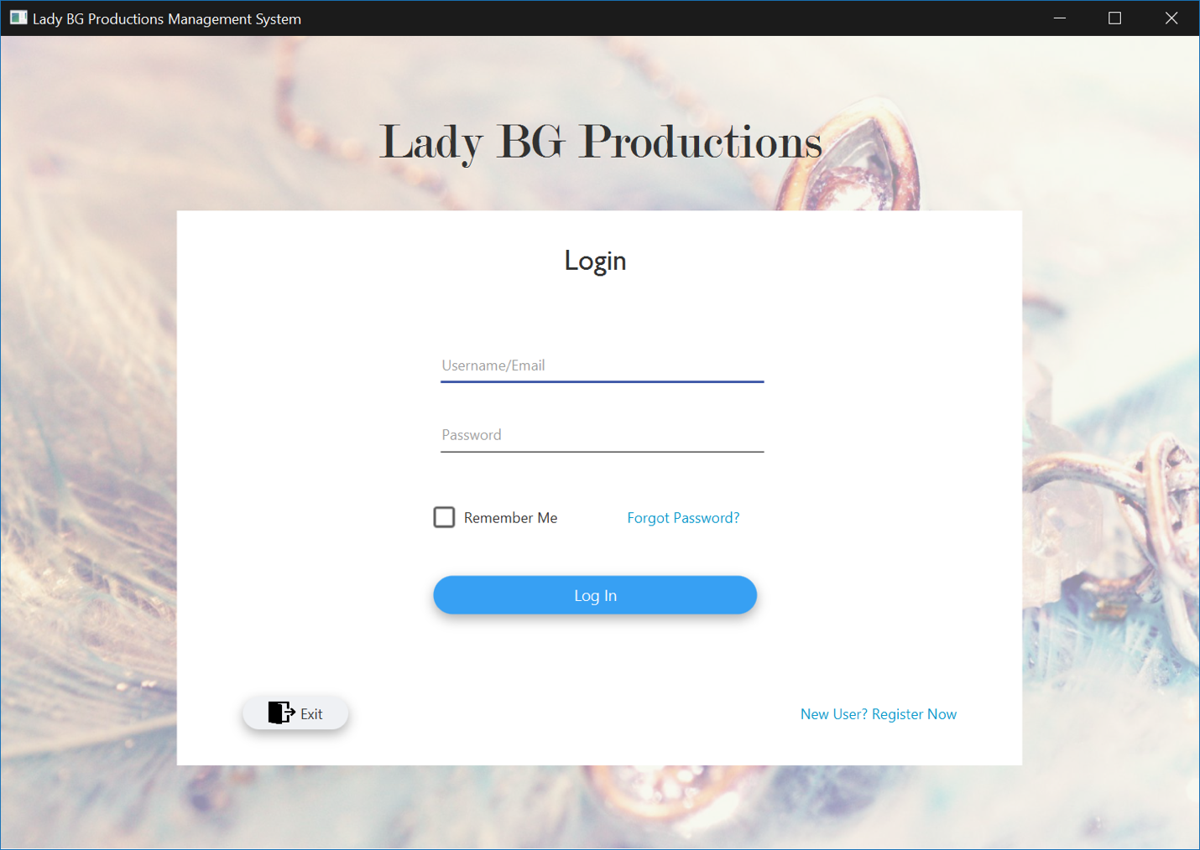

#### User Registration

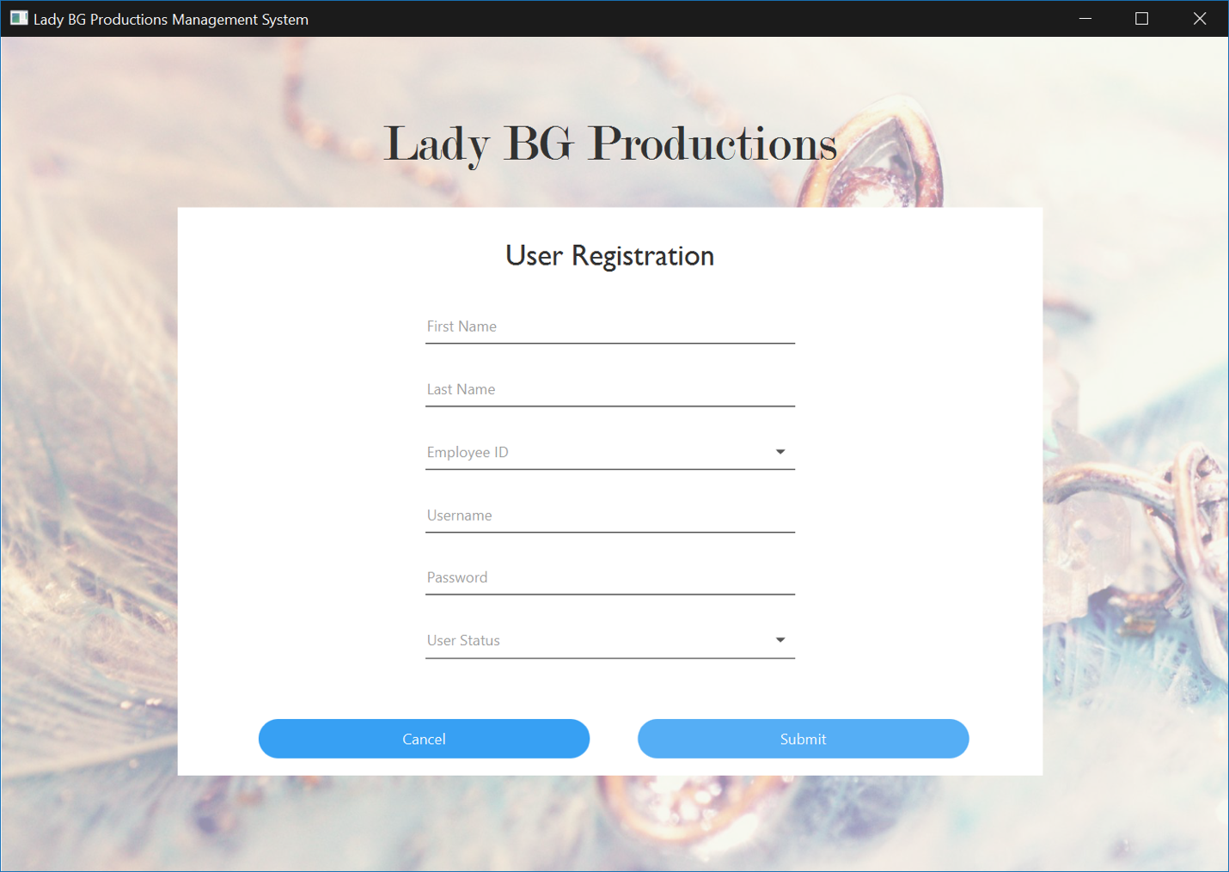

## Kristy Hoang

### Create Scripts

#### Postal Zip Code Table

create table PostalCode

(

   PostalCode_ID int not null identity(1,1),

   PostalCode varchar(25) not null,

   County varchar(25) not null,

   constraint PostalCode_pk

       primary key (PostalCode_ID)

);

#### County Table

create table County

(

   County_ID int not null identity(1,1),

   County_Name varchar(25) not null,

   constraint County_pk

       primary key (County_ID)

);

#### Client

create table Client

(

   Client_ID int not null identity(1,1),

   Client_First varchar(25) not null,

   Client_Last varchar(25) not null,

   Client_Email varchar(50) not null,

   Client_Phone varchar(25) not null,

   Client_Street varchar(25) not null,

   Client_City varchar(25) not null,

   Client_State varchar(2) not null,

   Client_Comments varchar(100),

   constraint Client_pk

       primary key (Client_ID));

### Alter Scripts

Alter table Payroll

 Add constraint Fk_Payroll

   Foreign key(Timesheet_ID) references Timesheet(Timesheet_ID);

Alter table Vacation_Request

 Add constraint Fk_Vacation_Request

   Foreign key(Employee_ID) references Employee(Employee_ID);

Alter table Vacation_Status

 Add constraint Fk_Vacation_Status

   Foreign key(Vacation_ID) references Vacation_Request(Vacation_ID);

Alter table User_Info

 Add constraint Fk_User_Info

   Foreign key(Employee_ID) references Employee(Employee_ID);

Alter table User_Login

 Add constraint Fk_User_Login

   Foreign key(User_ID) references User_Info(User_ID);

Alter table Event

 Add constraint Fk_Event_ID

   Foreign key(Client_ID) references Client(Client_ID);

Alter table Event_Location

 Add constraint Fk_Event_Location

   Foreign key(Event_ID) references Event(Event_ID);

Alter table Event_Date

 Add constraint Fk_Event_Date

   Foreign key(Event_ID) references Event(Event_ID);

### Bulk Insert Scripts

#### County Table Insert

bulk insert County

from 'C:\Users\khoang6\Downloads\List_of_Counties.csv'

with

(

rowterminator='\n',

fieldterminator=','

)

#### Postal Code Table Insert

bulk insert PostalCode

from 'C:\Users\khoang6\Downloads\Postal_ZipCodes.csv'

with

(

rowterminator='\n',

fieldterminator=','

)

#### Phone Number Table Insert

bulk insert Phone_Number

from 'C:\Users\khoang6\Downloads\Phone_Number.csv'

with

(

rowterminator='\n',

fieldterminator=','

)

### Data Records for Tables

#### County Table

1,Harris

2,Harris

3,Anchorage

4,Mobile

5,Sevier

6,Maricopa

7,San Diego

8,Pueblo

9,New Haven

10,District of Columbia

11,New Castle

12,Hillsborough

13,Dekalb

14,Honolulu

15,Lee

16,Jefferson

17,Autauga

18,Baldwin

19,Barbour

20,Bibb

21,Blount

22,Bullock

23,Butler

24,Calhoun

25,Chambers

26,Cherokee

27,Chilton

28,Choctaw

29,Clarke

30,Clay

31,Cleburne

32,coffee

33,Colbert

34,Conecuh

35,Coosa

36,covington

37,Crenshaw

38,Cullman

39,Dale

40,Dallas

41,Dekalb

42,elmore

43,Escambia

44,Etowah

45,Fayette

46,Franklin

47,Geneva

48,Greene

49,Half

50,Henry

51,Houston

52,Jackson

53,Jefferson

54,Ontario

55,Quebec

56,Lamar

57,Lauderdale

58,Lawrence

59,Lee

60,Limestone

61,Lowndes

62,Macon

63,Madison

64,Marengo

65,Marion

66,Marshall

67,Mobile

68,Monroe

69,Montgomery

70,Morgan

71,Perry

72,Pickens

73,Pike

74,Randolph

75,Russell

76,St. Clair

77,Shelby

78,Sumter

79,Talladega

80,Tallapoosa

81,Tuscaloosa

82,Walker

83,Washington

84,Wilcox

85,Winston

86,Denali Borough

87,Haines Borough

88,Apache

89,Cochise

90,Coconino

91,Gila

92,Graham

93,Greenlee

94,La Paz

95,Maricopa

96,Mohave

97,Navajo

98,Pima

99,Pinal

100,Santa Cruz

#### Postal Code Data

1,77025,Harris

2,77054,Harris

3,99503,Anchorage

4,36602,Mobile

5,71846,Sevier

6,85034,Maricopa

7,92111,San Diego

8,81003,Pueblo

9,06511,New Haven

10,20011,District of Columbia

11,19720,New Castle

12,33568,Hillsborough

13,30030,Dekalb

14,96813,Honolulu

15,52627,Lee

16,83443,Jefferson

17,62451,Autauga

18,46923,Baldwin

19,66215,Barbour

20,40115,Bibb

21,70501,Blount

22,02333,Bullock

23,21014,Butler

24,04092,Calhoun

25,48607,Chambers

26,56303,Cherokee

27,64842,Chilton

28,39667,Choctaw

29,59873,Clarke

30,28273,Clay

31,58701,Cleburne

32,68128,coffee

33,03103,Colbert

34,08021,Conecuh

35,87401,Coosa

36,89501,covington

37,10013,Crenshaw

38,43609,Cullman

39,74012,Dale

40,97205,Dallas

41,19115,Dekalb

42,02903,elmore

43,29720,Escambia

44,57051,Etowah

45,38110,Fayette

46,75067,Franklin

47,84119,Geneva

48,24501,Greene

49,05403,Half

50,98168,Henry

51,53572,Houston

52,26409,Jackson

53,82601,Jefferson

54,M3H 4J1,Ontario

55,S4P 3Y2,Quebec

56,84378,Lamar

57,06106,Lauderdale

58,32068,Lawrence

59,37803,Lee

60,30126,Limestone

61,48146,Lowndes

62,23451,Macon

63,46060,Madison

64,16001,Marengo

65,29646,Marion

66,54601,Marshall

67,21042,Mobile

68,11377,Monroe

69,49428,Montgomery

70,99504,Morgan

71,31313,Perry

72,16601,Pickens

73,11801,Pike

74,43612,Randolph

75,54880,Russell

76,20164,St. Clair

77,99654,Shelby

78,17331,Sumter

79,14450,Talladega

80,32708,Tallapoosa

81,32250,Tuscaloosa

82,18015,Walker

83,11793,Washington

84,55987,Wilcox

85,21244,Winston

86,10550,Denali Borough

87,48329,Haines Borough

88,02720,Apache

89,01844,Cochise

90,15108,Coconino

91,35209,Gila

92,27603,Graham

93,28376,Greenlee

94,48066,La Paz

95,20109,Maricopa

96,27253,Mohave

97,20748,Navajo

98,56601,Pima

99,37918,Pinal

100,33756,Santa Cruz

#### Phone Number Data

1,Avis,Moroz,(325) 372-8992

2,Floyd,Paek,(706) 578-8078

3,Marjory,Gisi,(405) 676-2234

4,Lance,Garnett,(338) 466-1980

5,Georgene,Bach,(629) 397-4936

6,Evonne,Seales,(553) 650-0503

7,Jeanette,Allinder,(414) 383-1439

8,Anh,Currier,(503) 246-2251

9,Major,Fuller,(691) 946-7716

10,Eldon,Mccolley,(973) 836-1042

11,Rudolf,Reza,(246) 581-8261

12,Norma,Flemister,(610) 503-6106

13,Carman,Turco,(716) 346-8068

14,Lovella,Jennette,(817) 768-7173

15,Rutha,Widman,(447) 410-5693

16,Annamarie,Alpers,(286) 468-4490

17,Kit,Blasko,(393) 238-9026

18,Jeanice,Grennan,(324) 772-6334

19,Janice,Son,(774) 850-5891

20,Alica,Alt,(992) 985-5684

21,Etsuko,Canter,(615) 773-6740

22,Ruby,Dube,(250) 999-5792

23,Laronda,Willcox,(938) 806-3607

24,Clifford,Theis,(828) 634-2499

25,Mozella,Elmendorf,(289) 496-8187

26,Zofia,Speas,(811) 257-0197

27,Marco,Wiest,(945) 376-6023

28,Flavia,Blay,(508) 217-8448

29,Tomoko,Gruber,(277) 613-0285

30,Maryanna,Tyer,(572) 676-0400

31,Lona,Muir,(781) 902-2575

32,Magdalen,Manges,(303) 514-2251

33,Ignacia,Hieber,(242) 739-2009

34,Marty,Townes,(542) 786-3607

35,Lyndon,Giffen,(263) 388-6261

36,Evelin,Trujillo,(816) 891-5184

37,Yuri,Shasteen,(406) 427-9084

38,Carmel,Troyer,(457) 675-3209

39,Velma,Matthies,(657) 822-9986

40,Lorna,Riker,(873) 745-8698

41,Jesenia,Sylvia,(452) 565-2100

42,Marceline,Strayer,(511) 484-9118

43,Garth,Gilbert,(269) 965-6236

44,India,Marse,(406) 620-8984

45,Mayme,Dahle,(515) 748-9554

46,Karena,Mangano,(548) 589-5419

47,Rheba,Mcqueary,(429) 796-4991

48,Echo,Kimbell,(385) 317-5465

49,Richard,Maillet,(889) 756-5131

50,Flor,Gattis,(773) 453-9843

51,Cyndi,Whitmer,(463) 904-9541

52,Janett,Willey,(200) 977-9228

53,Meridith,Lyford,(416) 824-8766

54,Malorie,Drost,(928) 999-1681

55,Belinda,Raber,(436) 214-7641

56,Rubie,Worthley,(388) 548-8993

57,Julissa,Mulero,(743) 672-0562

58,Geoffrey,Mauk,(398) 973-1290

59,Bailey,Hall,(541) 355-0783

60,Margert,Mahood,(791) 676-2053

61,Linnie,Kizer,(623) 893-0090

62,Keneth,Drewes,(625) 363-8483

63,Damian,Vanmeter,(855) 580-2806

64,Jaclyn,Paden,(721) 434-6317

65,Terrell,Craft,(282) 451-4984

66,Kira,Oropeza,(268) 395-5934

67,Cathy,Sowards,(430) 304-3519

68,Darlena,Meas,(854) 576-3606

69,Albertha,Vogus,(886) 476-7224

70,Estrella,Mees,(614) 708-1396

71,Latonia,Line,(251) 751-9095

72,Cathern,Blackmer,(726) 601-3299

73,Jonelle,Willman,(925) 586-2806

74,Mandy,Duke,(500) 202-3230

75,Yung,Capron,(565) 938-2204

76,Mistie,Dorado,(523) 526-7241

77,Jed,Powe,(766) 421-1498

78,Gidget,Griffis,(931) 638-8812

79,Yvonne,Mcarthur,(761) 796-2737

80,Mel,Godwin,(894) 465-1154

81,Cheryl,Webber,(443) 213-8770

82,Frank,Sawyer,(620) 669-2992

83,Clarissa,Sugg,(513) 439-8673

84,Daniell,Bluford,(393) 525-9620

85,Louann,Helget,(689) 772-8073

86,Nathalie,Toms,(968) 687-3830

87,Oretha,Duval,(905) 590-3845

88,Melony,Silberman,(556) 692-7841

89,Ghislaine,Zaldivar,(250) 549-5157

90,Haywood,Alward,(762) 974-6699

91,Tillie,Mengel,(785) 890-8483

92,Catharine,Thomason,(333) 251-2442

93,Catrina,Coward,(651) 876-4460

94,Roman,Molitor,(666) 859-2154

95,Mamie,Tennyson,(210) 973-4467

96,Dulce,Vallee,(444) 220-6692

97,Tyrell,Downing,(580) 289-2019

98,Lang,Arthurs,(794) 395-6456

99,Rosie,Wallis,(921) 899-7329

100,Kiesha,Buendia,(211) 835-9522

### SQL Report Queries

#### Query 1

Select loc.Location_ID, cli.Client_First, cli.Client_Last, ctype.New_Client, ctype.Returning_Client, pay.Payment_Type, pay.Payment_Amount

from Locations as loc inner join Client as cli

on loc.Location_ID = cli.Client_ID

inner join Client_Type ctype

on ctype.Client_ID = cli.Client_ID

inner join Payment_Method pay

on pay.Client_ID = cli.Client_ID

* This report query combines the following tables:
  + Location
  + Client
  + Client Type
  + Payment Method
* Using the location table, we find which company location that the client has requested his event from.
* The client table pulls the clients information such as the first and last name.
* The client type table allows us to see if the clients are returning or new. The owner can base off their prices and discounts on this.
* The payment method allows us to see how they paid for it and the amount paid.

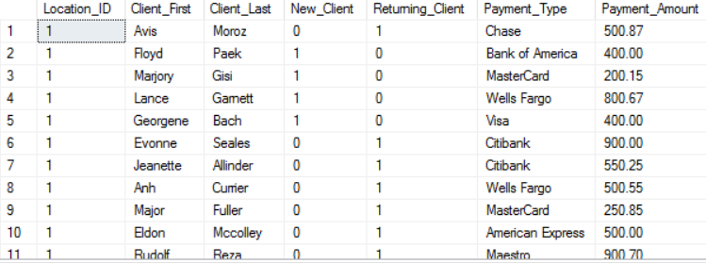

#### Query 2

Select loc.Location_ID, cli.Client_First, cli.Client_Last, ev.Event_ID, bs.Booking_Status

from Locations as loc inner join Client as cli

on loc.Location_ID = cli.Location_ID

inner join Event ev

on ev.Client_ID = cli.Client_ID

inner join Booking_Status bs

on bs.Client_ID = cli.Client_ID

* This report query combines the following tables:
  + Location
  + Client
  + Event
  + Booking_Status
* Using the location table, we find which company location that the client has requested his event from.
* The client table pulls the clients information such as the first and last name.
* The event table lets us find the event ID and connect it to our booking status.
* The booking status lets us determine whether or not it has been fulfilled.

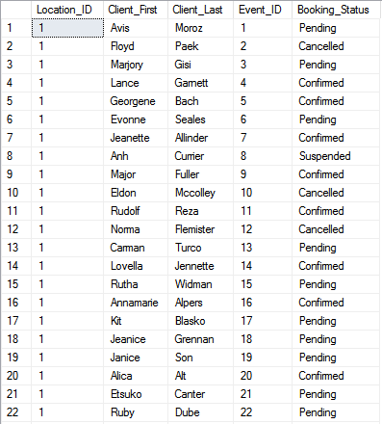

#### Query 3

Select loc.Location_ID, emp.First_Name, emp.Last_Name, vr.Reason, vr.Date_Requested, vr.Date_Return, vs.Status

from Locations as loc inner join Employee as emp

on loc.Location_ID = emp.Location_ID

inner join Vacation_Request vr

on vr.Employee_ID = emp.Employee_ID

inner join Vacation_Status vs

on vs.Vacation_ID = vr.Vacation_ID

* This report query combines the following tables:
  + Location
  + Employee
  + Vacation_Request
  + Vacation_Status
* Using the location table, we find which company location that the client has requested his event from.
* The employee table allows us to find information about the employee, such as the first and last name.
* The vacation request table allows us to find the requests for vacation made by employees.
* The vacation status table lets us know whether or not the request has been approved.

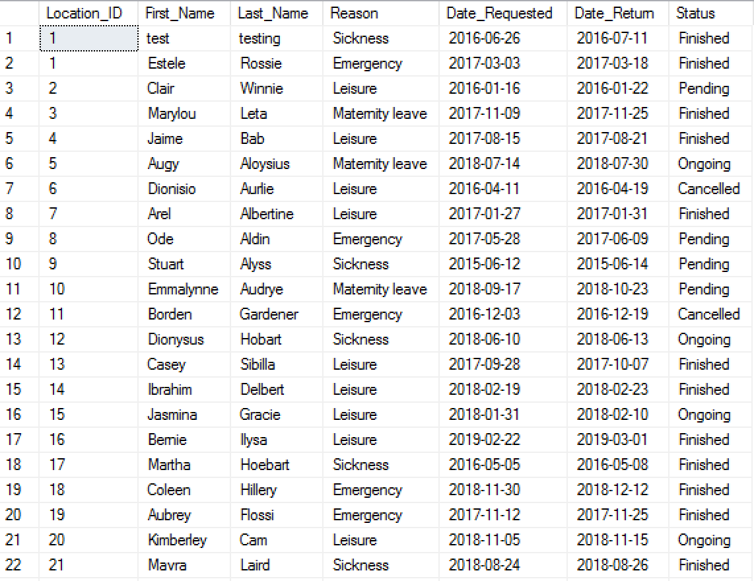

#### Query 4

Select loc.Location_ID, emp.First_Name, emp.Last_Name, et.Emp_Title, es.Employement_Status

from Locations as loc inner join Employee as emp

on loc.Location_ID = emp.Location_ID

inner join Employee_Title et

on et.Employee_ID = emp.Employee_ID

inner join Employee_Status es

on es.Employee_ID = emp.Employee_ID

* This report query combines the following tables:
  + Location
  + Employee
  + Employee_Title
  + Employee_Status
* Using the location table, we find which company location that the client has requested his event from.
* The employee table allows us to find information about the employee, such as the first and last name.
* The employee title table gives us information about the employee and their position in the company.
* The employee status lets us know whether or not the employee is active within the company.

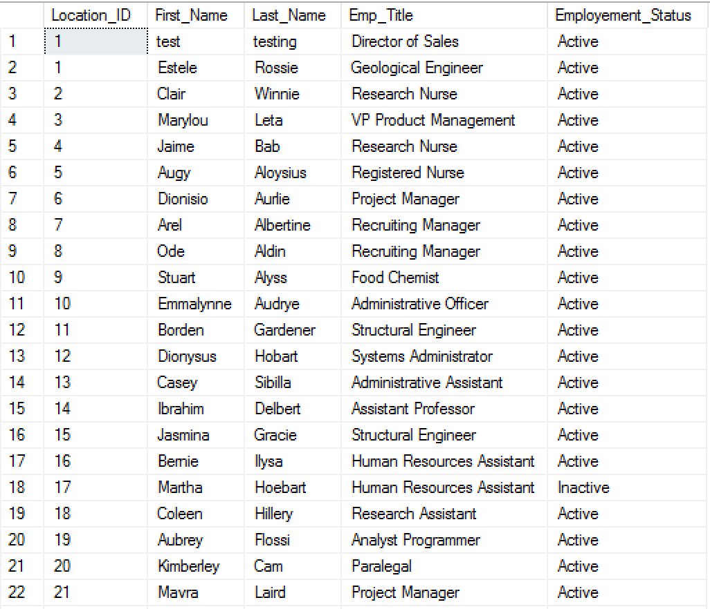

#### Query 5

Select loc.Location_ID, emp.First_Name, emp.Last_Name, ts.Work_day, ts.Time_in, ts.Time_out, tss.Status

from Locations as loc inner join Employee as emp

on loc.Location_ID = emp.Location_ID

inner join Timesheet ts

on ts.Employee_ID = emp.Employee_ID

inner join Timesheet_Status tss

on tss.Timesheet_ID = ts.Timesheet_ID

* This report query combines the following tables:
  + Location
  + Employee
  + Timesheet
  + Timesheet_Status
* Using the location table, we find which company location that the client has requested his event from.
* The employee table allows us to find information about the employee, such as the first and last name.
* The timesheet table lets us see the clock in and clock out time for each employee.
* The timesheet status allows us to see whether or not the timesheets submitted are approved or not.

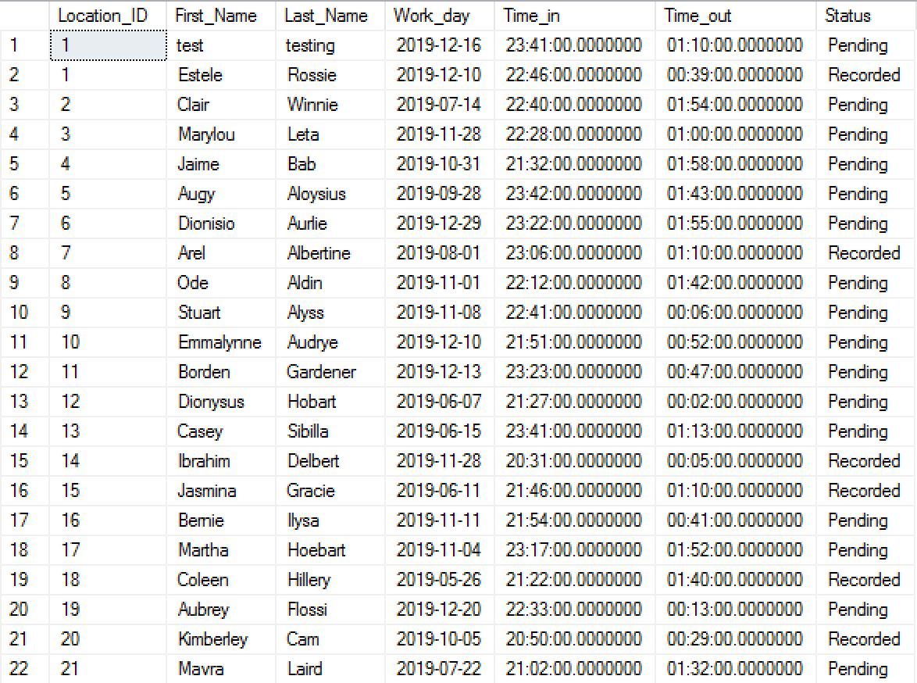

### SQL Insert, Update, and Delete Scripts

#### Insert Script 1

insert into County(County_ID, County_Name)

values(101 ,'Fort Ben');

Figure 1. *Before County insert*



Figure 2. *After County insert*

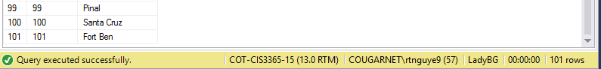

#### Insert Script 2

insert into Locations(Location_ID, Street_Address, City, State, Postal, Country)

values(101, '1725 Slough Ave.', 'Scranton', 'PA', '18504', 'United States');

Figure 3. *Before location insert*



Figure 4. *After location insert*

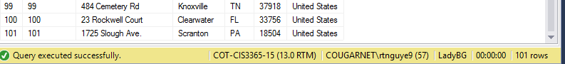

#### Update Script 1

update Locations

set Street_Address = '5831 Southford', Postal = '77033'

where Location_ID = 2;

Figure 5. *Before location update*

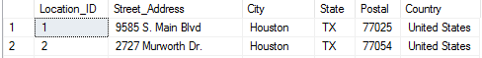

Figure 6. *After location update*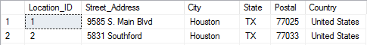

#### Update Script 2

update PostalCode

set PostalCode = '77406', County = 'Fort Bend'

where PostalCode_ID = 2;

Figure 7. *Before Postal Code update*



Figure 8. *After Postal Code update*



#### Delete Script 1

delete from County

where County_ID = 101;

Figure 9. *Before County delete*



Figure 10. *After County delete*



#### Delete Script 2

delete from Locations

where Location_ID = 101;

Figure 11. *Before Location delete*



Figure 12. *After Location delete*



### GUI User Views

#### Main Menu

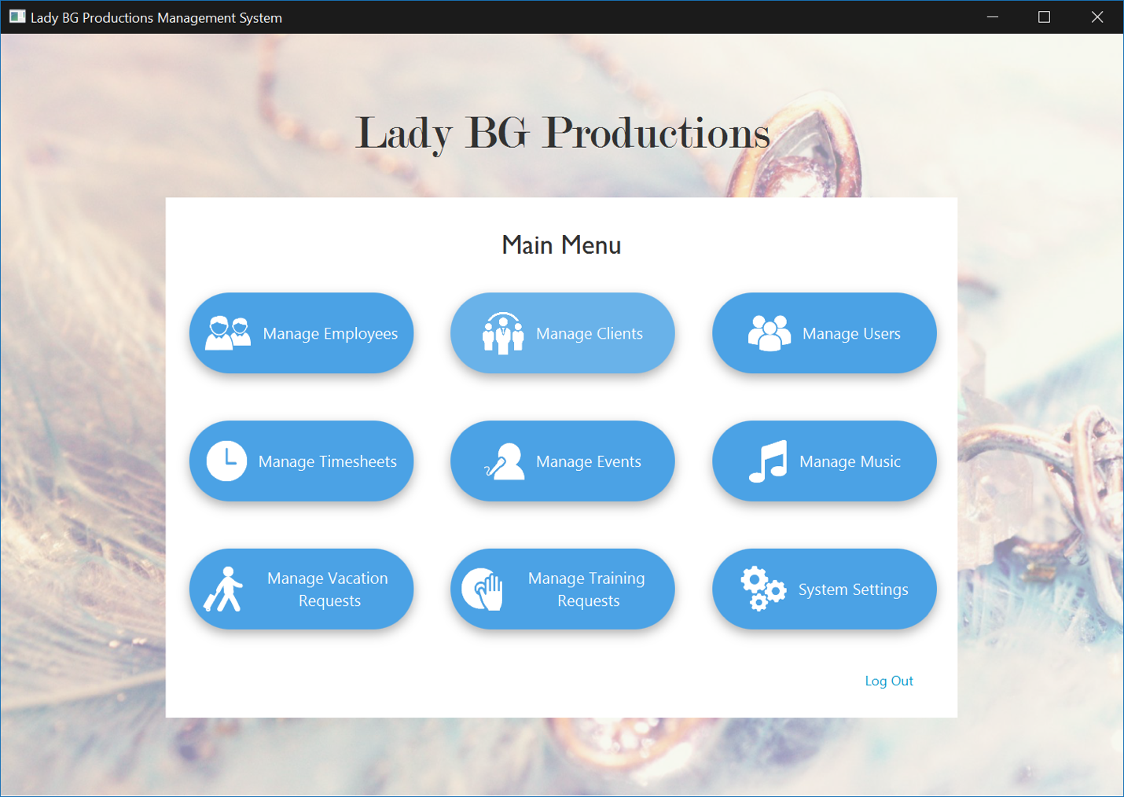

#### Manage Employee View

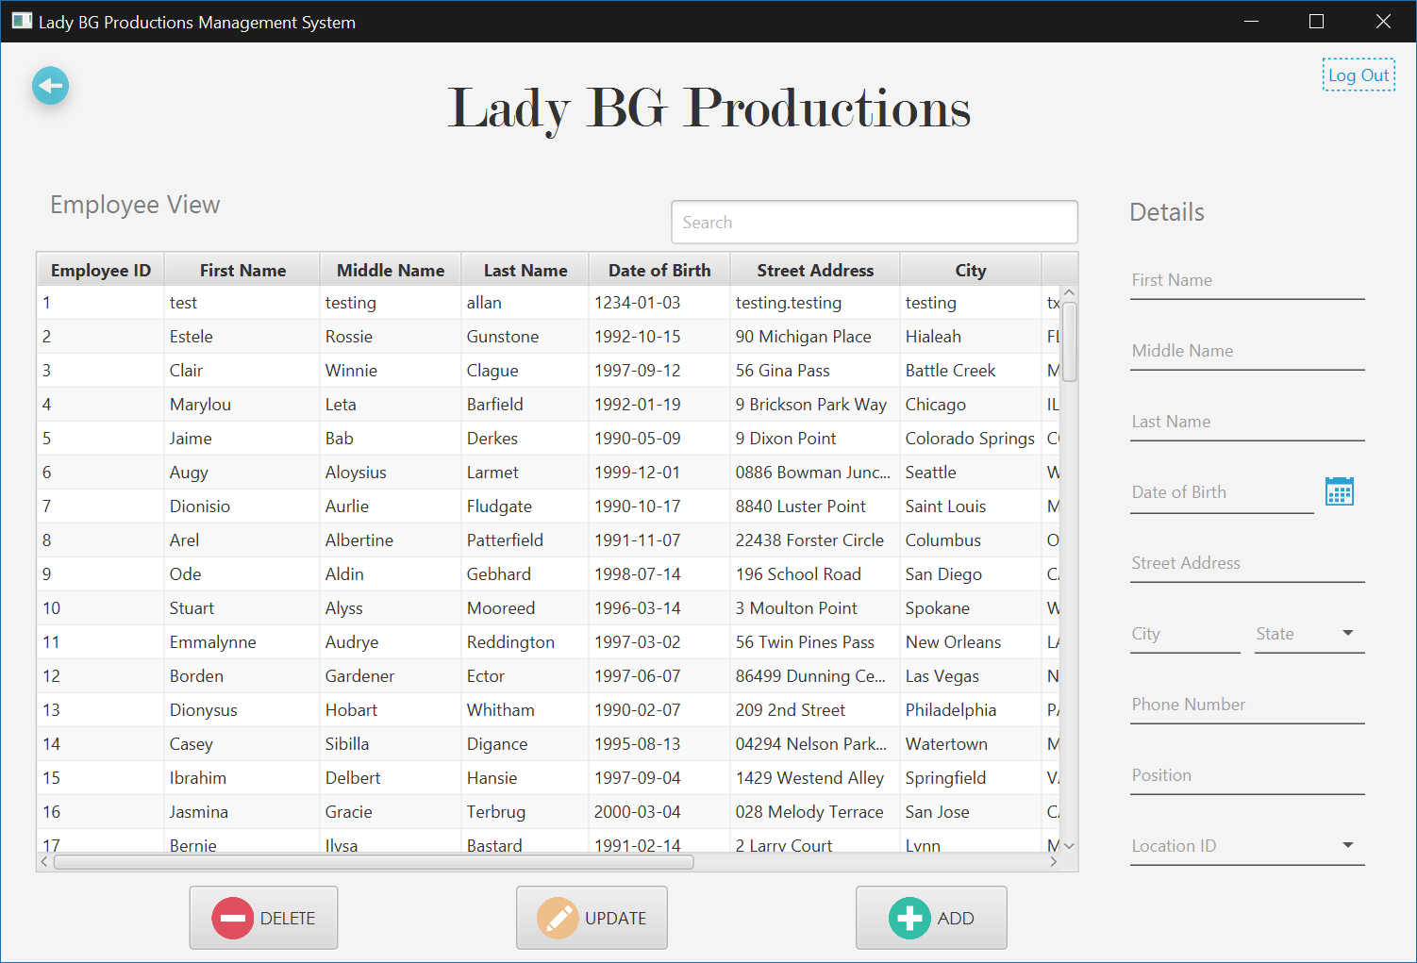

## Celesta Monsivaiz

### Create Table Scripts

#### Payroll_History Table

CREATE TABLE Payroll_History

(

PAYROLL_RECORDS int,

EMP_ID int,

TRANSACTION_ID int,

TRANSACTION_DATE date,

PAID_AMOUNT int not null

            Primary key (PAYROLL_RECORDS)

);

#### Payroll_Admin Table

CREATE TABLE Payroll_Admin

(

PAYROLL_ADMIN_ID int,

EMP_ID int,

F_NAME varchar(30),

L_NAME varchar(30),

M_NAME varchar(30)

            Primary key (PAYROLL_ADMIN_ID)

);

#### Payroll_Type Table

CREATE TABLE Payroll_Type

(

PAYROLL_TYPE_ID int,

EMP_ID int,

WAGES int not null,

MEDICARE int not null,

BENEFITS int not null,

RETIREMENT int not null

            Primary key (PAYROLL_TYPE_ID)

);

Payroll_payPeriod Table

CREATE TABLE Payroll_payPeriod

(

PAY_PERIOD date,

TRANSACTION_DATE date,

EMP_ID int

            Primary key (PAY_PERIOD)

);

### Alter Scripts

Alter table Employee_Training_Status

 Add constraint Fk_Employee_Training

   Foreign key(Training_ID) references Employee_Training_Request(Training_RequestID);

Alter table Timesheet

 Add constraint Fk_Timesheet_ID

   Foreign key(Employee_ID) references Employee(Employee_ID);

Alter table Timesheet_Status

 Add constraint Fk_Timesheet_StatusID

   Foreign key(Timesheet_ID) references Timesheet(Timesheet_ID);

### Bulk insert Scripts

#### Event Table

bulk insert Event

from ‘C:\Users\cemonsiv\Downloads\Event.cvs’

with

(

rowterminator= ‘\n’,

fieldterminator= ‘ , ’

)

#### Event_Status Table

bulk insert Event_Status

from ‘C:\Users\cemonsiv\Downloads\Event_Status.cvs’

with

(

rowterminator= ‘\n’,

fieldterminator= ‘ , ’

)

#### Event_Type Table

bulk insert Event_Type

from ‘C:\Users\cemonsiv\Downloads\Event_Type.cvs’

with

(

rowterminator= ‘\n’,

fieldterminator= ‘ , ’

)

#### Event_Expenses Table

bulk insert Event_Expenses

from ‘C:\Users\cemonsiv\Downloads\Event_Expenses.cvs’

with

(

rowterminator= ‘\n’,

fieldterminator= ‘ , ’

)

### Data Records for Tables

#### Event Data

1,1,21:00,1/2/2012,Downtown,Karaoke Only,17:00

2,2,19:00,8/17/2012,Upper Kirby,DJ & Karaoke,15:00

3,3,20:00,10/18/2012,Greater Northside,Undecided,16:00

4,4,20:00,2/15/2013,Baybrook,DJ & Karaoke,15:00

5,5,19:30,5/19/2014,Downtown,DJ & Karaoke,15:30

6,6,19:00,11/4/2014,Memorial,Karaoke Only,16:00

7,7,20:00,3/23/2015,Sharpstown,Karaoke Only,16:00

8,8,20:00,4/2/2015,Greater East End,Karaoke Only,17:00

9,9,21:00,4/22/2015,Houston Southeast,Karaoke Only,17:00

10,10,21:00,5/13/2015,Uptown Houston,Undecided,17:00

11,11,20:00,5/18/2015,Spring Branch,Karaoke Only,16:00

12,12,21:00,7/21/2015,Greater Northside,Karaoke Only,16:00

13,13,22:00,6/30/2016,Downtown,Karaoke Only,18:00

14,14,22:00,1/5/2019,Spring Branch,DJ & Karaoke,17:00

15,15,21:00,12/9/2017,Houston Southeast,DJ & Karaoke,18:00

16,16,22:30,1/12/2019,Baybrook,DJ & Karaoke,18:30

17,17,21:00,12/15/2017,Greater Northside,Karaoke Only,16:00

18,18,20:00,1/19/2019,Westchase,Karaoke Only,16:00

19,19,21:30,1/26/2019,Chinatown,DJ & Karaoke,17:30

20,20,18:00,1/12/2018,Uptown Houston,Karaoke Only,15:00

21,21,22:30,2/2/2019,Memorial,Karaoke Only,18:30

22,22,18:30,2/9/2019,Alief,Karaoke Only,15:30

23,23,20:00,1/21/2018,Midtown,DJ & Karaoke,16:00

24,24,19:30,3/2/2019,Greenspoint,Karaoke Only,15:30

25,25,19:30,2/23/2019,Baybrook,DJ & Karaoke,15:30

26,26,21:00,3/9/2019,Memorial,Karaoke Only,17:00

27,27,22:00,3/16/2019,Greater East End,DJ & Karaoke,18:00

28,28,21:00,2/3/2018,Spring Branch,DJ & Karaoke,18:00

29,29,20:00,3/23/2019,Greater Northside,DJ & Karaoke,17:00

30,30,21:00,2/9/2018,Downtown,DJ & Karaoke,17:00

31,31,21:00,2/10/2018,Upper Kirby,Karaoke Only,17:00

32,32,20:00,2/11/2018,Midtown,Karaoke Only,16:00

33,33,19:30,3/30/2019,Houston Southeast,Karaoke Only,15:30

34,34,22:00,2/23/2018,Memorial,DJ & Karaoke,18:00

35,35,19:30,4/6/2019,Alief,Karaoke Only,15:30

36,36,22:00,4/13/2019,Uptown Houston,DJ & Karaoke,17:00

37,37,22:00,3/2/2018,Greater Northside,Undecided,18:00

38,38,20:00,4/19/2019,Greenspoint,Karaoke Only,16:00

39,39,21:00,4/20/2019,Midtown,Karaoke Only,15:00

40,40,18:00,3/11/2018,Downtown,Karaoke Only,14:00

41,41,20:00,4/27/2019,Memorial,Karaoke Only,17:00

42,42,21:00,3/15/2018,Sharpstown,Karaoke Only,17:00

43,43,18:00,5/3/2019,Baybrook,Karaoke Only,15:00

44,44,21:00,3/24/2018,Uptown Houston,DJ & Karaoke,17:00

45,45,22:00,3/25/2018,Alief,DJ & Karaoke,17:00

46,46,23:00,5/4/2019,Chinatown,DJ & Karaoke,19:00

47,47,19:00,3/30/2018,Upper Kirby,Karaoke Only,16:00

48,48,22:00,3/31/2018,Greater East End,DJ & Karaoke,18:00

49,49,22:30,4/5/2018,Houston Southeast,DJ & Karaoke,18:30

50,50,23:00,4/6/2018,Greenspoint,DJ & Karaoke,18:00

51,51,22:00,4/7/2018,Upper Kirby,DJ & Karaoke,17:00

52,52,19:30,5/10/2019,Uptown Houston,Karaoke Only,15:30

53,53,21:00,5/11/2019,Midtown,DJ & Karaoke,17:00

54,54,22:00,5/17/2019,Greater East End,DJ & Karaoke,18:00

55,55,22:00,5/18/2019,Spring Branch,DJ & Karaoke,18:00

56,56,19:00,5/24/2019,Baybrook,Karaoke Only,15:00

57,57,19:00,5/25/2019,Memorial,Karaoke Only,16:00

58,58,22:30,4/28/2018,Memorial,DJ & Karaoke,18:30

59,59,22:30,5/31/2019,Baybrook,DJ & Karaoke,18:30

60,60,23:00,6/1/2019,Greater Northside,DJ & Karaoke,19:00

61,61,22:00,5/5/2018,Greater Northside,DJ & Karaoke,18:00

62,62,22:00,6/7/2019,Alief,DJ & Karaoke,17:00

63,63,22:00,6/8/2019,Midtown,DJ & Karaoke,18:00

64,64,22:00,5/12/2018,Westchase,DJ & Karaoke,17:00

65,65,23:00,6/14/2019,Memorial,DJ & Karaoke,19:00

66,66,22:00,6/15/2019,Upper Kirby,DJ & Karaoke,18:00

67,67,20:00,5/19/2018,Midtown,Karaoke Only,16:00

68,68,18:00,5/20/2018,Alief,Karaoke Only,15:00

69,69,18:00,5/18/2019,Westchase,DJ & Karaoke,15:00

70,70,23:00,5/26/2018,Memorial,DJ & Karaoke,19:00

71,71,18:00,5/25/2019,Upper Kirby,Karaoke Only,14:00

72,72,21:00,5/31/2019,Greater Northside,Undecided,17:00

73,73,20:00,6/3/2018,Greater Northside,Karaoke Only,16:00

74,74,21:00,6/17/2018,Greenspoint,Karaoke Only,17:00

75,75,22:00,6/1/2019,Alief,DJ & Karaoke,18:00

76,76,21:30,6/24/2018,Baybrook,DJ & Karaoke,17:30

77,77,20:30,6/7/2019,Westchase,DJ & Karaoke,16:30

78,78,20:00,6/29/2018,Memorial,DJ & Karaoke,16:00

79,79,19:00,6/30/2018,Alief,Karaoke Only,16:00

80,80,21:00,7/6/2018,Greater Northside,DJ & Karaoke,17:00

81,81,19:30,7/7/2018,Greater Northside,Karaoke Only,16:30

82,82,21:00,7/14/2018,Greater East End,DJ & Karaoke,17:00

83,83,22:00,7/15/2018,Greenspoint,DJ & Karaoke,18:00

84,84,22:30,7/21/2018,Uptown Houston,DJ & Karaoke,18:30

85,85,21:00,7/22/2018,Baybrook,Karaoke Only,18:00

86,86,18:00,7/27/2018,Memorial,Karaoke Only,15:00

87,87,19:00,7/28/2018,Greater Northside,Karaoke Only,16:00

88,88,22:00,8/4/2018,Alief,DJ & Karaoke,18:00

89,89,19:00,8/11/2018,Alief,Karaoke Only,16:00

90,90,21:00,8/18/2018,Greater Northside,DJ & Karaoke,16:00

91,91,18:00,8/25/2018,Greater Northside,Karaoke Only,15:00

92,92,18:30,9/1/2018,Uptown Houston,Karaoke Only,15:30

93,93,23:00,9/8/2018,Sharpstown,DJ & Karaoke,19:00

94,94,20:00,9/15/2018,Westchase,Karaoke Only,16:00

95,95,22:00,9/22/2018,Houston Southeast,DJ & Karaoke,18:00

96,96,21:30,9/29/2018,Alief,DJ & Karaoke,17:30

97,97,20:30,10/6/2018,Houston Southeast,Karaoke Only,16:30

98,98,21:00,10/13/2018,Spring Branch,DJ & Karaoke,17:00

99,99,19:00,11/3/2018,Alief,Karaoke Only,15:00

100,100,21:00,12/1/2018,Greater Northside,Undecided,17:00

#### Event_Status Table

1,1/2/2012,1,Fulfilled

2,8/17/2012,2,Fulfilled

3,10/18/2012,3,Fulfilled

4,2/15/2013,4,Fulfilled

5,5/19/2014,5,Fulfilled

6,11/4/2014,6,Fulfilled

7,3/23/2015,7,Fulfilled

8,4/2/2015,8,Fulfilled

9,4/22/2015,9,Fulfilled

10,5/13/2015,10,Fulfilled

11,5/18/2015,11,Fulfilled

12,7/21/2015,12,Fulfilled

13,6/30/2016,13,Fulfilled

15,12/9/2017,15,Fulfilled

17,12/15/2017,17,Fulfilled

20,1/12/2018,20,Fulfilled

23,1/21/2018,23,Fulfilled

28,2/3/2018,28,Fulfilled

30,2/9/2018,30,Fulfilled

31,2/10/2018,31,Fulfilled

32,2/11/2018,32,Fulfilled

34,2/23/2018,34,Fulfilled

37,3/2/2018,37,Fulfilled

40,3/11/2018,40,Fulfilled

42,3/15/2018,42,Fulfilled

44,3/24/2018,44,Fulfilled

45,3/25/2018,45,Fulfilled

47,3/30/2018,47,Fulfilled

48,3/31/2018,48,Fulfilled

49,4/5/2018,49,Fulfilled

50,4/6/2018,50,Fulfilled

51,4/7/2018,51,Fulfilled

58,4/28/2018,58,Fulfilled

61,5/5/2018,61,Fulfilled

64,5/12/2018,64,Fulfilled

67,5/19/2018,67,Fulfilled

68,5/20/2018,68,Fulfilled

70,5/26/2018,70,Fulfilled

73,6/3/2018,73,Fulfilled

74,6/17/2018,74,Fulfilled

76,6/24/2018,76,Fulfilled

78,6/29/2018,78,Fulfilled

79,6/30/2018,79,Fulfilled

80,7/6/2018,80,Fulfilled

81,7/7/2018,81,Fulfilled

82,7/14/2018,82,Fulfilled

83,7/15/2018,83,Fulfilled

84,7/21/2018,84,Fulfilled

85,7/22/2018,85,Fulfilled

86,7/27/2018,86,Fulfilled

87,7/28/2018,87,Fulfilled

88,8/4/2018,88,Fulfilled

89,8/11/2018,89,Fulfilled

90,8/18/2018,90,Fulfilled

91,8/25/2018,91,Fulfilled

92,9/1/2018,92,Fulfilled

93,9/8/2018,93,Fulfilled

94,9/15/2018,94,Fulfilled

95,9/22/2018,95,Fulfilled

96,9/29/2018,96,Fulfilled

97,10/6/2018,97,Fulfilled

98,10/13/2018,98,Fulfilled

99,11/3/2018,99,Fulfilled

100,12/1/2018,100,Fulfilled

14,1/5/2019,14,Fulfilled

16,1/12/2019,16,Fulfilled

18,1/19/2019,18,Fulfilled

19,1/26/2019,19,Fulfilled

21,2/2/2019,21,Fulfilled

22,2/9/2019,22,Fulfilled

25,2/23/2019,25,Fulfilled

24,3/2/2019,24,Fulfilled

26,3/9/2019,26,Fulfilled

27,3/16/2019,27,Fulfilled

29,3/23/2019,29,Fulfilled

33,3/30/2019,33,Fulfilled

35,4/6/2019,35,Fulfilled

36,4/13/2019,36,Fulfilled

38,4/19/2019,38,upcoming

39,4/20/2019,39,upcoming

41,4/27/2019,41,upcoming

43,5/3/2019,43,upcoming

46,5/4/2019,46,upcoming

52,5/10/2019,52,upcoming

53,5/11/2019,53,upcoming

54,5/17/2019,54,upcoming

55,5/18/2019,55,upcoming

69,5/18/2019,69,upcoming

56,5/24/2019,56,upcoming

57,5/25/2019,57,upcoming

71,5/25/2019,71,upcoming

59,5/31/2019,59,upcoming

72,5/31/2019,72,upcoming

60,6/1/2019,60,upcoming

75,6/1/2019,75,upcoming

62,6/7/2019,62,upcoming

77,6/7/2019,77,upcoming

63,6/8/2019,63,upcoming

65,6/14/2019,65,upcoming

66,6/15/2019,66,upcoming

#### Event_Type Table

1,1,Private Event

2,2,Kid Friendly

3,3,Kid Friendly

4,4,Kid Friendly

5,5,Private Event

6,6,Private Event

7,7,Private Event

8,8,Corporate Event

9,9,Corporate Event

10,10,Religious

11,11,Corporate Event

12,12,Kid Friendly

13,13,Kid Friendly

14,14,Corporate Event

15,15,Religious

16,16,Kid Friendly

17,17,Kid Friendly

18,18,Private Event

19,19,Private Event

20,20,Private Event

21,21,Private Event

22,22,Kid Friendly

23,23,Private Event

24,24,Private Event

25,25,Private Event

26,26,Corporate Event

27,27,Private Event

28,28,Private Event

29,29,Corporate Event

30,30,Corporate Event

31,31,Private Event

32,32,Private Event

33,33,Private Event

34,34,Private Event

35,35,Private Event

36,36,Kid Friendly

37,37,Kid Friendly

38,38,Kid Friendly

39,39,Private Event

40,40,Kid Friendly

41,41,Corporate Event

42,42,Private Event

43,43,Corporate Event

44,44,Private Event

45,45,Private Event

46,46,Private Event

47,47,Private Event

48,48,Kid Friendly

49,49,Private Event

50,50,Private Event

51,51,Private Event

52,52,Religious

53,53,Private Event

54,54,Private Event

55,55,Private Event

56,56,Private Event

57,57,Private Event

58,58,Private Event

59,59,Private Event

60,60,Private Event

61,61,Private Event

62,62,Private Event

63,63,Kid Friendly

64,64,Private Event

65,65,Private Event

66,66,Private Event

67,67,Corporate Event

68,68,Corporate Event

69,69,Private Event

70,70,Kid Friendly

71,71,Private Event

72,72,Private Event

73,73,Private Event

74,74,Private Event

75,75,Private Event

76,76,Kid Friendly

77,77,Private Event

78,78,Private Event

79,79,Private Event

80,80,Kid Friendly

81,81,Private Event

82,82,Corporate Event

83,83,Private Event

84,84,Private Event

85,85,Private Event

86,86,Kid Friendly

87,87,Private Event

88,88,Corporate Event

89,89,Private Event

90,90,Kid Friendly

91,91,Private Event

92,92,Kid Friendly

93,93,Private Event

94,94,Private Event

95,95,Religious

96,96,Private Event

97,97,Private Event

98,98,Kid Friendly

99,99,Corporate Event

100,100,Private Event

#### Event_Expenses Table

1,1,50,KJ,Karaoke Only,200

2,2,90,Outdoor Setup,DJ & Karaoke,500

3,3,50,KJ,Undecided,400

4,4,90,Outdoor Setup,DJ & Karaoke,550

5,5,50,KJ,DJ & Karaoke,500

6,6,50,KJ,Karaoke Only,300

7,7,90,Outdoor Setup,Karaoke Only,400

8,8,50,KJ,Karaoke Only,300

9,9,50,KJ,Karaoke Only,400

10,10,90,Outdoor Setup,Undecided,400

11,11,50,KJ,Karaoke Only,300

12,12,50,KJ,Karaoke Only,500

13,13,50,KJ,Karaoke Only,400

14,14,50,KJ,DJ & Karaoke,575

15,15,50,KJ,DJ & Karaoke,425

16,16,50,KJ,DJ & Karaoke,575

17,17,50,KJ,Karaoke Only,500

18,18,50,KJ,Karaoke Only,400

19,19,50,KJ,DJ & Karaoke,575

20,20,50,KJ,Karaoke Only,300

21,21,115,Outdoor Relocation,Karaoke Only,400

22,22,90,Outdoor Setup,Karaoke Only,300

23,23,50,KJ,DJ & Karaoke,575

24,24,90,Outdoor Setup,Karaoke Only,400

25,25,50,KJ,DJ & Karaoke,575

26,26,50,KJ,Karaoke Only,400

27,27,50,KJ,DJ & Karaoke,575

28,28,50,KJ,DJ & Karaoke,425

29,29,50,KJ,DJ & Karaoke,425

30,30,50,KJ,DJ & Karaoke,575

31,31,50,KJ,Karaoke Only,400

32,32,50,KJ,Karaoke Only,400

33,33,50,KJ,Karaoke Only,400

34,34,50,KJ,DJ & Karaoke,575

35,35,50,KJ,Karaoke Only,400

36,36,50,KJ,DJ & Karaoke,683

37,37,125,LED Party Lighting,Undecided,400

38,38,125,LED Party Lighting,Karaoke Only,400

39,39,90,Outdoor Setup,Karaoke Only,600

40,40,50,KJ,Karaoke Only,400

41,41,50,KJ,Karaoke Only,300

42,42,50,KJ,Karaoke Only,400

43,43,90,Outdoor Setup,Karaoke Only,300

44,44,50,KJ,DJ & Karaoke,575

45,45,50,KJ,DJ & Karaoke,683

46,46,50,KJ,DJ & Karaoke,575

47,47,50,KJ,Karaoke Only,300

48,48,50,KJ,DJ & Karaoke,575

49,49,50,KJ,DJ & Karaoke,575

50,50,90,Outdoor Setup,DJ & Karaoke,683

51,51,50,KJ,DJ & Karaoke,683

52,52,50,KJ,Karaoke Only,400

53,53,90,Outdoor Setup,DJ & Karaoke,575

54,54,50,KJ,DJ & Karaoke,575

55,55,50,KJ,DJ & Karaoke,575

56,56,50,KJ,Karaoke Only,400

57,57,90,Outdoor Setup,Karaoke Only,300

58,58,50,KJ,DJ & Karaoke,575

59,59,50,KJ,DJ & Karaoke,575

60,60,50,KJ,DJ & Karaoke,575

61,61,50,KJ,DJ & Karaoke,575

62,62,50,KJ,DJ & Karaoke,683

63,63,50,KJ,DJ & Karaoke,575

64,64,50,KJ,DJ & Karaoke,683

65,65,90,Outdoor Setup,DJ & Karaoke,575

66,66,50,KJ,DJ & Karaoke,575

67,67,50,KJ,Karaoke Only,400

68,68,50,KJ,Karaoke Only,300

69,69,50,KJ,DJ & Karaoke,425

70,70,50,KJ,DJ & Karaoke,575

71,71,90,Outdoor Setup,Karaoke Only,400

72,72,50,KJ,Undecided,575

73,73,50,KJ,Karaoke Only,400

74,74,50,KJ,Karaoke Only,400

75,75,50,KJ,DJ & Karaoke,575

76,76,125,LED Party Lighting,DJ & Karaoke,575

77,77,90,Outdoor Setup,DJ & Karaoke,575

78,78,90,Outdoor Setup,DJ & Karaoke,575

79,79,50,KJ,Karaoke Only,300

80,80,90,Outdoor Setup,DJ & Karaoke,575

81,81,50,KJ,Karaoke Only,300

82,82,50,KJ,DJ & Karaoke,575

83,83,50,KJ,DJ & Karaoke,575

84,84,50,KJ,DJ & Karaoke,575

85,85,50,KJ,Karaoke Only,300

86,86,50,KJ,Karaoke Only,300

87,87,50,KJ,Karaoke Only,300

88,88,50,KJ,DJ & Karaoke,575

89,89,50,KJ,Karaoke Only,300

90,90,50,KJ,DJ & Karaoke,575

91,91,50,KJ,Karaoke Only,300

92,92,90,Outdoor Setup,Karaoke Only,300

93,93,50,KJ,DJ & Karaoke,575

94,94,50,KJ,Karaoke Only,400

95,95,50,KJ,DJ & Karaoke,575

96,96,50,KJ,DJ & Karaoke,575

97,97,50,KJ,Karaoke Only,400

98,98,50,KJ,DJ & Karaoke,575

99,99,50,KJ,Karaoke Only,400

100,100,50,KJ,Undecided,575

### SQL Report Queries

#### Query 1

#### Query 2

SELECT dbo.Event.Event_Date, dbo.Service_Request.Service_Requested, dbo.Event_Date.Event_Start, dbo.Event_Date.Event_End, dbo.Event_Status.Status

FROM dbo.Event

INNER JOIN dbo.Event_Date

ON dbo.Event.Event_ID = dbo.Event_Date.Event_ID

INNER JOIN dbo.Event_Status

ON dbo.Event.Event_ID = dbo.Event_Status.Event_ID

INNER JOIN dbo.Service_Request

ON dbo.Event.Event_ID = dbo.Service_Request.Event_ID

* This report query combines the following tables:
  + Event
  + Service_Request
  + Event_Date
  + Event_Status
* Using the Event table, we find out which day the event falls under.
* The Service_Request table shows which type of service was requested for the Event.
* The Event_Date table pulls out information regarding the start and end times for the event.
* The Event_Status table will allow us to see what type of service the client requested for their event.

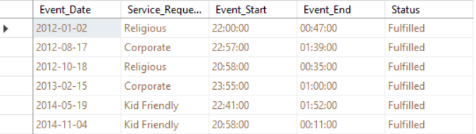

#### Query 3

SELECT dbo.Event.Event_Date, dbo.Service_Request.Service_Requested

AS Expr1, dbo.Event_Expenses.Other_Expenses, dbo.Event_Type.Event_Type

FROM dbo.Event

INNER JOIN dbo.Event_Expenses

ON dbo.Event.Event_ID = dbo.Event_Expenses.Event_ID

INNER JOIN dbo.Event_Type

ON dbo.Event.Event_ID = dbo.Event_Type.Event_ID

INNER JOIN dbo.Service_Request

ON dbo.Event.Event_ID = dbo.Service_Request.Event_ID

* This report query combines the following tables:
  + Event
  + Service_Request
  + Event_Expenses
  + Event_Type
* Using the Event table, we find out the date on which the event is held.
* The Service_Request table displays which kind of service was requested for the Event.
* The Event_Expenses table shows the information regarding what kind of other services where charged for the event.
* The Event_Type table will lastly display the type of event with these known it will inform which equipment is needed for a certain day.

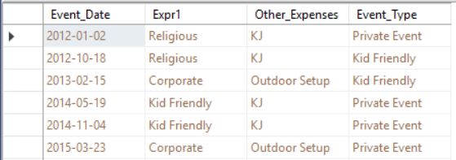

#### Query 4

SELECT dbo.Client.Client_First, dbo.Client.Client_Email, dbo.Client_Type.New_Client, dbo.Event.Client_ID, dbo.Event_Expenses.Other_Cost, dbo.Payment_Method.Payment_Amount

FROM dbo.Client

INNER JOIN dbo.Client_Type

ON dbo.Client.Client_ID = dbo.Client_Type.Client_ID

INNER JOIN dbo.Event

ON dbo.Client.Client_ID = dbo.Event.Client_ID

INNER JOIN dbo.Event_Expenses

ON dbo.Event.Event_ID = dbo.Event_Expenses.Event_ID

INNER JOIN dbo.Payment_Method

ON dbo.Client.Client_ID = dbo.Payment_Method.Client_ID

* This report query combines the following tables:
  + Client
  + Client_Type
  + Event
  + Event_Expenses
  + Payment_Method
* Using the Event table, we can personalize informing a client by email when using their first name.
* The Client _Type table informs if the Client is a new customer or not.
* The Event_Expenses table allows the connection of a client to an event thus using their ID.
* The Payment_Method table will show the current payment amount we can deduct a discount for being a new client and inform the client of this change through email.

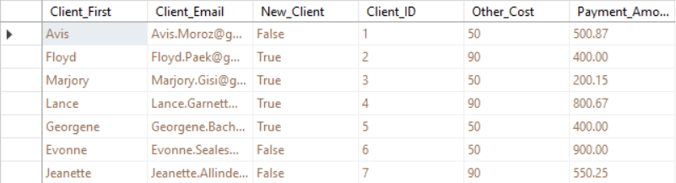

#### Query 5

SELECT dbo.Client.Client_First, dbo.Client.Client_Last, dbo.Event.Client_ID, dbo.Event_Date.Event_Date, dbo.Event_Status.Status

FROM dbo.Client

INNER JOIN dbo.Event

ON dbo.Client.Client_ID = dbo.Event.Client_ID

INNER JOIN dbo.Event_Status

ON dbo.Event.Event_ID = dbo.Event_Status.Event_ID

INNER JOIN dbo.Event_Date

ON dbo.Event.Event_ID = dbo.Event_Date.Event_ID

* This report query combines the following tables:
  + Client
  + Event
  + Event_Date
  + Event_Status
* Using the Client table, we can see the first and last name of the Client.
* The Event table allows the connection between the client and the event thus using the client’s ID.
* The Event_Date table displays what day the event is scheduled for.
* The Event_Status table will show if the status of the event informing if an event is currently upcoming.

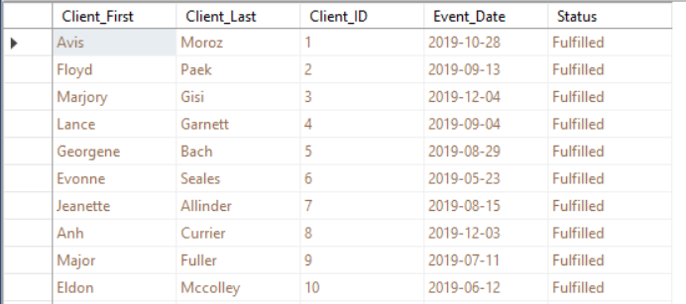

### SQL insert, update, & delete scripts

#### Insert script 1

Insert into Event(Event_ID,Client_ID,End_Time,Event_Date,Event_Location,Service_Requested,Start_Time)

Values(‘101’, ‘101’, ‘21:00’, ‘5/8/2019’, ‘Spring Branch’, ‘Karaoke Only’, ‘17:00’);

Figure1. Before Insert

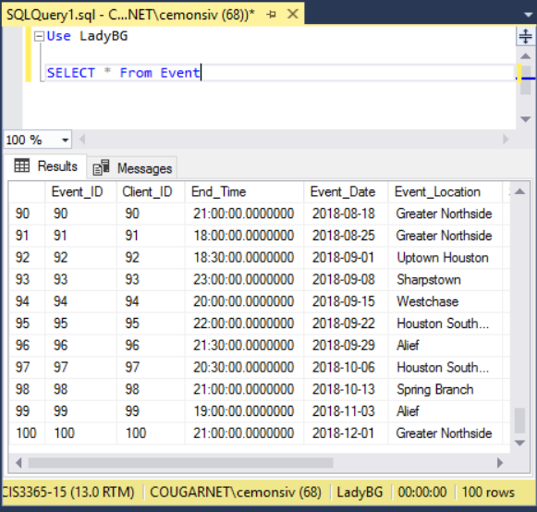

Figure2. After Insert

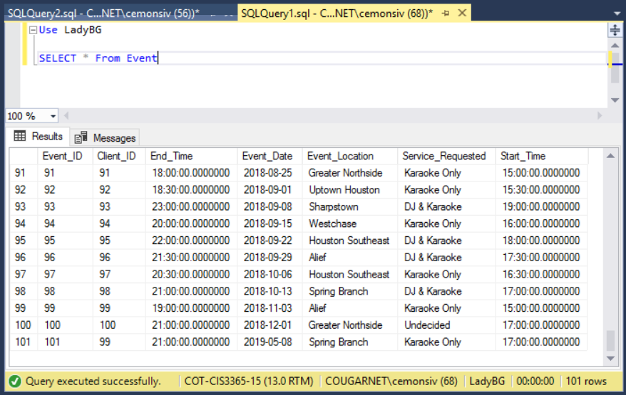

#### Insert Script 2

Insert into Event_Type(Event_Type_ID,Event_ID,Event_Type)

Values(‘101’, ‘101’, ‘Private Event’);

Figure1. Before Insert

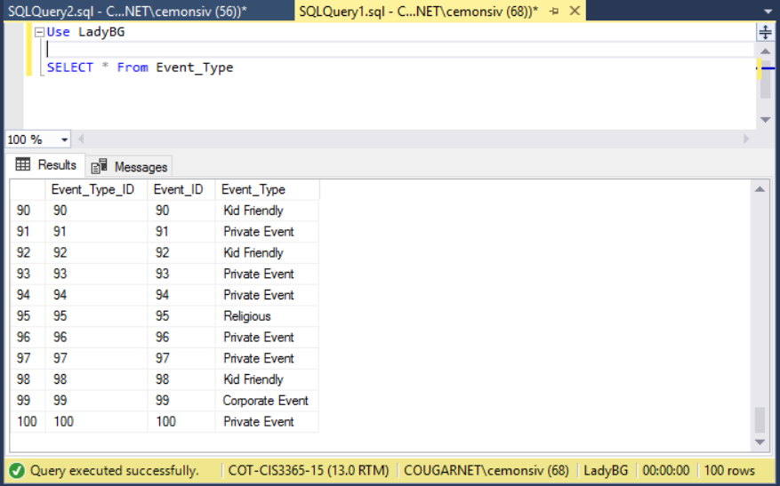

Figure2. After Insert

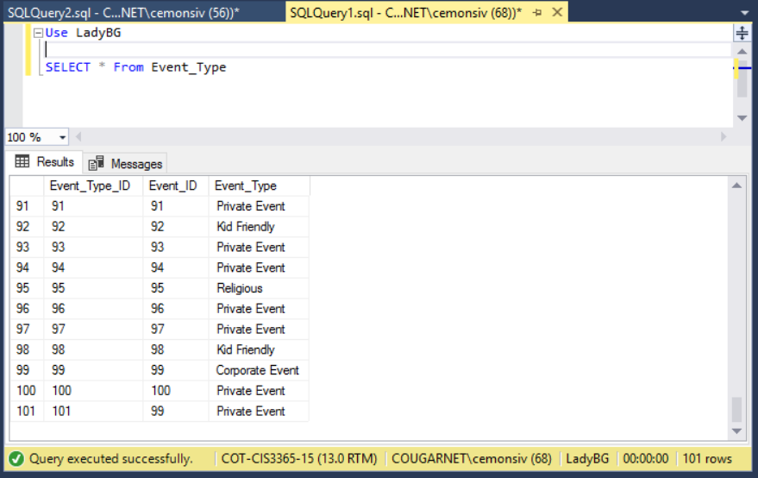

#### Update Script 1

Update Event_Type

set Event_Type = ‘Kid Friendly’

where Event_Type_ID = 101

Figure1. Before Update



Figure2.After Update

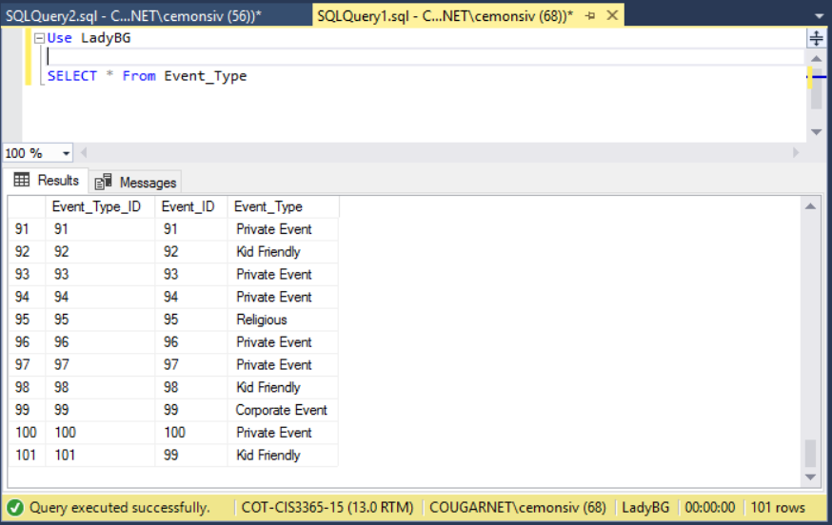

#### Update Script 2

Update Event_Status

set Status = ‘Fulfilled’

where Status_ID =79

Figure1. Before Update

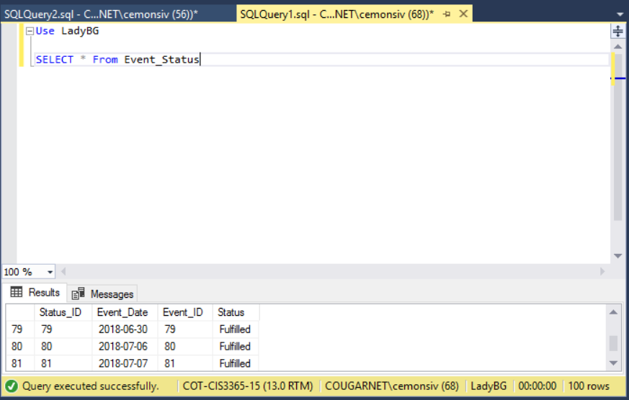

Figure2. After Update

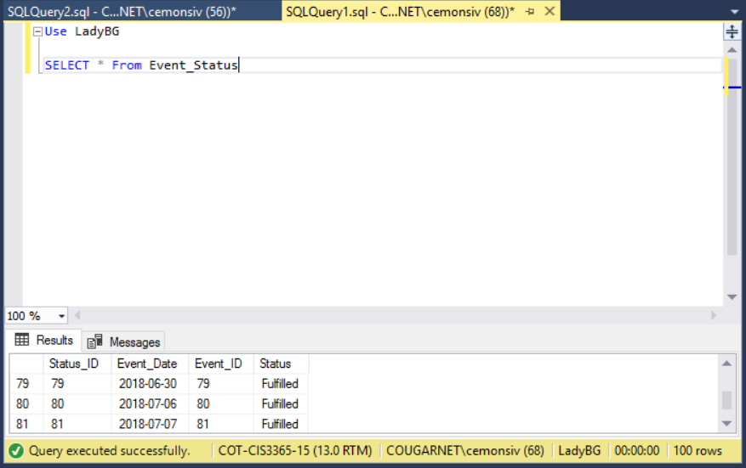

#### Delete script 1

Delete from Event

where Event_ID = 101;

Figure1. Before Delete



Figure2. After Delete

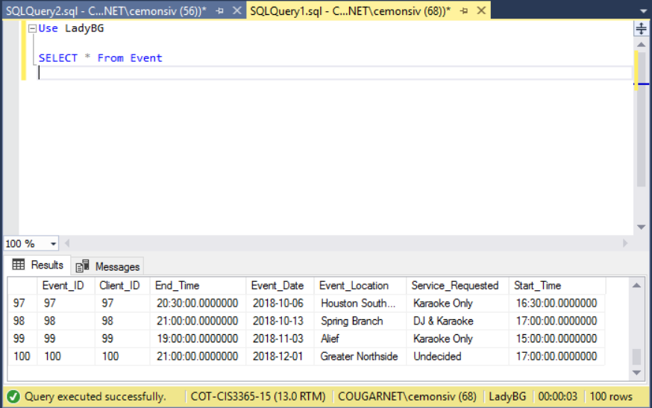

#### Delete Script 2

Delete from Event_Type

where Event_Type_ID = 2;

Figure1.Before Delete

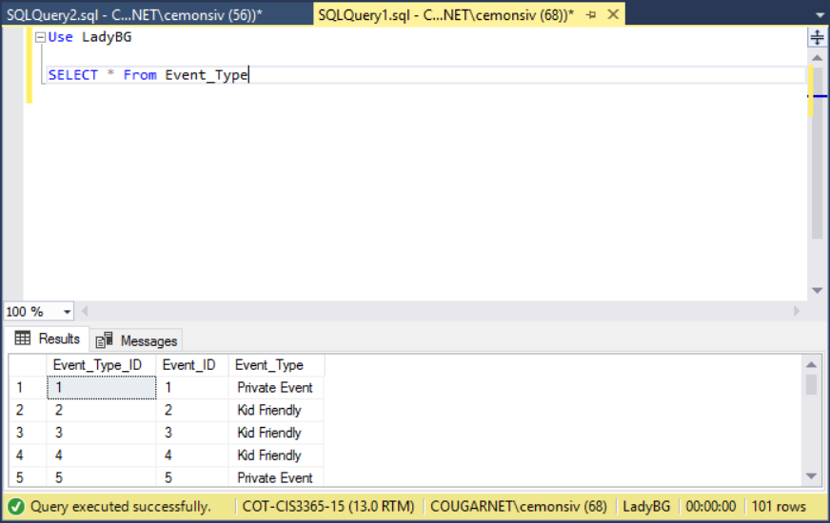

Figure2. After Delete

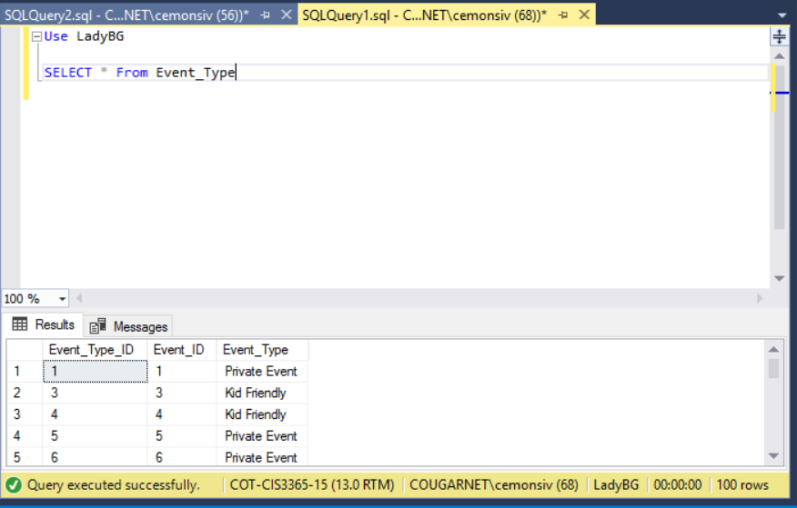

### GUI User View

#### Manage Music View

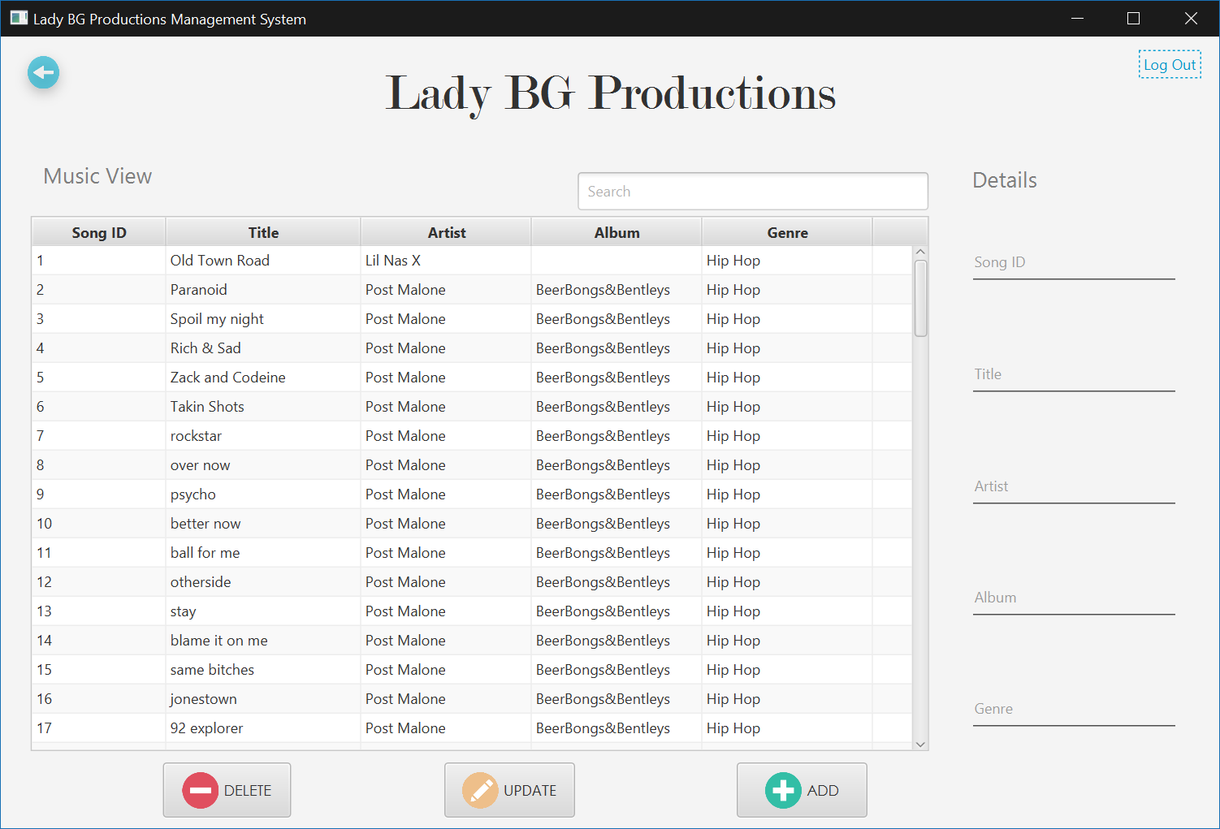

## Jason Ngo

### Create Script

#### Employee Table

CREATE TABLE Employee (

SSN varchar(11) not null,

F_NAME varchar(30) not null,

L_NAME varchar(30) not null,

M_NAME varchar(30),

BIRTH date not null,

ADDRESS_ varchar(50),

PHONE_NUM varchar(15),

EMP_ID numeric(3) not null,

POSITION varchar(15)

);

#### Vacation_Request Table

CREATE TABLE Vacation_Request (

VACATION_REQUEST_ID numeric(8) not null,

EMPLOYEE_EMP_ID numeric(3) not null,

REASON varchar(50),

LOCATION varchar(50),

COUNTRY varchar(50),

DATE_REQUESTED date not null,

DATE_RETURN date not null,

);

#### Vacation_Status Table

CREATE TABLE Vacation_Status (

VACATION_REQUEST_ID numeric(8) not null,

APPROVAL varchar(1) not null,

REASON varchar(50),

EMPLOYEE_EMP_ID numeric(3) not null

);

#### Payroll Table

CREATE TABLE Payroll (

EMPLOYEE_EMP_ID numeric(3) not null,

TRANSACTION_ID numeric(8) not null,

TOTAL_AMOUNT numeric(8,2) not null,

PAID_AMOUNT numeric(8,2) not null,

MEDICARE numeric(8,2) not null,

BENEFITS numeric(8,2) not null,

RETIREMENT numeric(8,2) not null,

TRANSACTION_DATE date

);

### Alter Scripts

Alter table Employee_Type

 Add constraint Fk_Employee_Type_ID

   Foreign key(Employee_ID) references Employee(Employee_ID);

Alter table Employee_Title

 Add constraint Fk_Employee_Title_ID

   Foreign key(Employee_ID) references Employee(Employee_ID);

Alter table Employee_Status

 Add constraint Fk_Employee_Status_ID

   Foreign key(Employee_ID) references Employee(Employee_ID);

### Bulk Inserts

#### Employee table bulk insert

bulk insert Employee

from 'C:\Users\JANGO\Downloads\Employee.csv'

with

(

rowterminator='\n',

fieldterminator=','

)

#### User_info table bulk insert

bulk insert User_info

from 'C:\Users\JANGO\Downloads\User_Info.csv'

with

(

rowterminator='\n',

fieldterminator=','

)

#### User_Login table bulk insert

bulk insert User_Login

from 'C:\Users\JANGO\Downloads\User_Login.csv'

with

(

rowterminator='\n',

fieldterminator=','

)

#### Employee_Type table bulk insert

bulk insert Employee_Type

from 'C:\Users\JANGO\Downloads\Employee_type.csv'

with

(

rowterminator='\n',

fieldterminator=','

)

### Data Records

#### Employee table data records

1,Estele,Gunstone,Rossie,'10/15/1992',90 Michigan Place,Hialeah,FL,305-138-9932,287-66-2187,Sales,1

2,Clair,Clague,Winnie,'9/12/1997',56 Gina Pass,Battle Creek,MI,269-778-2446,553-40-9847,Audio Engineer,2

3,Marylou,Barfield,Leta,'1/19/1992',9 Brickson Park Way,Chicago,IL,773-501-1727,881-41-4101,Sales,3

4,Jaime,Derkes,Bab,'5/9/1990',9 Dixon Point,Colorado Springs,CO,719-710-2194,245-42-9453,Social Media Manager,4

5,Augy,Larmet,Aloysius,'12/1/1999',0886 Bowman Junction,Seattle,WA,206-400-9944,631-73-0874,Sales,5

6,Dionisio,Fludgate,Aurlie,'10/17/1990',8840 Luster Point,Saint Louis,MO,314-963-9236,689-66-6011,Social Media Manager,6

7,Arel,Patterfield,Albertine,'11/7/1991',22438 Forster Circle,Columbus,OH,614-508-1120,128-92-4801,Project Manager,7

8,Ode,Gebhard,Aldin,'7/14/1998',196 School Road,San Diego,CA,619-858-4440,308-24-4291,Recruiting Manager,8

9,Stuart,Mooreed,Alyss,'3/14/1996',3 Moulton Point,Spokane,WA,509-752-4757,828-90-6978,Recruiting Manager,9

10,Emmalynne,Reddington,Audrye,'3/2/1997',56 Twin Pines Pass,New Orleans,LA,504-692-6910,740-79-1096,Social Media Manager,10

11,Borden,Ector,Gardener,'6/7/1997',86499 Dunning Center,Las Vegas,NV,702-387-0048,793-37-2854,Administrative Officer,11

12,Dionysus,Whitham,Hobart,'2/7/1990',209 2nd Street,Philadelphia,PA,215-657-1818,270-21-9769,Social Media Manager,12

13,Casey,Digance,Sibilla,'8/13/1995',04294 Nelson Parkway,Watertown,MA,978-455-4013,841-48-0849,Social Media Manager,13

14,Ibrahim,Hansie,Delbert,'9/4/1997',1429 Westend Alley,Springfield,VA,571-503-3171,870-06-2531,Social Media Manager,14

15,Jasmina,Terbrug,Gracie,'3/4/2000',028 Melody Terrace,San Jose,CA,408-299-2557,578-13-0134,Assistant Professor,15

16,Bernie,Bastard,Ilysa,'2/14/1991',2 Larry Court,Lynn,MA,339-239-0174,780-31-5304,Structural Engineer,16

17,Martha,Owbridge,Hoebart,'2/5/1997',87 Scoville Way,Springfield,MO,417-435-7390,566-53-4846,Human Resources,17

18,Coleen,Davidovitch,Hillery,'5/7/1993',36571 Village Green Way,Lexington,KY,859-214-7189,823-38-1836,Human Resources,18

19,Aubrey,Drowsfield,Flossi,'3/9/1994',3 Loftsgordon Way,New Haven,CT,203-873-1533,455-07-6289,Human Resources,19

20,Kimberley,Hassey,Cam,'10/15/1999',0 Warbler Terrace,Huntington Beach,CA,562-752-5310,591-14-2871,Analyst Programmer,20

21,Mavra,Edlin,Laird,'11/14/1997',36110 Anthes Pass,New York City,NY,917-591-7186,672-61-9942,Human Resources,21

22,Nikolas,Platt,Dixie,'10/7/1996',07186 Becker Trail,Oklahoma City,OK,405-571-0405,823-99-1280,Project Manager,22

23,Chrissy,Plaid,Ainslie,'12/15/1994',6 Sunnyside Place,Valdosta,GA,229-851-1675,364-37-9385,Project Assistant,23

24,Jacquenetta,McGarel,Kirk,'4/11/1997',203 Carioca Lane,Olympia,WA,253-502-7376,272-18-6541,Social Media Manager,24

25,Rudy,Lanney,Ewen,'4/6/1993',6 John Wall Court,Joliet,IL,815-350-2748,695-73-4027,Social Media Manager,25

26,Marti,Midden,Ronald,'1/18/1994',698 Fuller Avenue,Austin,TX,512-743-6722,694-36-2352,Human Resources,26

27,Eartha,Ganniclifft,Wiley,'1/16/1990',110 Algoma Point,San Diego,CA,619-547-1140,280-11-0224,Clerk,27

28,Eva,Whinray,Mable,'4/2/1997',8 Warbler Junction,Minneapolis,MN,612-469-1654,590-26-9988,Clerk,28

29,Tarrah,Bruhke,Cassius,'1/9/1990',1 Division Court,Newark,NJ,973-447-4982,342-20-8045,Graphic Designer,29

30,Rayner,MacDuffie,Cecilia,'9/2/1992',32141 Union Lane,Fort Smith,AR,479-712-1240,771-74-1209,Assistant Manager,30

31,Allyn,Lilleycrop,Lishe,'9/11/2000',4 Talisman Road,Baltimore,MD,443-927-0852,881-11-3922,Clerk,31

32,Welbie,Carmen,Doug,'7/28/1998',0584 Sycamore Way,Silver Spring,MD,240-764-7466,352-97-3902,Clerk,32

33,Lorette,Halsey,Dianne,'4/31/1997',78 Moose Plaza,Boulder,CO,303-762-8815,468-83-9340,Software Engineer II,33

34,Zeke,Whittlesey,Aleda,'1/18/1995',04679 Gulseth Parkway,Des Moines,IA,515-570-4009,417-91-0289,Recruiter,34

35,Laina,Goodliffe,Beverlee,'1/2/1998',9566 Kinsman Court,Shreveport,LA,318-674-7645,892-60-2800,Audio Engineer,35

36,Alexandra,Manie,Duncan,'8/27/1996',9501 Mallory Plaza,Houston,TX,713-900-7401,176-44-7911,Web Designer,36

37,Ursola,Bartoli,Garret,'8/21/2001',3 Iowa Center,Amarillo,TX,806-719-2982,306-88-9954,Audio Engineer,37

38,Gretna,Giacobbo,Winna,'1/19/2001',0 Northfield Pass,Detroit,MI,586-553-4174,514-73-8844,General Manager,38

39,Alan,Castelin,Zorina,'7/30/1993',630 Gina Avenue,Lake Charles,LA,337-714-5654,621-26-8181,Design Engineer,39

40,Hoyt,Lidgely,Brocky,'2/24/1999',373 Lerdahl Center,Houston,TX,281-834-8973,616-97-2686,Design Engineer,40

41,Abrahan,Matthias,Demetrius,'12/27/1995',7 Anthes Terrace,Dallas,TX,214-121-2523,382-02-9682,Audio Engineer,41

42,Marney,Sidary,Bonnee,'7/4/2001',92 Gale Street,Pittsburgh,PA,412-935-1711,846-14-6883,Human Resources,42

43,Godfrey,Jirka,Hadleigh,'6/9/1994',0052 Clarendon Hill,Temple,TX,254-519-9207,394-11-2337,Social Media Manager,43

44,Marin,Prestney,August,'3/11/1996',9469 Hazelcrest Point,Minneapolis,MN,952-308-9662,272-62-8808,Recruiter,44

45,Kathye,Hendrickx,Godard,'2/17/1999',88 Sherman Drive,Chicago,IL,773-607-9847,563-22-6946,Promoter ,45

46,Wilie,O'Connell,Luciana,'6/9/2002',6730 Scoville Alley,Des Moines,IA,515-271-7148,701-94-4534,Promoter ,46

47,Corella,Ply,Kathleen,'4/13/1997',83753 Knutson Hill,Syracuse,NY,315-321-1623,491-12-1284,Clerk,47

48,Frieda,Bassam,Cass,'5/8/1999',925 Iowa Plaza,San Jose,CA,408-991-3592,883-85-0402,Clerk,48

49,Ginny,Devanny,Gerianna,'3/14/1996',24983 Muir Terrace,Corona,CA,951-560-9428,826-19-4903,Audio Engineer,49

50,Marvin,Bradforth,Wilie,'9/2/1998',87 Merchant Avenue,Lincoln,NE,402-242-7259,164-40-8261,Audio Engineer,50

51,Pavla,Robardey,Helge,'1/15/1992',60 Sutherland Lane,Wichita,KS,316-971-7111,421-38-8740,Clerk,51

52,Nelia,Hiscocks,Randa,'10/15/1989',9827 Graceland Junction,New York City,NY,212-471-5968,460-82-5061,Promoter ,52

53,Kennie,Kundert,Vanni,'4/10/1996',693 Ridge Oak Center,Wilmington,DE,302-851-4506,874-49-5622,Software Engineer,53

54,Marylin,Besant,Mellisent,'10/30/1989',91 Ohio Crossing,Cincinnati,OH,513-337-6154,313-70-1606,Social Media Manager,54

55,Dawn,Murrthum,Roddy,'2/22/1991',663 Delaware Place,Dayton,OH,937-621-0925,185-51-6186,Social Media Manager,55

56,Leslie,Crook,Cordy,'5/9/1994',8959 Acker Pass,Atlanta,GA,404-506-8054,526-42-2334,Product Engineer,56

57,Maxine,Cabrara,Zahara,'6/10/1996',811 Forest Run Crossing,Naples,FL,239-911-0026,633-66-3212,Graphic Designer,57

58,Bride,Bausor,Doyle,'8/9/1990',2275 Ruskin Plaza,Atlanta,GA,404-563-4888,553-07-4555,Graphic Designer,58

59,Leslie,Marsy,Godfree,'12/10/2001',02700 Summer Ridge Avenue,Alexandria,VA,703-247-8519,260-90-8035,Human Resources,59

60,Sile,Fitzpatrick,Ferdie,'12/19/2000',3 Eastwood Court,Minneapolis,MN,952-682-1118,896-43-5654,Graphic Designer,60

61,Klemens,Bennetts,Noel,'9/23/1996',9 Blaine Avenue,Corpus Christi,TX,361-726-3737,317-28-4019,Event Manager,61

62,Sibel,Surmon,Janina,'7/16/1995',0240 Chive Trail,El Paso,TX,915-135-8425,611-39-4244,Event Manager,62

63,Lacie,Fordyce,Darbie,'1/5/1996',0 Sommers Way,Fairbanks,AK,907-340-1362,252-78-8054,Event Manager,63

64,Wynnie,Jenkinson,Tymothy,'8/19/1999',0667 Lakewood Drive,Chicago,IL,312-463-4979,128-03-5423,Human Resources,64

65,Helene,Walling,Annnora,'12/1/1994',652 Eliot Drive,Corpus Christi,TX,361-254-1927,823-36-7751,Social Media Manager,65

66,Randy,Benjefield,Walther,'4/4/1994',47 Melody Parkway,Gainesville,FL,352-185-9271,398-46-5045,Event Manager,66

67,Kerri,Koba,Rey,'9/4/1996',194 Hollow Ridge Trail,Washington,DC,202-514-5494,238-54-6599,Audio Engineer,67

68,Corabella,Ortsmann,Phyllis,'9/1/1996',5 Bayside Avenue,Elmira,NY,607-748-2600,642-07-3229,Actuary,68

69,Maggy,Jery,Lacey,'4/19/1996',6300 North Terrace,Boca Raton,FL,561-275-2902,211-40-4608,Accounting Analyist,69

70,Colby,Gennrich,Nissie,'12/8/1996',04 Welch Road,Elmira,NY,607-656-8983,596-63-7023,Accounting Analyist,70

71,Blithe,Axleby,Cherry,'12/9/1990',87625 Cascade Way,Palo Alto,CA,310-713-4727,485-57-9489,Senior Quality Engineer,71

72,Bord,Allworthy,Aeriela,'10/31/1997',16 Kensington Road,Akron,OH,330-895-0061,359-62-9323,Sales,72

73,Ly,Moutray Read,Auberta,'10/15/1997',49 Express Crossing,Cleveland,OH,440-555-2101,578-27-9443,Recruiter,73

74,Mead,Ovens,Tobye,'4/10/1994',30 Eagle Crest Road,Oklahoma City,OK,405-635-2974,400-48-8089,Sales,74

75,Wylie,Mansour,Raynor,'8/19/1991',48 Pennsylvania Court,Baton Rouge,LA,225-320-1627,310-16-0742,Social Media Manager,75

76,Tallie,Sangar,Margareta,'5/17/1988',70 Pond Trail,New York City,NY,212-921-5198,592-27-2459,Human Resources,76

77,Lucien,Beggio,Gerrilee,'6/19/1997',7 Tomscot Drive,Springfield,VA,571-779-5441,675-40-7987,Promoter ,77

78,Araldo,Gosforth,Stevana,'5/9/1993',9 Shopko Circle,Des Moines,IA,515-615-9334,513-33-3995,Recruiter,78

79,Pyotr,Bartelot,Sullivan,'5/30/1992',159 Canary Parkway,Lakewood,WA,253-520-0248,155-12-6123,Web Designer,79

80,Electra,Manjot,Jourdan,'4/30/1999',719 Nancy Lane,Chicago,IL,312-678-4450,140-75-6375,Web Designer,80

81,Madlen,Fleischmann,Tailor,'7/9/1987',0258 Judy Lane,Savannah,GA,912-587-7749,882-86-8025,Graphic Designer,81

82,Jeffy,Sconce,Gnni,'5/7/1981',424 Nelson Avenue,Atlanta,GA,404-400-7668,372-39-5671,Graphic Designer,82

83,Reggi,Aldersea,Nowell,'6/4/1993',230 Trailsway Crossing,New Haven,CT,203-359-6150,167-89-5858,Graphic Designer,83

84,Abran,Applegate,Jaclin,'4/10/1999',977 Roth Crossing,New Haven,CT,203-792-2176,126-08-1336,Database Manager,84

85,Donella,Goforth,Maurizio,'9/4/1993',7 Lukken Terrace,Jamaica,NY,212-232-5320,171-38-6095,Safety Technician,85

86,Marje,Sanja,Berkly,'8/27/1997',7 Beilfuss Place,Birmingham,AL,205-757-1163,737-30-6619,Audio Engineer,86

87,Erl,Guilleton,Tandy,'5/19/1997',426 Scott Terrace,Houston,TX,713-455-7867,511-32-2250,Audio Engineer,87

88,Chloe,Couvert,Penny,'5/10/1989',389 Fair Oaks Terrace,Ashburn,VA,571-459-9053,773-98-2648,Senior Quality Engineer,88

89,Clotilda,Ayres,Chan,'4/20/1998',47 Kenwood Road,Syracuse,NY,315-204-7427,183-78-5499,Operator,89

90,Flynn,Bloggett,Nappie,'4/13/1990',9673 Sunfield Hill,Honolulu,HI,808-809-1741,568-24-9622,Human Resources,90

91,Korney,Fehner,Law,'5/7/1989',97 Menomonie Hill,El Paso,TX,915-793-2864,544-13-1797,Clerk,91

92,Tiena,Artindale,Reba,'8/19/1987',8846 Corben Court,Salt Lake City,UT,801-123-7762,804-53-2866,Clerk,92

93,Kimberlee,Sabie,Kalvin,'12/1/1997',560 Portage Center,Tampa,FL,813-100-6911,528-69-5590,Accounting Analyist,93

94,Jeana,Hurburt,Artus,'3/19/1994',560 Hermina Way,Colorado Springs,CO,719-202-7498,211-28-3299,Graphic Designer,94

95,Rebecka,Heselwood,Ignacio,'2/11/1999',47479 Orin Street,Tucson,AZ,520-213-1011,308-29-7605,Editor,95

96,Baillie,Hamon,Marshall,'1/18/1990',09633 Stang Road,West Palm Beach,FL,561-491-7761,230-74-4921,Software Engineer II,96

97,Maxy,More,Alane,'1/14/1989',80933 Scofield Junction,Pittsburgh,PA,412-890-1208,785-53-3702,Senior Quality Engineer,97

98,Giles,Wray,Jamill,'12/16/1994',58488 Spenser Pass,Santa Barbara,CA,702-931-4304,320-52-3391,Senior Quality Engineer,98

99,Eugene,Larder,Bria,'12/14/1996',8070 Village Avenue,Tucson,AZ,520-432-6684,807-77-2749,Project Manager,99

100,Catie,McGawn,Jimmie,'1/17/1994',75 Arizona Parkway,Washington,DC,202-150-2628,430-87-9931,Design Engineer,100

#### Employee_type data records

1,1,1,0

2,2,1,1

3,3,0,0

4,4,0,0

5,5,0,1

6,6,0,1

7,7,1,1

8,8,0,0

9,9,0,0

10,10,0,1

11,11,0,1

12,12,1,1

13,13,0,0

14,14,0,1

15,15,1,0

16,16,1,0

17,17,1,1

18,18,1,0

19,19,1,1

20,20,1,1

21,21,1,1

22,22,1,1

23,23,1,1

24,24,1,1

25,25,1,1

26,26,1,1

27,27,1,1

28,28,0,1

29,29,0,1

30,30,0,0

31,31,1,1

32,32,1,0

33,33,0,1

34,34,1,1

35,35,1,0

36,36,0,0

37,37,0,0

38,38,0,1

39,39,0,1

40,40,1,1

41,41,1,0

42,42,0,0

43,43,1,0

44,44,1,1

45,45,0,0

46,46,0,1

47,47,1,1

48,48,1,0

49,49,0,0

50,50,0,1

51,51,1,0

52,52,0,0

53,53,1,0

54,54,1,1

55,55,0,1

56,56,0,1

57,57,1,1

58,58,1,1

59,59,0,1

60,60,1,1

61,61,0,0

62,62,0,0

63,63,1,0

64,64,1,0

65,65,1,1

66,66,1,0

67,67,0,0

68,68,0,0

69,69,0,1

70,70,0,0

71,71,0,0

72,72,1,0

73,73,1,0

74,74,1,0

75,75,1,1

76,76,0,1

77,77,0,0

78,78,0,0

79,79,1,0

80,80,1,1

81,81,1,1

82,82,0,0

83,83,1,0

84,84,0,0

85,85,0,1

86,86,1,0

87,87,0,1

88,88,1,1

89,89,1,1

90,90,1,0

91,91,0,0

92,92,1,1

93,93,1,1

94,94,0,1

95,95,0,1

96,96,1,1

97,97,1,1

98,98,1,0

99,99,1,1

100,100,0,1

#### User_Login data records

1,15:27,23:06,1

2,10:18,21:17,2

3,16:42,20:44,3

4,15:01,23:34,4

5,12:44,18:17,5

6,17:44,20:23,6

7,9:00,19:06,7

8,9:30,20:41,8

9,14:58,21:06,9

10,16:06,22:05,10

11,12:47,19:36,11

12,13:53,23:37,12

13,16:06,18:28,13

14,10:08,22:09,14

15,15:36,19:34,15

16,8:36,18:35,16

17,16:09,19:16,17

18,14:44,18:52,18

19,11:33,20:46,19

20,11:14,18:20,20

21,17:28,21:22,21

22,10:33,22:59,22

23,16:47,19:40,23

24,15:04,23:19,24

25,10:09,23:35,25

26,9:45,23:05,26

27,16:36,23:08,27

28,13:29,22:02,28

29,12:33,22:36,29

30,13:54,18:09,30

31,16:34,20:51,31

32,9:32,20:20,32

33,9:28,22:27,33

34,10:57,18:32,34

35,10:12,22:26,35

36,16:31,18:36,36

37,12:53,22:16,37

38,17:05,19:03,38

39,11:43,20:03,39

40,9:14,23:11,40

41,17:19,21:03,41

42,13:22,20:34,42

43,9:32,19:59,43

44,17:02,18:18,44

45,16:27,22:33,45

46,17:26,22:28,46

47,12:51,19:48,47

48,10:53,20:36,48

49,8:45,18:27,49

50,13:19,23:36,50

51,13:46,21:19,51

52,16:22,20:52,52

53,14:00,18:57,53

54,9:35,21:33,54

55,12:52,22:12,55

56,17:52,23:45,56

57,10:20,19:39,57

58,13:08,20:56,58

59,13:05,19:30,59

60,14:20,23:17,60

61,8:32,23:04,61

62,11:51,20:31,62

63,10:39,19:12,63

64,9:20,21:34,64

65,8:41,21:11,65

66,15:24,21:56,66

67,10:41,20:21,67

68,16:23,18:23,68

69,15:05,20:09,69

70,10:13,23:47,70

71,16:53,20:06,71

72,11:53,23:10,72

73,16:47,21:48,73

74,17:19,23:49,74

75,14:15,23:18,75

76,15:49,23:46,76

77,14:20,22:36,77

78,12:24,18:50,78

79,10:26,20:31,79

80,13:52,22:44,80

81,9:47,20:49,81

82,16:06,21:55,82

83,13:02,18:36,83

84,16:20,18:09,84

85,14:22,21:03,85

86,17:10,19:10,86

87,12:33,22:44,87

88,12:57,18:47,88

89,17:43,18:33,89

90,13:17,23:15,90

91,13:17,21:25,91

92,15:32,19:35,92

93,17:49,22:09,93

94,16:42,20:30,94

95,14:05,18:46,95

96,11:06,19:02,96

97,14:53,21:39,97

98,8:15,19:28,98

99,10:40,19:49,99

100,14:53,19:57,100

#### User_Info data records

1,btatersale0,5JtMutnkltr,ACTIVE,1,Brad,Tatersale

2,mdionis1,ifDAtsI,ACTIVE,2,Marcus,Dionis

3,tzecchii2,sUpEqs5rqxU,ACTIVE,3,Tiffani,Zecchii

4,pgronow3,d3YHdR,INACTIVE,4,Pincus,Gronow

5,ischimmang4,AhN1p7IlMac,INACTIVE,5,Issie,Schimmang

6,ssowerby5,Bw1WQcST,ACTIVE,6,Sheilakathryn,Sowerby

7,cbedenham6,iRVtqMH0DeC,INACTIVE,7,Clarie,Bedenham

8,rmandry7,ygy6whY,INACTIVE,8,Riane,Mandry

9,crosander8,bVp0uh,ACTIVE,9,Christoffer,Rosander

10,lfusedale9,A9TTuvnmXdUO,ACTIVE,10,Lana,Fusedale

11,cpapachristophoroua,Q9mKI9,ACTIVE,11,Carol-jean,Papachristophorou

12,bbealb,TrqE8Cvfj,ACTIVE,12,Brodie,Beal

13,rtewc,8oQjPoRc,ACTIVE,13,Rory,Tew

14,obrookesd,e5TDNNO6S,ACTIVE,14,Orran,Brookes

15,kferentze,4J2GIM,ACTIVE,15,Katee,Ferentz

16,achisholmef,f2Ho2X39,INACTIVE,16,Ambur,Chisholme

17,ccornelisseg,XFAfmA,LOA,17,Culley,Cornelisse

18,gradborneh,zM1XsakSfhZQ,ACTIVE,18,George,Radborne

19,rgustusi,Su11w5ttD7Om,LOA,19,Richart,Gustus

20,gpiercyj,fcT1Sct,LOA,20,Granny,Piercy

21,abowsteadk,1beQ4cO,ACTIVE,21,Angeli,Bowstead

22,arubanenkol,CUTDfGI,ACTIVE,22,Amandi,Rubanenko

23,smcilhattonm,yn4SRlsU2s8,ACTIVE,23,Sharlene,McIlhatton

24,lbolithon,GiEKdgY3ZHe,ACTIVE,24,Liz,Bolitho

25,rtresloveo,bduz8x,ACTIVE,25,Ryley,Treslove

26,jlongshawp,9n0amJ,INACTIVE,26,Jaquelyn,Longshaw

27,lestabrookq,TBar2MI,INACTIVE,27,Lola,Estabrook

28,mstrottonr,Urmx9Kspqq,INACTIVE,28,Minnie,Strotton

29,rolsens,uv4iris9Er,ACTIVE,29,Remus,Olsen

30,tatlingt,N9xvfHD2,ACTIVE,30,Teodoor,Atling

31,ehavvocku,JEGJO8wQM8,ACTIVE,31,Ethe,Havvock

32,fdalglishv,lsuicEtH,ACTIVE,32,Fransisco,Dalglish

33,lfleisw,lmX7B3,LOA,33,Langston,Fleis

34,avescovinix,cPUi2rDdRV,LOA,34,Addi,Vescovini

35,npetrovy,pgRMYzhV,ACTIVE,35,Nike,Petrov

36,flongthornz,WD8MUHysUpA,ACTIVE,36,Farrell,Longthorn

37,abaldung10,hXpgNz9AiP,ACTIVE,37,Andriette,Baldung

38,bboow11,w0U86FHo6AP8,INACTIVE,38,Barb,Boow

39,gpetriello12,OxFf6ONEvN,INACTIVE,39,Gwenni,Petriello

40,cnelius13,AHz6DEUZ7,ACTIVE,40,Con,Nelius

41,kfaccini14,GmlzzhcK5,ACTIVE,41,Kenton,Faccini

42,fedgeller15,GBlERDz,LOA,42,Fabiano,Edgeller

43,mbonus16,V3eTTitbEfIg,ACTIVE,43,Michel,Bonus

44,mwalas17,9axzJ5tb,ACTIVE,44,Modesta,Walas

45,jvanichev18,qQLleY8tgetL,ACTIVE,45,Jan,Vanichev

46,fsolway19,zFlsgUvndD1l,LOA,46,Florina,Solway

47,kgiamitti1a,x4OLOCyOnomr,INACTIVE,47,Keelby,Giamitti

48,gbardwell1b,xZ6c0g8S,INACTIVE,48,Giorgio,Bardwell

49,crochford1c,pUaORx0D,INACTIVE,49,Catharine,Rochford

50,lmakepeace1d,GbEcRdsyQ,ACTIVE,50,Lewiss,Makepeace

51,wbaynard1e,OchYy4UYm,ACTIVE,51,Wallache,Baynard

52,lbroome1f,GiSFlPLV1BoR,ACTIVE,52,Lodovico,Broome

53,broon1g,C6D5uKg8rEF,ACTIVE,53,Bord,Roon

54,cjouhan1h,4CdFvV0TNuMv,ACTIVE,54,Cherise,Jouhan

55,stuttle1i,BmzPUnXr,INACTIVE,55,Shina,Tuttle

56,trushton1j,zk8Bof2qx,ACTIVE,56,Tamma,Rushton

57,lboness1k,FMhjmabpYFr,ACTIVE,57,Lari,Boness

58,nmanoch1l,8EIoQnUy51az,ACTIVE,58,Nani,Manoch

59,spinwell1m,FIcrwvp,ACTIVE,59,Selle,Pinwell

60,dcorten1n,I1xu6SfOpc,INACTIVE,60,Devora,Corten

61,lqueree1o,qH4cvMnRHqX,INACTIVE,61,Luelle,Queree

62,abenedyktowicz1p,9tJW4cH,ACTIVE,62,Arlen,Benedyktowicz

63,bmcclure1q,FIHjgPi2tI,ACTIVE,63,Bengt,McClure

64,dhaglinton1r,Tw05FiOH,LOA,64,Dulcy,Haglinton

65,ttargetter1s,RrarM32oL,ACTIVE,65,Thedrick,Targetter

66,dreasce1t,9bLQzmWJ,ACTIVE,66,Dyan,Reasce

67,iabrahamson1u,eJmTNOz2NdVp,ACTIVE,67,Issiah,Abrahamson

68,ncosham1v,wfsygIyO,LOA,68,Norine,Cosham

69,fdewer1w,7BBHwln1VB,ACTIVE,69,Falito,Dewer

70,kgrief1x,lck7mLB03Ax,ACTIVE,70,Kipp,Grief

71,tmatys1y,2o4Ot85e3CG,ACTIVE,71,Tobye,Matys

72,lcousins1z,ybZDmPs,ACTIVE,72,Lucinda,Cousins

73,gadams20,OBLsOM,INACTIVE,73,Georgie,Adams

74,aadshed21,PZs3hR5cbQxn,ACTIVE,74,Allis,Adshed

75,jconibeer22,xrHOSJilLPQ,INACTIVE,75,Jewel,Conibeer

76,cworton23,8PnIfxTnCO8,ACTIVE,76,Channa,Worton

77,ayakobovitz24,z8QFdVacTqQ,ACTIVE,77,Alfonse,Yakobovitz

78,bkulas25,RPQVGa7,ACTIVE,78,Beitris,Kulas

79,tfloch26,5l7Hyv,ACTIVE,79,Tedi,Floch

80,ebyres27,1plZXn78,LOA,80,Emery,Byres

81,gdielhenn28,S0ThmwF,ACTIVE,81,Ginelle,Dielhenn

82,gtreadgear29,H1TwDBO,ACTIVE,82,Gene,Treadgear

83,hswatten2a,6xpWNU5zKiJU,ACTIVE,83,Hayward,Swatten

84,mwoehler2b,XMPrAD6ELB7T,LOA,84,Marylee,Woehler

85,mmollatt2c,apa9ZzrQP8S,LOA,85,Mahala,Mollatt

86,mshallcross2d,aTE2np4W9hL,ACTIVE,86,Mei,Shallcross

87,pfeatherston2e,Io8vrcCF,ACTIVE,87,Perle,Featherston

88,bgebhardt2f,eX3MnjMcN,ACTIVE,88,Beverlie,Gebhardt

89,hbuckles2g,Vns9rXwRoO69,ACTIVE,89,Hasheem,Buckles

90,mhughland2h,qzeMSn,ACTIVE,90,Minni,Hughland

91,dyerby2i,2memZQdln,INACTIVE,91,Drugi,Yerby

92,msolan2j,bCi58aiEZ,ACTIVE,92,Madelyn,Solan

93,mfessby2k,1JEBTIXcnU,ACTIVE,93,Morie,Fessby

94,mphare2l,DBLdE6b,ACTIVE,94,Matelda,Phare

95,estrevens2m,LfJpQEO09,ACTIVE,95,Emili,Strevens

96,pnissle2n,ujWrZpX,LOA,96,Paola,Nissle

97,mmooring2o,pKJySyytUa9w,ACTIVE,97,Minette,Mooring

98,asarsfield2p,ZJW1W083AYQ,ACTIVE,98,Aprilette,Sarsfield

99,ekeaveny2q,zkocwkANK,INACTIVE,99,Evangelia,Keaveny

100,flambard2r,ENGCjp6G9pY,ACTIVE,100,Farrell,Lambard

### SQL Report Queries

#### Query 1

SELECT dbo.Locations.Location_ID, dbo.Employee.First_Name, dbo.Employee.Last_Name, dbo.User_Info.User_ID, dbo.User_Login.Login_Time, dbo.User_Login.Logout_Time, dbo.Locations.City

FROM dbo.Locations INNER JOIN

dbo.Employee ON dbo.Locations.Location_ID = dbo.Employee.Location_ID INNER JOIN

dbo.User_Info ON dbo.Employee.Employee_ID = dbo.User_Info.Employee_ID INNER JOIN

dbo.User_Login ON dbo.User_Info.User_ID = dbo.User_Login.User_ID

WHERE (dbo.Locations.City = 'houston')

* This report query combines the following tables:
  + Location
  + Employee
  + User Info
  + User Login
* Using the location table, we find which company location that the client has requested his event from
* The Employee table pulls the Employee information such as the first and last name
* The User info table can check which employee is logged in at the time
* The User login table allows us to track work activity and productivity of any employee

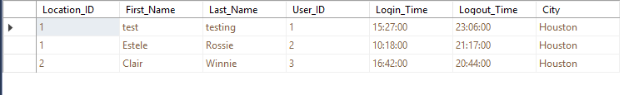

#### Query 2

SELECT dbo.Locations.Location_ID, dbo.Employee.First_Name, dbo.Employee.Last_Name, dbo.Employee_Training_Request.Training_RequestID, dbo.Employee_Training_Status.Training_Status

FROM dbo.Locations INNER JOIN

dbo.Employee ON dbo.Locations.Location_ID = dbo.Employee.Location_ID INNER JOIN

dbo.Employee_Training_Request ON dbo.Employee.Employee_ID = dbo.Employee_Training_Request.Employee_ID INNER JOIN

dbo.Employee_Training_Status ON dbo.Employee.Employee_ID = dbo.Employee_Training_Status.Employee_ID AND

dbo.Employee_Training_Request.Training_RequestID = dbo.Employee_Training_Status.Training_ID

* This report query combines the following tables:
  + Location
  + Employee
  + Employee Training Request
  + Employee Training Status
* Using the location table, we find which company location that the client has requested his event from
* The Employee table pulls the Employee information such as the first and last name
* The Employee Training Request table can check which employee is asking for what type of training
* The Employee Training Status table allows us to see if the Training Request was approved or pending

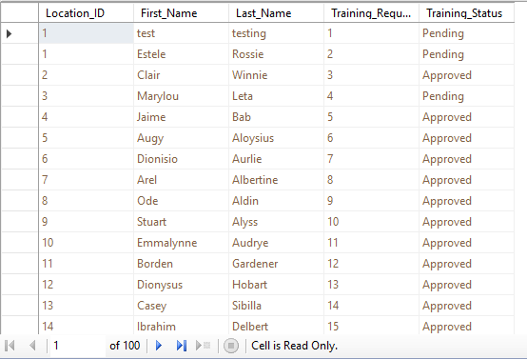

#### Query 3

SELECT dbo.Locations.Location_ID, dbo.Client.Client_First, dbo.Client.Client_Last, dbo.Booking_Status.Booking_ID, dbo.Event_Expenses.Service_Cost

FROM dbo.Locations INNER JOIN

dbo.Client ON dbo.Locations.Location_ID = dbo.Client.Location_ID INNER JOIN

dbo.Booking_Status ON dbo.Client.Client_ID = dbo.Booking_Status.Client_ID CROSS JOIN

dbo.Event_Expenses

* This report query combines the following tables:
  + Location
  + Client
  + Booking Status
  + Event Expenses
* Using the location table, we find which company location that the client has requested his event from
* The Client table pulls the Client information such as the first and last name
* The Booking Status table can check which event the client is asking about
* The Event Expenses table allows us to see how much the event will cost if the client asks or if there’s a verbal discrepancies



#### Query 4

SELECT dbo.Client.Client_First, dbo.Client.Client_Last, dbo.Locations.Location_ID, dbo.Booking_Status.Booking_ID, dbo.Event_Status.Status

FROM dbo.Client INNER JOIN

dbo.Locations ON dbo.Client.Location_ID = dbo.Locations.Location_ID INNER JOIN

dbo.Booking_Status ON dbo.Client.Client_ID = dbo.Booking_Status.Client_ID CROSS JOIN

dbo.Event_Status

* This report query combines the following tables:
  + Location
  + Client
  + Booking Status
  + Event Status
* Using the location table, we find which company location that the client has requested his event from
* The Client table pulls the Client information such as the first and last name
* The Booking Status table can check which event the client is asking about
* The Event Status table allows us to see if the event has been fulfilled, missed, or overlooked if a client has a dispute

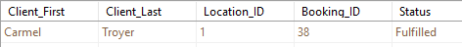

#### Query 5

SELECT dbo.Employee.First_Name, dbo.Employee.Last_Name, dbo.Timesheet.Work_day, dbo.Employee_Type.Employee_Type_ID, dbo.Payroll.Wage

FROM dbo.Employee INNER JOIN

dbo.Timesheet ON dbo.Employee.Employee_ID = dbo.Timesheet.Employee_ID INNER JOIN

dbo.Employee_Type ON dbo.Employee.Employee_ID = dbo.Employee_Type.Employee_ID INNER JOIN

dbo.Payroll ON dbo.Timesheet.Timesheet_ID = dbo.Payroll.Timesheet_ID

* This report query combines the following tables:
  + Employee
  + Timesheet
  + Employee Type
  + Payroll
* Using the Employee Type table, we can find out what type of employee they are to see if the wage makes sense/matches up
* The Employee table pulls the Employee information such as the first and last name
* The Timesheet table can check any employee’s working productivity
* The Payroll table allows us to see how much that certain employee is getting paid
* All this information together is useful to see if certain employees are being paid fairly based on performance and type of employee they are

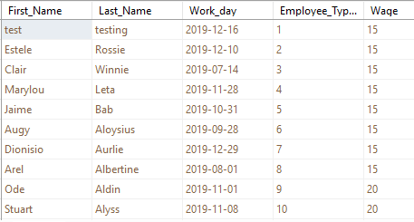

### SQL Insert, Delete, Update Scripts

#### Insert Script 1

Before (Max 99 rows):

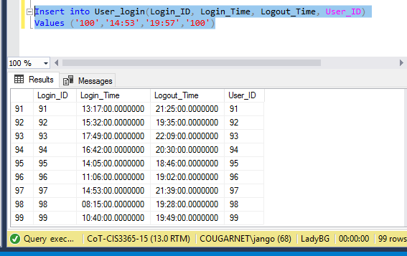

After (Row 100 is added with values):

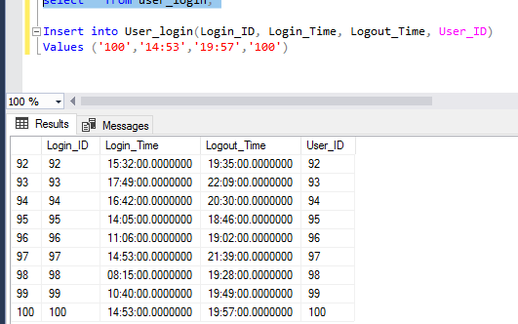

#### Insert script 2

Before (no data):

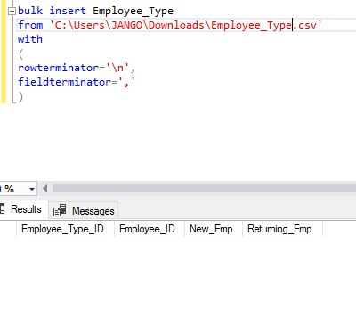

After (data is populated from bulk insert):

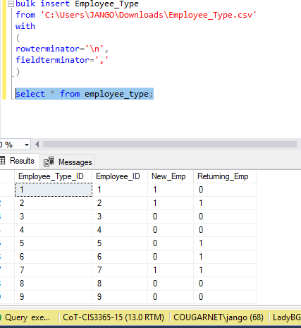

#### Delete script 1

Before (there is up to 150 results):

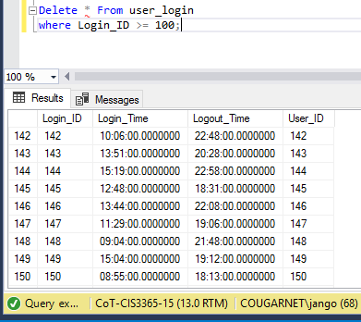

After (Rows after 99 are deleted):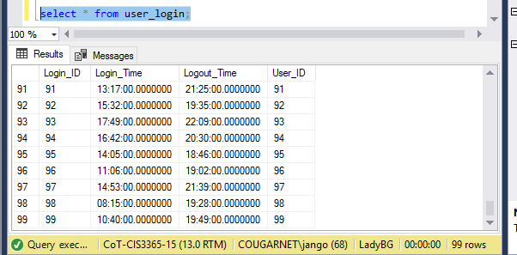

#### Delete script 2

Before (table view of Employee_type shows it is populated):

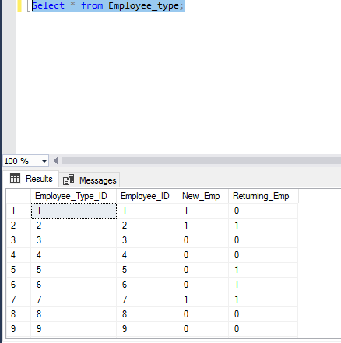

After (the whole employee_type table is deleted because there was no specification):

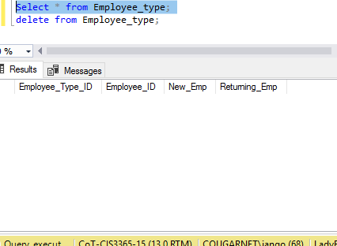

#### Update script 1

Before (middle name NULL):

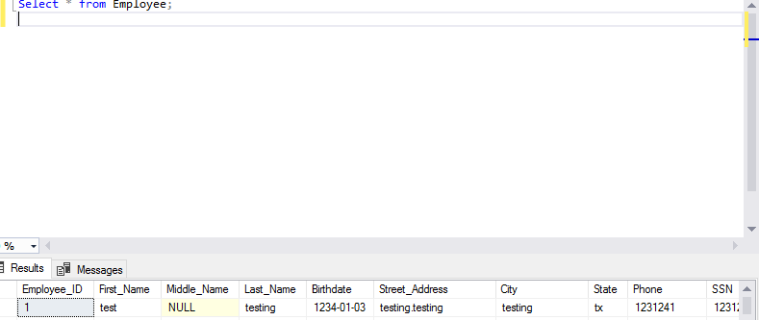

After (middle name has been updated to ‘allan’):

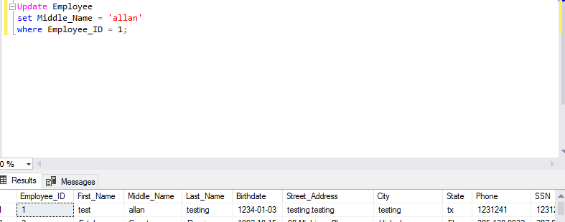

#### Update script 2

Before:

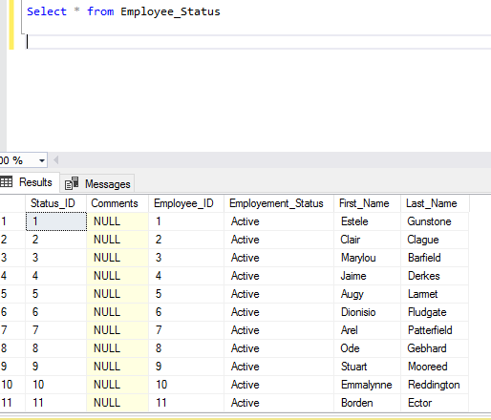

After (employee with the status_ID=’1’ has been ‘let go’):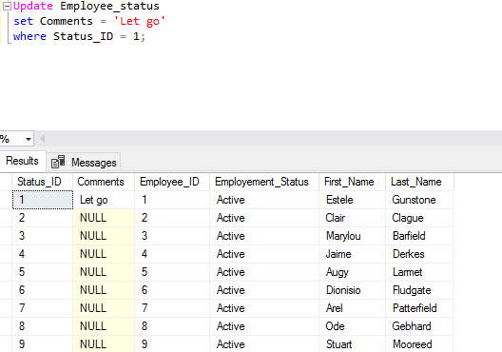

### GUI User Views

#### Manage Clients View

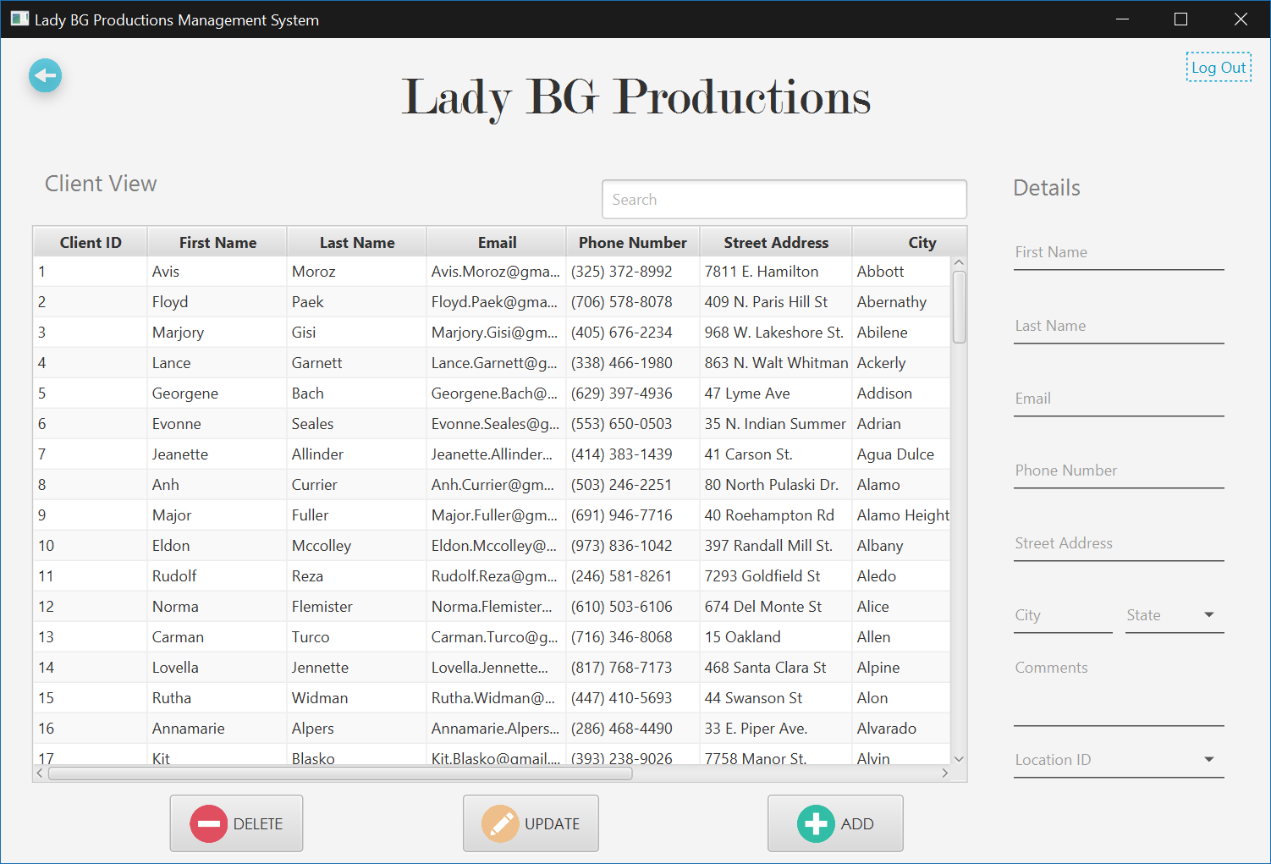

#### Manage User’s View



## Brandon Nguyen

### Create Script

#### Employee Training Request Table

create table Employee_Training_Request

(

   Training_RequestID int not null identity(1,1),

   Employee_ID int not null,

   Training_Date date not null,

   Training_Description varchar(100) not null,

   Training_Type varchar(25) not null,

   constraint Employee_Training_Request_pk

       primary key (Training_RequestID)

);

#### Employee Training Status Table

create table Employee_Training_Status

(

   Training_Status_ID int not null identity(1,1),

   Employee_ID int not null,

   Training_ID int not null,

   Training_Status varchar(25) not null,

   constraint Employee_Training_Status_pk

       primary key (Training_Status_ID)

);

#### Employee Title Table

create table Employee_Title

(

   Title_ID int not null identity(1,1),

   Employee_ID int not null,

   Emp_Title varchar(25) not null,

   constraint Employee_Title_pk

       primary key (Title_ID)

);

#### Employee Status Table

create table Employee_Status

(

   Status_ID int not null identity(1,1),

   First_Name varchar(25) not null,

   Last_Name varchar(25) not null,

   Employement_Status varchar(25) not null,

   Employee_ID int not null,

   Comments varchar(100),

   constraint Employee_Status_pk

       primary key (Status_ID)

);

### Alter Scripts

Alter table Booking_Status

 Add constraint Fk_Booking_ID

   Foreign key(Client_ID) references Client(Client_ID);

Alter table Employee_Training_Request

 Add constraint Fk_Employee_Training_RequestID

   Foreign key(Employee_ID) references Employee(Employee_ID);

Alter table Employee_Training_Status

 Add constraint Fk_Employee_Training_StatusID

   Foreign key(Employee_ID) references Employee(Employee_ID);

### Bulk Inserts

#### Employee Training Request Table Bulk Insert

Use ladyBG  
Bulk insert Employee_Training_Request  
from ‘C:\Users\brand\Desktop\Employee_Training_Request.csv.’  
with   
(  
rowterminator=’\n’,  
fieldterminator=’,’  
)

Select * from Employee_Training_Request

#### Employee Training Status Bulk Insert

Use ladyBG  
Bulk insert Employee_Training_Status  
from ‘C:\Users\brand\Desktop\Employee_Training_Status.csv.’  
with   
(  
rowterminator=’\n’,  
fieldterminator=’,’  
)

Select * from Employee_Training_Status

#### Employee Title Bulk Insert

Use ladyBG  
Bulk insert Employee_Title  
from ‘C:\Users\brand\Desktop\Employee_Title.csv.’  
with   
(  
rowterminator=’\n’,  
fieldterminator=’,’  
)

Select * from Employee_Title

#### Employee Status Bulk Insert

Use ladyBG  
Bulk insert Employee_Status  
from ‘C:\Users\brand\Desktop\Employee_Status.csv.’  
with   
(  
rowterminator=’\n’,  
fieldterminator=’,’  
)

Select * from Employee_Status

### Data Records

#### Employee Training Request Data Records

1001,Orientation,4/17/2018,Fundamentals of LadyBG,1

1002,Orientation,7/26/2018,Fundamentals of LadyBG,2

1003,Orientation,8/27/2018,Fundamentals of LadyBG,3

1004,Orientation,2/13/2019,Fundamentals of LadyBG,4

1005,Orientation,6/16/2008,Fundamentals of LadyBG,5

1006,Orientation,7/6/2009,Fundamentals of LadyBG,6

1007,Orientation,5/5/2009,Fundamentals of LadyBG,7

1008,Orientation,4/25/2011,Fundamentals of LadyBG,8

1009,Orientation,6/26/2009,Fundamentals of LadyBG,9

1010,Orientation,9/11/2011,Fundamentals of LadyBG,10

1011,Orientation,10/24/2011,Fundamentals of LadyBG,11

1012,Orientation,11/11/2012,Fundamentals of LadyBG,12

1013,Orientation,12/31/2013,Fundamentals of LadyBG,13

1014,Orientation,5/5/2010,Fundamentals of LadyBG,14

1015,Orientation,2/17/2017,Fundamentals of LadyBG,15

1016,Orientation,8/23/2015,Fundamentals of LadyBG,16

1017,Orientation,3/22/2016,Fundamentals of LadyBG,17

1018,Orientation,6/5/2016,Fundamentals of LadyBG,18

1019,Orientation,7/18/2018,Fundamentals of LadyBG,19

1020,Orientation,5/3/2018,Fundamentals of LadyBG,20

1021,Orientation,5/3/2018,Fundamentals of LadyBG,21

1022,Orientation,10/24/2014,Fundamentals of LadyBG,22

1023,Orientation,9/27/2016,Fundamentals of LadyBG,23

1024,Orientation,11/24/2014,Fundamentals of LadyBG,24

1025,Orientation,11/28/2016,Fundamentals of LadyBG,25

1026,Orientation,12/5/2016,Fundamentals of LadyBG,26

1027,Orientation,12/9/2017,Fundamentals of LadyBG,27

1028,Orientation,1/25/2014,Fundamentals of LadyBG,28

1029,Orientation,8/28/2013,Fundamentals of LadyBG,29

1030,Orientation,4/4/2011,Fundamentals of LadyBG,30

1031,Orientation,4/28/2015,Fundamentals of LadyBG,31

1032,Orientation,6/1/2018,Fundamentals of LadyBG,32

1033,Orientation,6/26/2016,Fundamentals of LadyBG,33

1034,Orientation,8/22/2018,Fundamentals of LadyBG,34

1035,Orientation,1/3/2019,Fundamentals of LadyBG,35

1036,Orientation,2/28/2019,Fundamentals of LadyBG,36

1037,Orientation,3/24/2015,Fundamentals of LadyBG,37

1038,Orientation,5/25/2015,Fundamentals of LadyBG,38

1039,Orientation,4/21/2016,Fundamentals of LadyBG,39

1040,Orientation,3/25/2015,Fundamentals of LadyBG,40

1041,Orientation,6/22/2012,Fundamentals of LadyBG,41

1042,Orientation,4/20/2012,Fundamentals of LadyBG,42

1043,Orientation,11/28/2016,Fundamentals of LadyBG,43

1044,Orientation,11/29/2014,Fundamentals of LadyBG,44

1045,Orientation,1/3/2019,Fundamentals of LadyBG,45

1046,Orientation,6/1/2018,Fundamentals of LadyBG,46

1047,Orientation,11/28/2013,Fundamentals of LadyBG,47

1048,Orientation,6/5/2016,Fundamentals of LadyBG,48

1049,Orientation,7/18/2018,Fundamentals of LadyBG,49

1050,Orientation,5/3/2018,Fundamentals of LadyBG,50

1051,Orientation,5/25/2015,Fundamentals of LadyBG,51

1052,Orientation,7/6/2011,Fundamentals of LadyBG,52

1053,Orientation,5/5/2011,Fundamentals of LadyBG,53

1054,Orientation,4/25/2013,Fundamentals of LadyBG,54

1055,Orientation,6/26/2012,Fundamentals of LadyBG,55

1056,Orientation,3/25/2015,Fundamentals of LadyBG,56

1057,Orientation,7/24/2013,Fundamentals of LadyBG,57

1058,Orientation,6/27/2012,Fundamentals of LadyBG,58

1059,Orientation,5/3/2012,Fundamentals of LadyBG,59

1060,Orientation,7/2/2013,Fundamentals of LadyBG,60

1061,Orientation,7/27/2017,Fundamentals of LadyBG,61

1062,Orientation,6/7/2017,Fundamentals of LadyBG,62

1063,Orientation,4/5/2018,Fundamentals of LadyBG,63

1064,Orientation,5/5/2016,Fundamentals of LadyBG,64

1065,Orientation,3/22/2017,Fundamentals of LadyBG,65

1066,Orientation,1/20/2019,Fundamentals of LadyBG,66

1067,Orientation,12/9/2017,Fundamentals of LadyBG,67

1068,Orientation,12/9/2015,Fundamentals of LadyBG,68

1069,Orientation,12/10/2012,Fundamentals of LadyBG,69

1070,Orientation,12/5/2017,Fundamentals of LadyBG,70

1071,Orientation,12/9/2016,Fundamentals of LadyBG,71

1072,Orientation,12/10/2014,Fundamentals of LadyBG,72

1073,Orientation,6/5/2013,Fundamentals of LadyBG,73

1074,Orientation,4/25/2018,Fundamentals of LadyBG,74

1075,Orientation,5/25/2014,Fundamentals of LadyBG,75

1076,Orientation,3/2/2015,Fundamentals of LadyBG,76

1077,Orientation,11/20/2019,Fundamentals of LadyBG,77

1078,Orientation,2/9/2017,Fundamentals of LadyBG,78

1079,Orientation,2/9/2015,Fundamentals of LadyBG,79

1080,Orientation,2/10/2012,Fundamentals of LadyBG,80

1081,Orientation,3/5/2017,Fundamentals of LadyBG,81

1082,Orientation,12/9/2016,Fundamentals of LadyBG,82

1083,Orientation,11/10/2013,Fundamentals of LadyBG,83

1084,Orientation,4/5/2011,Fundamentals of LadyBG,84

1085,Orientation,5/25/2018,Fundamentals of LadyBG,85

1086,Orientation,6/25/2014,Fundamentals of LadyBG,86

1087,Orientation,3/2/2015,Fundamentals of LadyBG,87

1088,Orientation,11/20/2019,Fundamentals of LadyBG,88

1089,Orientation,2/19/2017,Fundamentals of LadyBG,89

1090,Orientation,2/19/2015,Fundamentals of LadyBG,90

1091,Orientation,2/10/2012,Fundamentals of LadyBG,91

1092,Orientation,3/25/2013,Fundamentals of LadyBG,92

1093,Orientation,12/5/2015,Fundamentals of LadyBG,93

1094,Orientation,11/10/2013,Fundamentals of LadyBG,94

1095,Orientation,4/5/2014,Fundamentals of LadyBG,95

1096,Orientation,5/5/2018,Fundamentals of LadyBG,96

1097,Orientation,3/25/2013,Fundamentals of LadyBG,97

1098,Orientation,2/5/2015,Fundamentals of LadyBG,98

1099,Orientation,11/11/2013,Fundamentals of LadyBG,99

1100,Orientation,4/25/2020,Fundamentals of LadyBG,100

1101,Orientation,5/23/2017,Fundamentals of LadyBG,101

#### Employee Training Status Data Records

1,1,1001,Pending

2,2,1002,Pending

3,3,1003,Approved

4,4,1004,Pending

5,5,1005,Approved

6,6,1006,Approved

7,7,1007,Approved

8,8,1008,Approved

9,9,1009,Approved

10,10,1010,Approved

11,11,1011,Approved

12,12,1012,Approved

13,13,1013,Approved

14,14,1014,Approved

15,15,1015,Approved

16,16,1016,Approved

17,17,1017,Approved

18,18,1018,Approved

19,19,1019,Approved

20,20,1020,Approved

21,21,1021,Approved

22,22,1022,Approved

23,23,1023,Approved

24,24,1024,Approved

25,25,1025,Approved

26,26,1026,Pending

27,27,1027,Pending

28,28,1028,Pending

29,29,1029,Pending

30,30,1030,Approved

31,31,1031,Approved

32,32,1032,Approved

33,33,1033,Approved

34,34,1034,Approved

35,35,1035,Pending

36,36,1036,Pending

37,37,1037,Pending

38,38,1038,Approved

39,39,1039,Approved

40,40,1040,Approved

41,41,1041,Approved

42,42,1042,Approved

43,43,1043,Approved

44,44,1044,Pending

45,45,1045,Pending

46,46,1046,Approved

47,47,1047,Approved

48,48,1048,Approved

49,49,1049,Approved

50,50,1050,Approved

51,51,1051,Approved

52,52,1052,Pending

53,53,1053,Pending

54,54,1054,Approved

55,55,1055,Approved

56,56,1056,Approved

57,57,1057,Approved

58,58,1058,Approved

59,59,1059,Approved

60,60,1060,Approved

61,61,1061,Approved

62,62,1062,Pending

63,63,1063,Pending

64,64,1064,Approved

65,65,1065,Approved

66,66,1066,Approved

67,67,1067,Approved

68,68,1068,Approved

69,69,1069,Approved

70,70,1070,Pending

71,71,1071,Approved

72,72,1072,Approved

73,73,1073,Approved

74,74,1074,Approved

75,75,1075,Approved

76,76,1076,Approved

77,77,1077,Approved

78,78,1078,Approved

79,79,1079,Approved

80,80,1080,Approved

81,81,1081,Approved

82,82,1082,Approved

83,83,1083,Approved

84,84,1084,Approved

85,85,1085,Approved

86,86,1086,Approved

87,87,1087,Approved

88,88,1088,Approved

89,89,1089,Approved

90,90,1090,Approved

91,91,1091,Approved

92,92,1092,Approved

93,93,1093,Approved

94,94,1094,Approved

95,95,1095,Approved

96,96,1096,Approved

97,97,1097,Approved

98,98,1098,Approved

99,99,1099,Approved

100,100,1100,Approved

101,101,1101,Approved

#### Employee Title Data Records

1,1,Director of Sales

2,2,Geological Engineer

3,3,Research Nurse

4,4,VP Product Management

5,5,Research Nurse

6,6,Registered Nurse

7,7,Project Manager

8,8,Recruiting Manager

9,9,Recruiting Manager

10,10,Food Chemist

11,11,Administrative Officer

12,12,Structural Engineer

13,13,Systems Administrator III

14,14,Administrative Assistant IV

15,15,Assistant Professor

16,16,Structural Engineer

17,17,Human Resources Assistant III

18,18,Human Resources Assistant IV

19,19,Research Assistant III

20,20,Analyst Programmer

21,21,Paralegal

22,22,Project Manager

23,23,Nurse

24,24,Tax Accountant

25,25,Developer III

26,26,Structural Analysis Engineer

27,27,Software Consultant

28,28,Analog Circuit Design manager

29,29,Graphic Designer

30,30,Assistant Manager

31,31,Administrative Assistant III

32,32,Database Administrator III

33,33,Software Engineer II

34,34,Recruiting Manager

35,35,Research Nurse

36,36,Technical Writer

37,37,Project Manager

38,38,General Manager

39,39,Food Chemist

40,40,Design Engineer

41,41,Analog Circuit Design manager

42,42,Internal Auditor

43,43,Engineer III

44,44,Recruiter

45,45,Financial Analyst

46,46,Food Chemist

47,47,Desktop Support Technician

48,48,Physical Therapy Assistant

49,49,Geological Engineer

50,50,Analog Circuit Design manager

51,51,Compensation Analyst

52,52,Geological Engineer

53,53,Community Outreach Specialist

54,54,Librarian

55,55,Social Worker

56,56,Product Engineer

57,57,Graphic Designer

58,58,Software Engineer I

59,59,VP Product Management

60,60,Teacher

61,61,Assistant Media Planner

62,62,Nuclear Power Engineer

63,63,Nurse

64,64,Payment Adjustment Coordinator

65,65,VP Quality Control

66,66,Cost Accountant

67,67,Social Worker

68,68,Actuary

69,69,Budget/Accounting Analyst I

70,70,Geologist III

71,71,Senior Quality Engineer

72,72,Director of Sales

73,73,Recruiter

74,74,Professor

75,75,Paralegal

76,76,Senior Quality Engineer

77,77,Financial Analyst

78,78,Web Designer III

79,79,Environmental Specialist

80,80,Mechanical Systems Engineer

81,81,Nurse Practicioner

82,82,Speech Pathologist

83,83,Graphic Designer

84,84,Information Systems Manager

85,85,Safety Technician III

86,86,Registered Nurse

87,87,Electrical Engineer

88,88,Senior Quality Engineer

89,89,Operator

90,90,Professor

91,91,Librarian

92,92,Office Assistant III

93,93,Office Assistant IV

94,94,Computer Systems Analyst IV

95,95,Editor

96,96,Software Engineer II

97,97,Actuary

98,98,Senior Quality Engineer

99,99,Project Manager

#### Employee Status Data Records

1,Estele,Gunstone,Active,1

2,Clair,Clague,Active,2

3,Marylou,Barfield,Active,3

4,Jaime,Derkes,Active,4

5,Augy,Larmet,Active,5

6,Dionisio,Fludgate,Active,6

7,Arel,Patterfield,Active,7

8,Ode,Gebhard,Active,8

9,Stuart,Mooreed,Active,9

10,Emmalynne,Reddington,Active,10

11,Borden,Ector,Active,11

12,Dionysus,Whitham,Active,12

13,Casey,Digance,Active,13

14,Ibrahim,Hansie,Active,14

15,Jasmina,Terbrug,Active,15

16,Bernie,Bastard,Active,16

17,Martha,Owbridge,Active,17

18,Coleen,Davidovitch,Inactive ,18

19,Aubrey,Drowsfield,Active,19

20,Kimberley,Hassey,Active,20

21,Mavra,Edlin,Active,21

22,Nikolas,Platt,Active,22

23,Chrissy,Plaid,Active,23

24,Jacquenetta,McGarel,Active,24

25,Rudy,Lanney,Active,25

26,Marti,Midden,Active,26

27,Eartha,Ganniclifft,Active,27

28,Eva,Whinray,Inactive ,28

29,Tarrah,Bruhke,Active,29

30,Rayner,MacDuffie,Active,30

31,Allyn,Lilleycrop,Active,31

32,Welbie,Carmen,Active,32

33,Lorette,Halsey,Active,33

34,Zeke,Whittlesey,Active,34

35,Laina,Goodliffe,Active,35

36,Alexandra,Manie,Active,36

37,Ursola,Bartoli,Active,37

38,Gretna,Giacobbo,Inactive ,38

39,Alan,Castelin,Active,39

40,Hoyt,Lidgely,Active,40

41,Abrahan,Matthias,Active,41

42,Marney,Sidary,Active,42

43,Godfrey,Jirka,Active,43

44,Marin,Prestney,Active,44

45,Kathye,Hendrickx,Active,45

46,Wilie,O'Connell,Active,46

47,Corella,Ply,Active,47

48,Frieda,Bassam,Inactive ,48

49,Ginny,Devanny,Active,49

50,Marvin,Bradforth,Active,50

51,Pavla,Robardey,Active,51

52,Nelia,Hiscocks,Active,52

53,Kennie,Kundert,Active,53

54,Marylin,Besant,Active,54

55,Dawn,Murrthum,Active,55

56,Leslie,Crook,Active,56

57,Maxine,Cabrara,Active,57

58,Bride,Bausor,Active,58

59,Leslie,Marsy,Active,59

60,Sile,Fitzpatrick,Active,60

61,Klemens,Bennetts,Active,61

62,Sibel,Surmon,Active,62

63,Lacie,Fordyce,Active,63

64,Wynnie,Jenkinson,Active,64

65,Helene,Walling,Active,65

66,Randy,Benjefield,Active,66

67,Kerri,Koba,Active,67

68,Corabella,Ortsmann,Active,68

69,Maggy,Jery,Active,69

70,Colby,Gennrich,Active,70

71,Blithe,Axleby,Active,71

72,Bord,Allworthy,Active,72

73,Ly,Moutray Read,Active,73

74,Mead,Ovens,Active,74

75,Wylie,Mansour,Active,75

76,Tallie,Sangar,Active,76

77,Lucien,Beggio,Active,77

78,Araldo,Gosforth,Active,78

79,Pyotr,Bartelot,Inactive ,79

80,Electra,Manjot,Active,80

81,Madlen,Fleischmann,Active,81

82,Jeffy,Sconce,Active,82

83,Reggi,Aldersea,Active,83

84,Abran,Applegate,Active,84

85,Donella,Goforth,Active,85

86,Marje,Sanja,Active,86

87,Erl,Guilleton,Active,87

88,Chloe,Couvert,Active,88

89,Clotilda,Ayres,Active,89

90,Flynn,Bloggett,Active,90

91,Korney,Fehner,Active,91

92,Tiena,Artindale,Inactive ,92

93,Kimberlee,Sabie,Inactive ,93

94,Jeana,Hurburt,Active,94

95,Rebecka,Heselwood,Active,95

96,Baillie,Hamon,Active,96

97,Maxy,More,Active,97

98,Giles,Wray,Active,98

99,Eugene,Larder,Active,99

### SQL Report Queries

#### Query 1

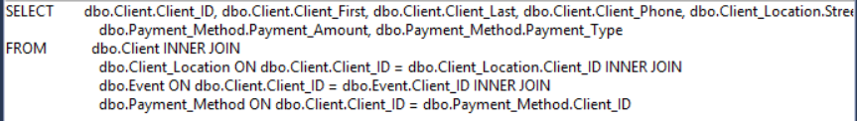

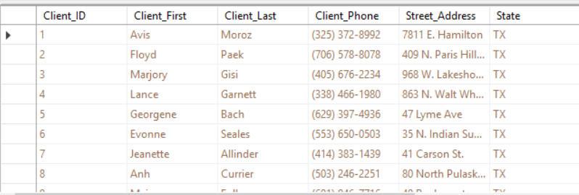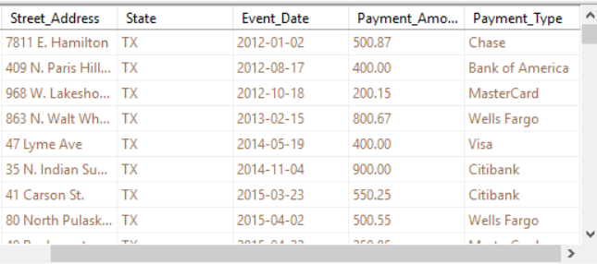

This Report Combines the tables:

* Client
* Client Location
* Event
* Payment Method

The Client table displays the client ID, first name, last name, and phone number to search for a specific individual

The Client Location table shows the address of each client

The Event table shows the event of which each client attended

The Payment Method table shows the payment method and amount of each event for a specific individual

#### Query 2

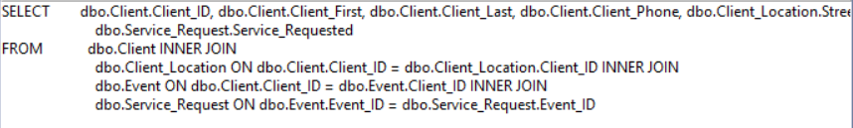

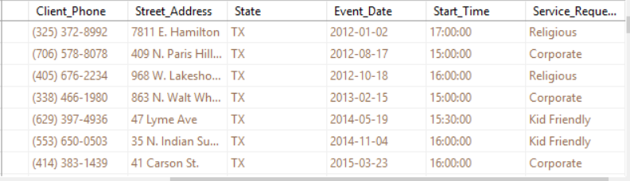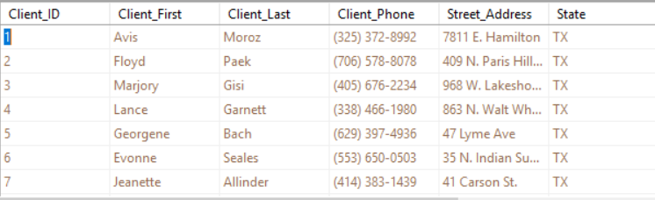

This Report combines the tables:

* Client
* Client Location
* Event
* Service Requested

The Client Table shows the Client ID, first name, last name and phone number associated with an individual if a search is required

The Client Location table shows the client’s address

The Event Table shows the event of which each client attended

The Service Requested table shows kind of service a client requested and can be associated with which event

#### Query 3

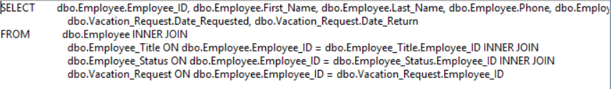

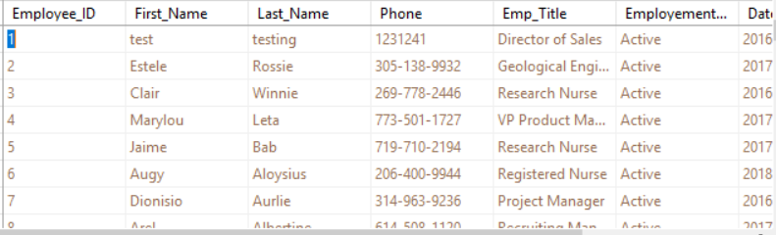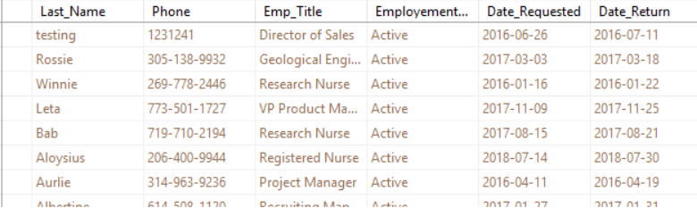

This report combines the tables:

* Employee
* Employee Title
* Employee Status
* Vacation Request

The employee table shows the Employee ID, first name, last name, and phone number associated with an individual

The Employee Title table shows the position or title of a specific employee

The Employee Status table shows if an employee is currently active or inactive within the company

The Vacation Request table shows the date requested for a vacation and the date returned for a vacation for each employee

#### Query 4

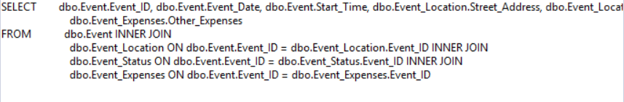

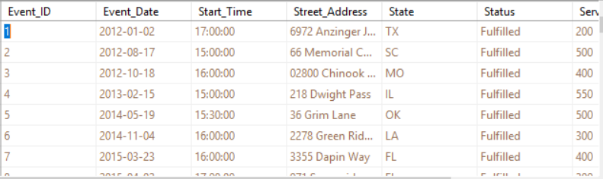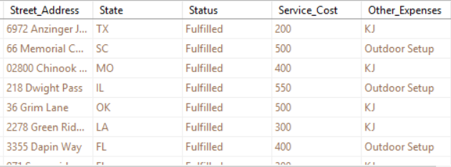

This Report combines the tables:

* Event
* Event Location
* Event Status
* Event Expenses

The Event table associates each event with an Event ID for efficient searching as well as the start time of each event

The Event Location table shows the street address and state of each event held

The Event Status table shows if an event is fulfilled, meaning it was booked and complete

The Event Expenses table shows the service cost and any other expenses that may have been associated with an event

#### Query 5

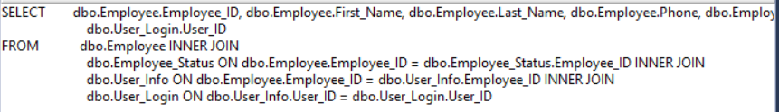

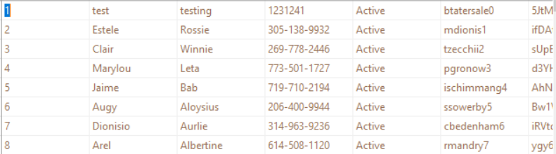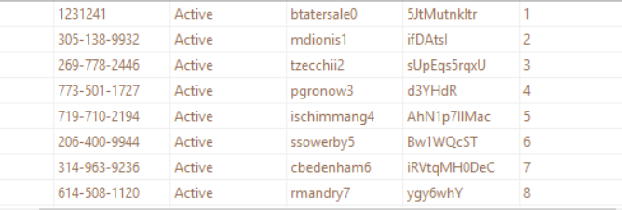

This report combines the tables:

* Employee
* Employee Status
* User Info
* User Login

The employee table shows the Employee ID, first name, last name, and phone number associated with an individual

The Employee Status table shows the current status of an specific employee, whether or not they are active within the company

The User Info table shows the assigned login and password for each individual in case an employee forgets. This information would require specific authorization

The User Login table associates a login ID with each individual’s Employee ID

### SQL Insert, Delete, Update Scripts

#### Insert Script 1

Before and after inserting Catie Mcgawn into Employee Status Table 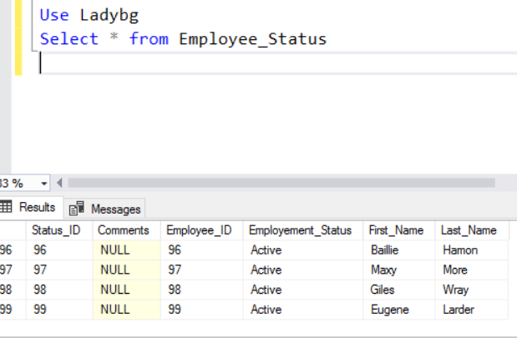

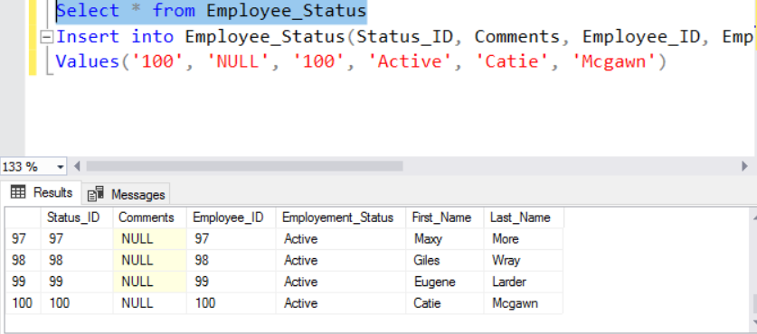

#### Insert Script 2

Before and after Inserting Employee ID 100 into Employee Title table

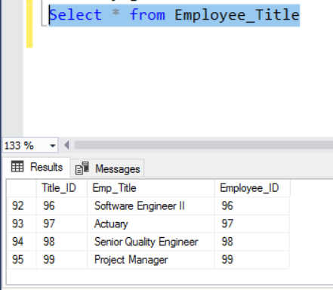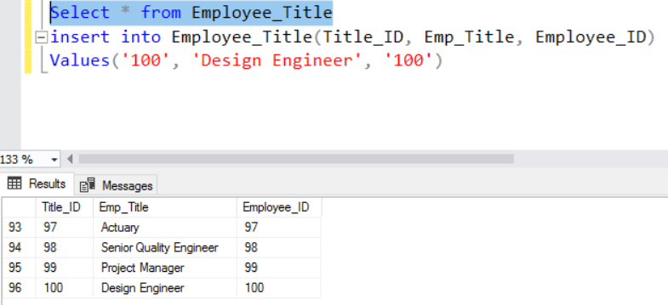

#### Delete Script 1

Before and after deleting training status ID 100 from Employee Training Status Table

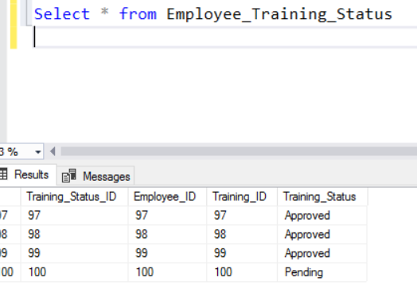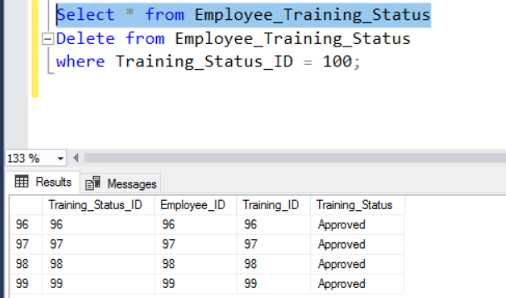

#### Delete Script 2

Before and after deleting Training Status ID 101 from Employee Training Status Table 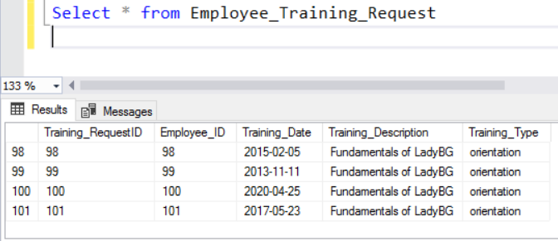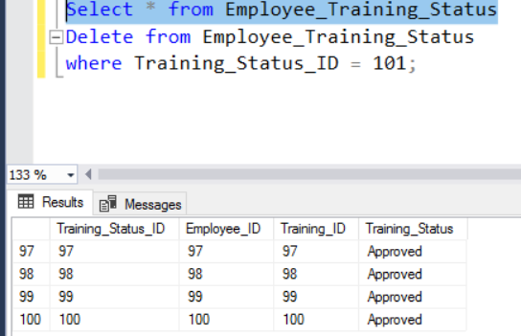

#### Update Script 1

Before and after updating employee ID 27 training status to “Approved” 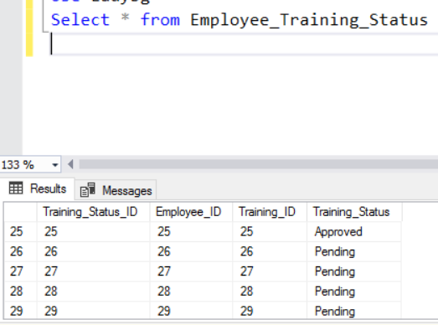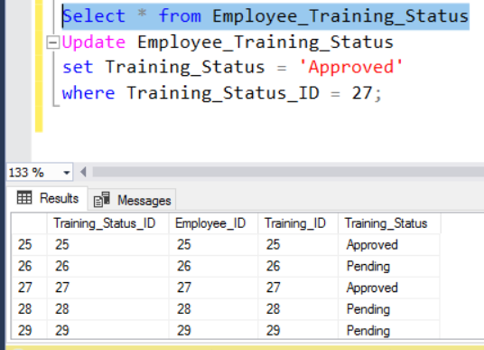

#### Update Script 2

Before and after updating employee ID 100 training status to “Pending” 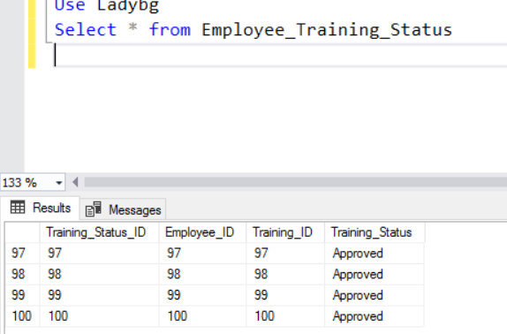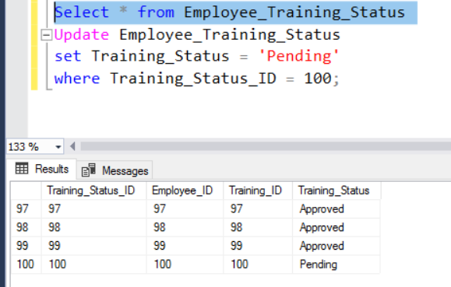

### GUI User Views

#### Manage Events View

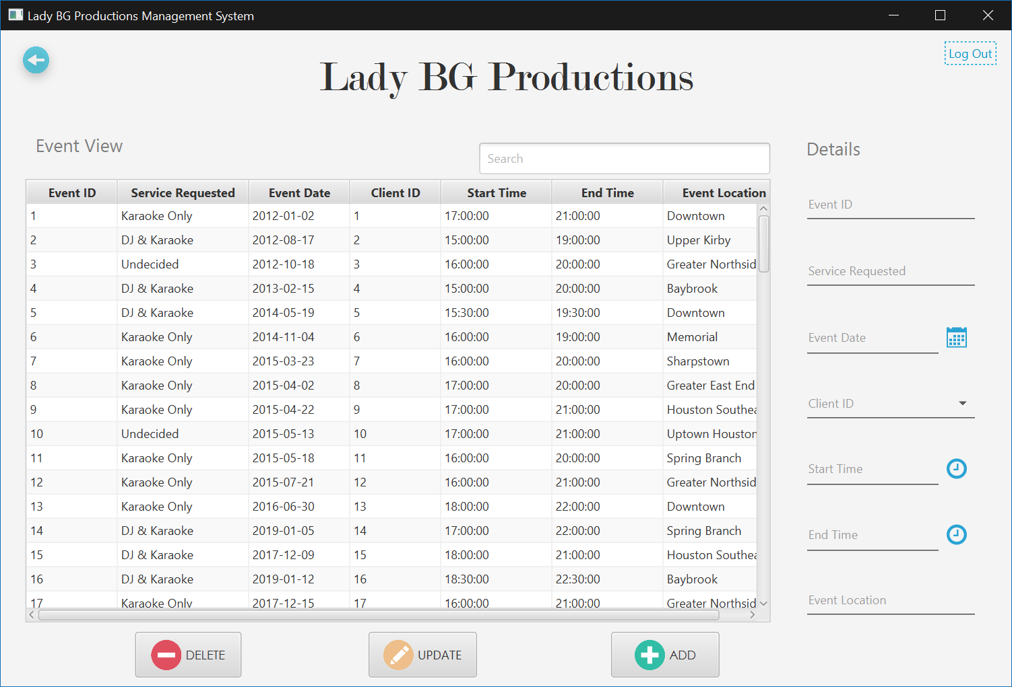

## Muktar Abubakar

### Created Scripts

#### Client_Table

create table Client_Type

(

   Client_Type_ID int not null identity(1,1),

   Client_ID int not null,

   First_Name varchar(25) not null,

   New_Client bit not null,

   Returning_Client bit not null,

   constraint Client_Type_pk

       primary key (Client_Type_ID)

);

#### Location Table

create table Client_Location

(

   Location_ID int not null identity(1,1),

   Client_ID int not null,

   Street_Address varchar(25) not null,

   City varchar(25) not null,

   State varchar(2) not null,

   Postal varchar(10) not null,

   constraint Client_Location_pk

       primary key (Location_ID)

);

#### Payment Method Table

create table Payment_Method

(

   Payment_ID int not null identity(1,1),

   Client_ID int not null,

   Payment_Type varchar(25) not null,

   Payment_Amount decimal(18,2) not null,

   constraint Payment_Method_pk

       primary key (Payment_ID)

);

#### Booking Status

create table Booking_Status

(

   Booking_ID int not null identity(1,1),

   Booking_Date date not null,

   Client_ID int not null,

   Booking_Status varchar(25) not null,

   constraint Booking_Status_pk

       primary key (Booking_ID)

);

### Alter Scripts

Alter table Client_Type

 Add constraint Fk_Client_Type_ID

   Foreign key(Client_ID) references Client(Client_ID);

Alter table Client_Location

 Add constraint Fk_Client_Location_ID

   Foreign key(Client_ID) references Client(Client_ID);

Alter table Payment_Method

 Add constraint Fk_Payment_ID

   Foreign key(Client_ID) references Client(Client_ID);

### Bulk Insert Scripts

#### Payment Method Insert

From ‘C:\Users\C:\Users\maabuba2\Desktop\Payment_Method.csv’

With

(

Rowterminator=’\n’,

Fieldterminator=’,’

)

#### Client Location Insert

From ‘C:\Users\C:\Users\maabuba2\Desktop\Client_Location.csv’

With

(

Rowterminator=’\n’,

Fieldterminator=’,’

)

#### Client Type Insert

From ‘C:\Users\C:\Users\maabuba2\Desktop\Client_Type.csv’

With

(

Rowterminator=’\n’,

Fieldterminator=’,’

)

#### Booking Status Insert

From ‘C:\Users\C:\Users\maabuba2\Desktop\Booking_Status.csv’

With

(

Rowterminator=’\n’,

Fieldterminator=’,’

)

### Data Records for Tables

#### Payment Method

1,1,500.87,Chase

2,2,400.00,Bank of America

3,3,200.15,MasterCard

4,4,800.67,Wells Fargo

5,5,400.00,Visa

6,6,900.00,Citibank

7,7,550.25,Citibank

8,8,500.55,Wells Fargo

9,9,250.85,MasterCard

10,10,500.00,American Express

11,11,900.70,Maestro

12,12,500.00,Capital One

13,13,500.00,Maestro

14,14,1011.13,UnionPay

15,15,234.74,Wells Fargo

16,16,523.55,American Express

17,17,1224.15,Bank of America

18,18,754.34,MasterCard

19,19,107.80,Visa

20,20,74.19,Chase

21,21,54.52,UnionPay

22,22,85.18,Citibank

23,23,857.34,American Express

24,24,352.63,Capital One

25,25,1447.59,Wells Fargo

26,26,1077.68,Citibank

27,27,1087.57,Bank of America

28,28,1270.85,Citibank

29,29,421.11,Chase

30,30,551.88,Discover

31,31,1449.96,Capital One

32,32,918.08,Citibank

33,33,417.47,Wells Fargo

34,34,782.95,Citibank

35,35,1483.82,Discover

36,36,1098.90,Bank of America

37,37,628.83,Bank of America

38,38,229.07,Bank of America

39,39,80.74,Bank of America

40,40,597.51,Wells Fargo

41,41,249.84,Citibank

42,42,768.42,Visa

43,43,229.70,American Express

44,44,589.93,Visa

45,45,498.44,Maestro

46,46,499.52,Visa

47,47,612.01,Maestro

48,48,795.85,Chase

49,49,951.59,Cash App

50,50,845.42,Cash App

51,51,963.39,Discover

52,52,212.53,UnionPay

53,53,654.44,Chase

54,54,964.10,UnionPay

55,55,284.36,American Express

56,56,368.21,Bank of America

57,57,342.98,MasterCard

58,58,606.33,Discover

59,59,88.60,Wells Fargo

60,60,638.77,Wells Fargo

61,61,170.24,American Express

62,62,961.76,Cash App

63,63,225.51,Cash App

64,64,424.90,American Express

65,65,780.15,Bank of America

66,66,692.04,Discover

67,67,371.00,Chase

68,68,564.36,Visa

69,69,540.41,MasterCard

70,70,518.37,Cash App

71,71,186.97,Discover

72,72,719.39,Wells Fargo

73,73,58.57,Discover

74,74,572.41,Cash App

75,75,67.24,Wells Fargo

76,76,189.52,Chase

77,77,295.77,Wells Fargo

78,78,157.04,Chase

79,79,252.71,Chase

80,80,999.87,Visa

81,81,844.49,Citibank

82,82,520.27,Capital One

83,83,767.61,Chase

84,84,560.83,Capital One

85,85,328.28,American Express

86,86,178.71,MasterCard

87,87,256.30,Chase

88,88,673.86,Cash App

89,89,549.33,Visa

90,90,482.66,Bank of America

91,91,10.73,Cash App

92,92,124.88,Cash App

93,93,826.68,Discover

94,94,910.69,American Express

95,95,710.54,Capital One

96,96,351.48,MasterCard

97,97,364.93,Visa

98,98,22.31,American Express

99,99,395.77,Capital One

100,100,198.78,Cash App

#### Client Location

1,Abbott,1,97793,TX,7811 E. Hamilton

2,Abernathy,2,34570,TX,409 N. Paris Hill St

3,Abilene,3,77503,TX,968 W. Lakeshore St.

4,Ackerly,4,84411,TX,863 N. Walt Whitman

5,Addison,5,54550,TX,47 Lyme Ave

6,Adrian,6,85764,TX,35 N. Indian Summer

7,Agua Dulce,7,91308,TX,41 Carson St.

8,Alamo,8,87127,TX,80 North Pulaski Dr.

9,Alamo Heights,9,86185,TX,40 Roehampton Rd

10,Albany,10,65148,TX,397 Randall Mill St.

11,Aledo,11,28544,TX,7293 Goldfield St

12,Alice,12,76077,TX,674 Del Monte St

13,Allen,13,84224,TX,15 Oakland

14,Alpine,14,63248,TX,468 Santa Clara St

15,Alon,15,12956,TX,44 Swanson St

16,Alvarado,16,49568,TX,33 E. Piper Ave.

17,Alvin,17,61380,TX,7758 Manor St.

18,Amarillo,18,81956,TX,748 Brandywine Rd

19,Ames,19,86324,TX,814 Trenton Lane

20,Amherst,20,99906,TX,8697 Oak Meadow St

21,Anahuac,21,70703,TX,601 Peg Shop

22,Anderson,22,36499,TX,432 Durham St.

23,Andrews,23,75011,TX,73 Ridge Dr

24,Angelton,24,91760,TX,92 Eagle Lane

25,Angus,25,14445,TX,61 E. Illinois St

26,Anna,26,15951,TX,12 E. Atlantic St

27,Anson,27,72838,TX,9020 Wintergreen St

28,Anton,28,82263,TX,8900 N. Essex St

29,Appleby,29,41841,TX,67 Country Dr

30,Aquilla,30,94513,TX,381 N. Addison St

31,Aransas,31,41159,TX,49 New Lane

32,Archer City,32,90639,TX,308 W. Edgewater Dr

33,Arcola,33,13538,TX,5 Nicolls Dr

34,Argyle,34,35248,TX,9712 Pawnee Lane

35,Arlington,35,26136,TX,658 Fulton Ave

36,Arp,36,48818,TX,9438 2nd St

37,Asherton,37,14071,TX,40 Applegate St

38,Athens,38,92410,TX,131 Shirley St

39,Atlanta,39,15490,TX,8748 Peachtree Dr

40,Aubrey,40,94256,TX,5 Logan Ave

41,Aurora,41,16958,TX,596 Windsor St

42,Austin,42,72160,TX,1 Philmont Dr

43,Austwell,43,95675,TX,555 Tallwood St

44,Avery,44,35399,TX,7275 Schoolhouse st

45,Azel,45,35701,TX,472 Williams st

46,Bailey,46,83681,TX,266 Wintergreen ave

47,Baird,47,48249,TX,8750 Sussex st

48,Balch Springs,48,15575,TX,477 Cemetery ave

49,Balcones Heights,49,37432,TX,8412 W. Oak dr

50,Ballinger,50,77227,TX,65 Glenridge st

51,Balmorhea,51,95464,TX,7176 Carpenter ave

52,Bandera,52,60837,TX,277 High Point st

53,Bangs,53,10260,TX,42 Border dr

54,Bardwell,54,50664,TX,9250 Prairie dr

55,Barry,55,30054,TX,46 Harrison st

56,Bellaire,56,64448,TX,15 Mayfield st

57,Bellevue,57,22357,TX,8 Cleveland lan

58,Bellmead,58,76324,TX,806 Rock Creek st

59,Bellville,59,72230,TX,992 S. Indian Summer

60,Belton,60,51215,TX,7058 Kingston st

61,Benavides,61,10563,TX,9347 Pin Oak dr

62,Benbrook,62,60862,TX,938 Fifth rd

63,Benjamin,63,61646,TX,9299 Fieldstone ave

64,Bertram,64,23484,TX,79 Old Tower ave

65,Beverly Hills,65,53902,TX,9810 Bay Meadows ave

66,Bevil Oaks,66,14920,TX,9421 Vernon st

67,Big Lake,67,61286,TX,9643 E. Vine rd

68,Big Spring,68,25038,TX,7973 N. El Dorado

69,Big Wells,69,99951,TX,980 Canterbury st

70,Bishop,70,47097,TX,9266 Rockville ave

71,Blackwell,71,36794,TX,4 Poplar st

72,Blanco,72,79513,TX,82 W. Hill Field

73,Blessing,73,69717,TX,680 River ave

74,Blossom,74,99543,TX,44 Laurel ave

75,Blue Mound,75,65410,TX,4 W. Cobblestone rd

76,Blue Ridge,76,44045,TX,8571 Mayfair st

77,Boerne,77,40684,TX,8109 Lafayette ave

78,Bogata,78,98321,TX,350 College rd

79,Bonham,79,22974,TX,688 W. Kingston ave

80,Borger,80,85595,TX,594 Glendale dr

81,Bovina,81,58731,TX,490 Walk Whitman

82,Bowie,82,42802,TX,9535 W. Ivy st

83,Brackettville,83,35419,TX,31 Shub Farm ave

84,Brady,84,91867,TX,162 Manchester ave

85,Brazoria,85,54191,TX,7723 Fairfield ave

86,Brazos Country,86,87090,TX,7722 N. Sunset ave

87,Bremond,87,91971,TX,2 W. Bridge st

88,Brookshire,88,30209,TX,122 High Ridge rd

89,Houston,89,64708,TX,80 S. Ivy st.

90,Buda,90,55228,TX,102 Bay Meadows

91,Buffalo,91,79002,TX,31 William st

92,Burke,92,81773,TX,596 Penn st

93,Byers,93,86040,TX,254 Princess st

94,Cactus,94,27989,TX,441 Old York st

95,Cisco,95,53098,TX,9464 Baker dr

96,Celina,96,92069,TX,91 W. Boston rd

97,Chandler,97,47229,TX,418 E. Winchester ct

98,Cleaveland,98,36557,TX,7615 Atlantic dr

99,Coleman,99,36736,TX,915 San Carlos st

100,Dayton,100,10101,TX,701 Rocky River st

#### Client Type

1,1,Avis,0,1

2,2,Floyd,1,0

3,3,Marjory,1,0

4,4,Lance,1,0

5,5,Georgene,1,0

6,6,Evonne,0,1

7,7,Jeanette,0,1

8,8,Anh,0,1

9,9,Major,0,1

10,10,Eldon,0,1

11,11,Rudolf,0,1

12,12,Norma,0,1

13,13,Carman,0,1

14,14,Lovella,1,0

15,15,Rutha,0,1

16,16,Annamarie,1,0

17,17,Kit,0,1

18,18,Jeanice,0,1

19,19,Janice,0,1

20,20,Alica,0,1

21,21,Etsuko,0,1

22,22,Ruby,1,0

23,23,Laronda,0,1

24,24,Clifford,1,0

25,25,Mozella,1,0

26,26,Zofia,0,1

27,27,Marco,0,1

28,28,Flavia,0,1

29,29,Tomoko,0,1

30,30,Maryanna,0,1

31,31,Lona,1,0

32,32,Magdalen,0,1

33,33,Ignacia,0,1

34,34,Marty,1,0

35,35,Lyndon,1,0

36,36,Evelin,0,1

37,37,Yuri,1,0

38,38,Carmel,1,0

39,39,Velma,0,1

40,40,Lorna,0,1

41,41,Jesenia,0,1

42,42,Marceline,1,0

43,43,Garth,1,0

44,44,India,0,1

45,45,Mayme,0,1

46,46,Karena,1,0

47,47,Rheba,0,1

48,48,Echo,1,0

49,49,Richard,0,1

50,50,Flor,0,1

51,51,Cyndi,0,1

52,52,Janett,0,1

53,53,Meridith,1,0

54,54,Malorie,1,0

55,55,Belinda,1,0

56,56,Rubie,1,0

57,57,Julissa,0,1

58,58,Geoffrey,1,0

59,59,Bailey,1,0

60,60,Margert,0,1

61,61,Linnie,0,1

62,62,Keneth,1,0

63,63,Damian,1,0

64,64,Jaclyn,0,1

65,65,Terrell,0,1

66,66,Kira,0,1

67,67,Cathy,1,0

68,68,Darlena,1,0

69,69,Albertha,1,0

70,70,Estrella,0,1

71,71,Latonia,0,1

72,72,Cathern,1,0

73,73,Jonelle,1,0

74,74,Mandy,1,0

75,75,Yung,1,0

76,76,Mistie,1,0

77,77,Jed,0,1

78,78,Gidget,1,0

79,79,Yvonne,1,0

80,80,Mel,0,1

81,81,Cheryl,1,0

82,82,Frank,0,1

83,83,Clarissa,0,1

84,84,Daniell,1,0

85,85,Louann,0,1

86,86,Nathalie,1,0

87,87,Oretha,0,1

88,88,Melony,1,0

89,89,Ghislaine,1,0

90,90,Haywood,0,1

91,91,Tillie,0,1

92,92,Catharine,1,0

93,93,Catrina,0,1

94,94,Roman,1,0

95,95,Mamie,1,0

96,96,Dulce,0,1

97,97,Tyrell,0,1

98,98,Lang,1,0

99,99,Rosie,1,0

100,100,Kiesha,1,0

#### Booking Status

1,09/15/2019,Pending,1

2,03/21/2020,Cancelled,2

3,04/17/2018,Pending,3

4,11/24/2018,Confirmed,4

5,08/21/2018,Confirmed,5

6,08/26/2019,Pending,6

7,03/19/2019,Confirmed,7

8,07/19/2018,Suspended,8

9,04/16/2018,Confirmed,9

10,04/11/2020,Cancelled,10

11,08/24/2018,Confirmed,11

12,02/26/2020,Cancelled,12

13,09/07/2019,Pending,13

14,07/06/2019,Confirmed,14

15,04/09/2020,Pending,15

16,04/26/2018,Confirmed,16

17,09/02/2019,Pending,17

18,05/05/2018,Pending,18

19,07/07/2018,Pending,19

20,07/18/2019,Confirmed,20

21,11/30/2019,Pending,21

22,03/25/2020,Pending,22

23,08/26/2019,Pending,23

24,04/29/2019,Cancelled,24

25,01/22/2020,Waiting,25

26,03/20/2019,ReScheduled,26

27,10/19/2018,ReScheduled,27

28,10/15/2019,ReScheduled,28

29,11/18/2018,ReScheduled,29

30,12/16/2019,Pending,30

31,07/11/2019,Pending,31

32,04/29/2018,Pending,32

33,04/02/2019,Pending,33

34,12/30/2018,Pending,34

35,07/09/2018,Cancelled,35

36,05/24/2018,Cancelled,36

37,04/06/2019,Cancelled,37

38,09/14/2018,Confirmed,38

39,04/16/2019,Confirmed,39

40,01/08/2020,Confirmed,40

41,05/08/2018,Confirmed,41

42,08/13/2019,ReScheduled,42

43,11/20/2018,ReScheduled,43

44,06/22/2018,ReScheduled,44

45,06/14/2019,ReScheduled,45

46,05/16/2019,Waiting,46

47,08/26/2019,Waiting,47

48,08/21/2019,Waiting,48

49,01/08/2020,ReScheduled,49

50,09/05/2019,Confirmed,50

51,01/02/2020,Confirmed,51

52,03/15/2020,Confirmed,52

53,06/03/2018,Confirmed,53

54,10/12/2018,Confirmed,54

55,10/22/2018,Confirmed,55

56,08/01/2018,Confirmed,56

57,10/05/2019,Confirmed,57

58,01/20/2020,Confirmed,58

59,10/28/2019,Confirmed,59

60,08/16/2019,Confirmed,60

61,11/27/2019,Confirmed,61

62,06/10/2018,Cancelled,62

63,12/07/2019,Cancelled,63

64,02/22/2020,Cancelled,64

65,07/10/2019,Cancelled,65

66,04/14/2019,Cancelled,66

67,01/06/2020,Pending,67

68,02/16/2020,Pending,68

69,11/26/2019,Pending,69

70,10/30/2019,Pending,70

71,03/07/2020,Pending,71

72,04/02/2019,ReScheduled,72

73,09/26/2018,Pending,73

74,07/14/2019,Confirmed,74

75,02/18/2020,Confirmed,75

76,02/21/2020,ReScheduled,76

77,04/09/2019,ReScheduled,77

78,02/09/2020,Waiting,78

79,01/01/2019,Waiting,79

80,05/02/2019,Confirmed,80

81,10/21/2019,ReScheduled,81

82,05/08/2018,Confirmed,82

83,09/28/2019,Confirmed,83

84,10/31/2019,Confirmed,84

85,11/07/2019,Confirmed,85

86,08/29/2019,Confirmed,86

87,11/15/2018,ReScheduled,87

88,03/30/2019,ReScheduled,88

89,08/06/2019,ReScheduled,89

90,10/21/2019,Confirmed,90

91,06/07/2019,Confirmed,91

92,11/11/2019,Confirmed,92

93,04/18/2018,Confirmed,93

94,12/11/2018,Confirmed,94

95,08/07/2019,Confirmed,95

96,12/22/2018,Confirmed,96

97,02/05/2019,Confirmed,97

98,10/08/2019,Confirmed,98

99,05/26/2018,Confirmed,99

100,11/27/2019,Confirmed,100

### SQL Query

#### Query 1

SELECT dbo.Client.Client_First, dbo.Client.Client_Last, dbo.Event.Event_ID, dbo.Event_Type.Event_Type, dbo.Event_Date.Event_Date

FROM dbo.Client INNER JOIN

dbo.Event ON dbo.Client.Client_ID = dbo.Event.Client_ID INNER JOIN

dbo.Event_Type ON dbo.Event.Event_ID = dbo.Event_Type.Evnt_ID INNER JOIN

dbo.Event_Date ON dbo.Event_ID = dbo.Event_Date.Event_ID

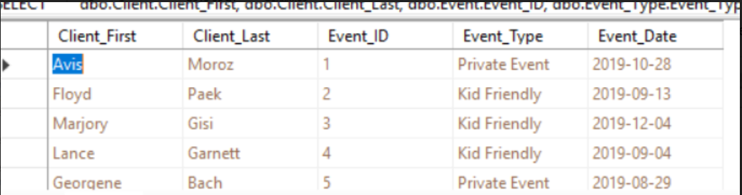

This report would be able to show the Client information, what type of event and the date of the event.

#### Query 2

SELECT dbo.Client.Client_First, dbo.Client.Client_Last, dbo.Event.Event_ID, dbo.Event_Type.Event_Type, dbo.Event_Date.Event_Date, dbo.Event.End_Time, dbo.Event.Start_Time, dbo.Service_Request.Service_Requested

Form dbo.Client INNER JOIN dbo.Event ON dbo.Client.Client_ID = dbo.Event.Client_ID INNER JOIN dbo.Event_Date ON dbo.Event.Event_ID = dbo.Event_Date.Event_ID INNER JOIN dbo.Service_Request ON dbo.Event.Event_ID = dbo.Service_Request.Event_ID

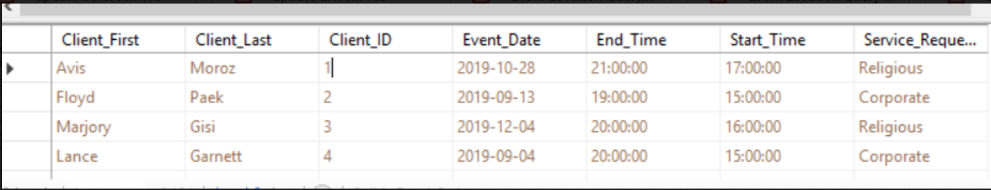

This report would show the Client names, the event start and end time and the type of service requested.

#### Query 3

SELECT dbo.Client.Client_ID, dbo.Client.Client_First, dbo.Client.Client_Last, dbo.Client_Location.City, dbo.Client_Type.New_Client, dbo.Client_Type.Returning_Client, dbo.Payment_Method.Payment_Amount, dbo.Payment_Method.Payemnt_Type

FORM dbo.Client INNER JOIN dbo.Cleint_Location ON dbo.Client.Client_ID = dbo.Client_Locaiton.Client_ID INNER JOIN dbo.Client_Type ON dbo.Client.Client_ID = dbo.Client_Type.Client_ID INNER JOIN dbo.Payment_Method ON dbo.Client.Client_ID = dbo.Payment_Method.Client_ID

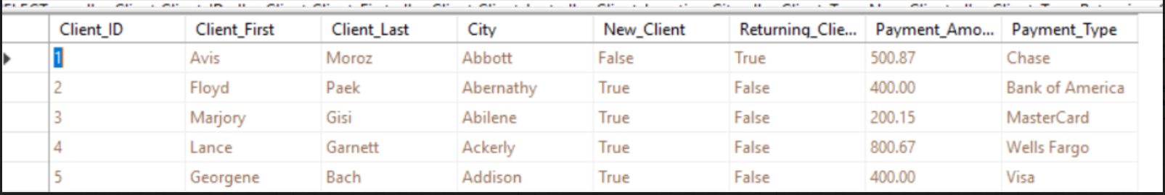

This report would show both types of client. It could be used to compared both types of client.

#### Query 4

SELECT dbo.Employee.First_Name, dbo.Employee.Last_Name, dbo.Employee.Employee_ID, dbo.Employee_Training_Status.Training_Status, dbo.Employee_Title.Emp_Title, dbo.Employee_Training_Request.Training_Date

FORM dbo.Employee INNER JOIN

Dbo.Employee.Training_Request ON dbo.Employee.Employee_ID = dbo.Employee_Training_Request.Employee_ID INNER JOIN

Dbo.Employee_Training_Request.Training_RequestID = dbo.Employee_Training_Status.Training_ID INNER JOIN

dbo.Employee_Tilte ON dbo.Employee.Employee_ID = dbo.Employee_Title.Employee_ID

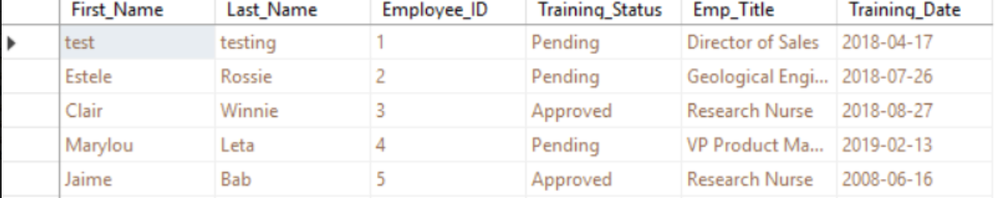

This report would show which employee has completed training, training status and what are their titles.

#### Query 5

SELECT dbo.Locations.Loaction_ID, dbo.Locations.City, dbo.Event.Event_ID

dbo.Event_Date.Event_Date, dbo.Event_Expenses.Service_Ceost, dbo.Event_Expenses.Services, dbo.Locations.State

FORM dbo.Event_Date INNER JOIN

dbo.Event On dbo.Event_Date.Event_ID = dbo.Event.Event_ID INNER JOIN

DBO.Event_Express ON dbo.Event.Event_ID = dbo.Event_Expenses.Event_ID CROSS JOIN

Dbo.Locations

WHERE (dbo.Locations.State=’TX’) AND (dbo.Location.City = ‘Houston’)

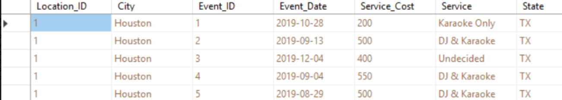

This report would compare expenses in Houston to other city.

### SQL Insert, Update, and Delete Scripts

#### Insert Script 1

Insert into Payment_Method(Payment_ID, Client_ID, Payment_Amount, Payment_Type)

Values(‘5’,’5’,’890.95’, ‘Chase’);

Figure 1. Before insert

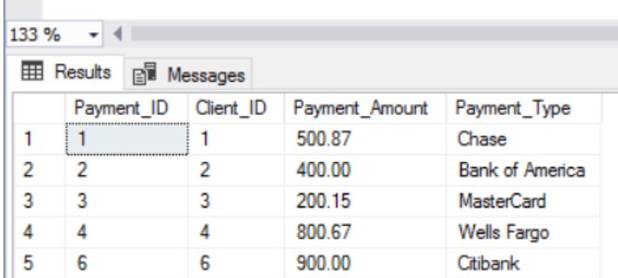

Figure 2. After insert

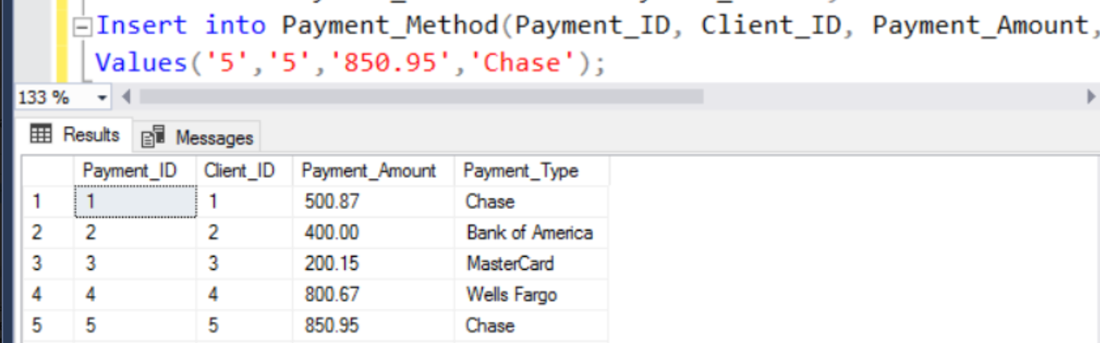

#### Insert Script 2

From ‘C:\Users\maabuba2\Desktop\Payment_Method.csv’

With

(

rowterminator=’\n’,

fieldterminator=’,’

)

Figure 3. bulk insert

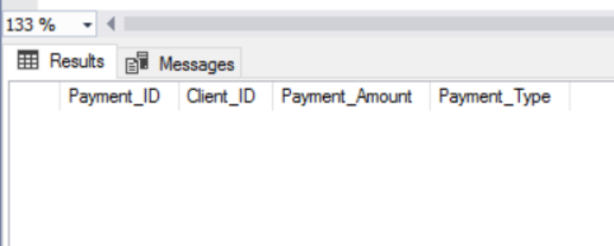

Figure 4. After bulk insert

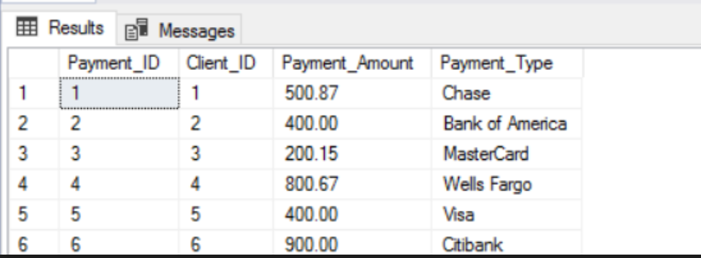

#### Update Script 1

Update Payment_Method set payment_Amount = 1000 where payment_ID = 2;

Figure 5. Before update script 1

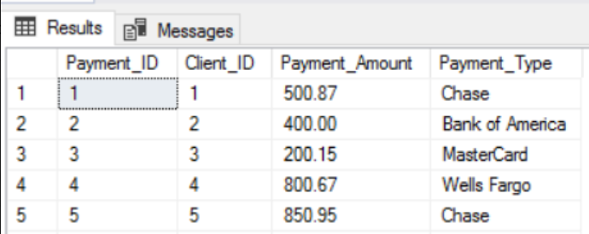

Figure 6. After update script 1

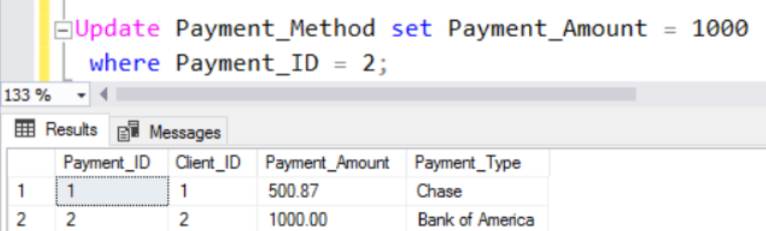

#### Update Script 2

Update Booking_Status set Booking_Status = ‘Confirmed’ where Booking_ID = 1;

Figure 7. Before update script 2

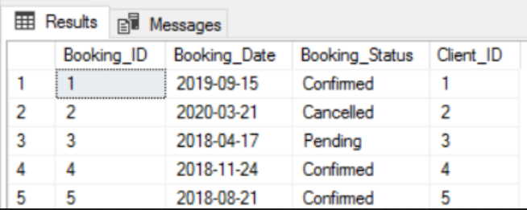

Figure 8. After update script 2

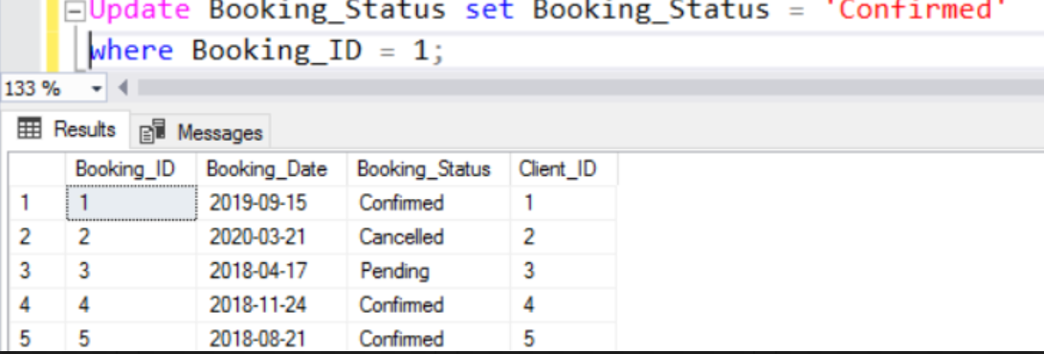

#### Delete Script 1

Delete Scripts

Delete Payment_Method;

Figure 9. Before delete script 1

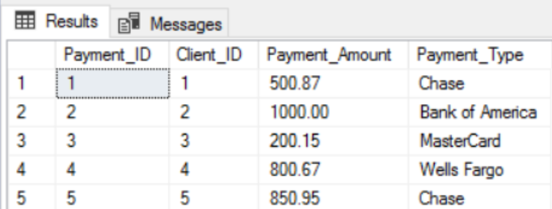

Figure 10. After delete script 1

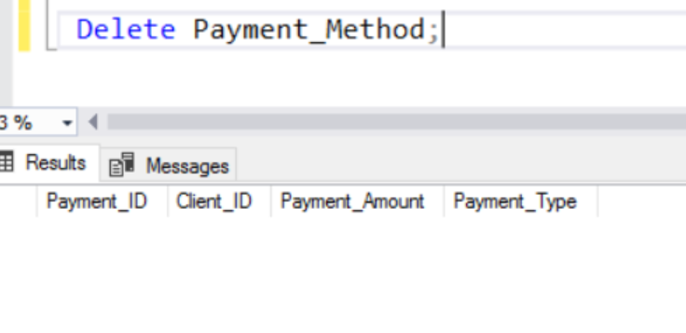

#### Delete Script 2

Figure 11. Before delete script 2

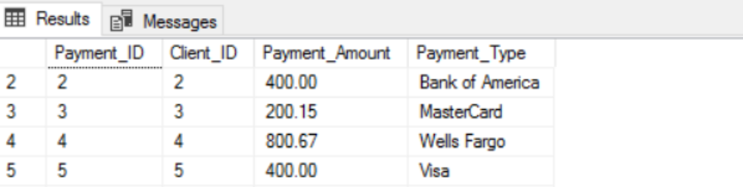

Figure 12. After delete script 2

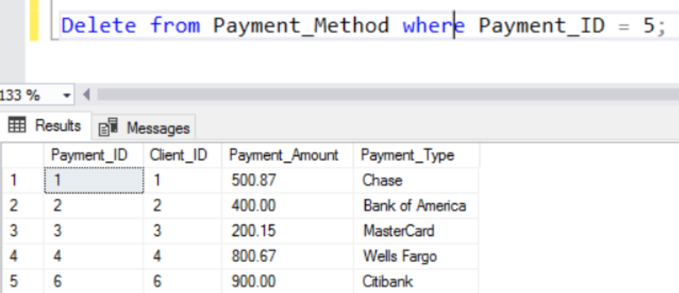

### GUI User View

#### Manage Vacation Requests View

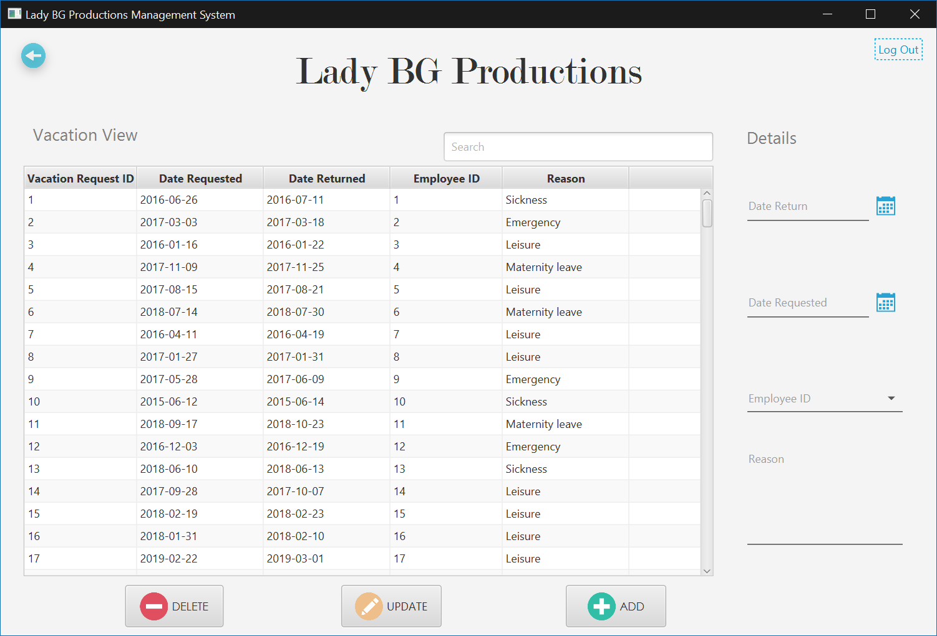

## Brady Acevedo

### Created Scripts

#### Event Expenses Table

Use LadyBG

create table Event_Expenses

(

Service_Requested varchar(50) not null Identity Primary Key,

State varchar(2) not null,

City varchar(25) not null,

Street varchar(50) not null,

Date_of_Event date not null,

Event_Start time(7) not null,

Event_End time(7) not null,

Event_Type varchar(5) not null

);

#### Event Report Table

Use LadyBG

create Table Event_Report

(

Client_ID int not null Identity Primary Key,

First_Name varchar(50) not null,

Last_Name varchar(50) not null,

Email varchar(50) not null,

Phone int not null,

Street varchar(50) not null,

City varchar(25) not null,

State varchar(2) not null,

Date_of_Event date not null,

Event_Start time(7) not null,

Event_End time(7) not null,

Even_Type varchar(50) not null,

Service_Requested varchar(5) not null,

Comments varchar(100));

#### Service Request Table

Use LadyBG

create Table Service_Request

(

Service_Requested varchar(50) not null Identity Primary Key,

Event_Type varchar(50) not null,

Comments varchar(100),

Date_of_Event date not null,

Event_Start time(7) not null,

Event_End time(7) not null,

);

#### Event Status Table

Use LadyBG

create Table Event_Status

(

Client_ID int not null Identity Primary Key,

Service_Requested varchar(50) not null,

Event_Type varchar(50) not null,

Comments varchar(100) not null,

Event_Start time(7) not null,

Event_End time(7) not null,

Email varchar(50) not null,

Phone int not null,

Street varchar(50) not null,

City varchar(25) not null,

State varchar(2) not null

EMP_ID int not null

);

### Alter Scripts

Alter table Event_Date

 Add Event_Date date not null;

Alter table Timesheet

 Drop column Work_Day;

Alter table Timesheet_Status

 Alter column Comments varchar;

### Bulk Insert Scripts

#### Event Date Insert

bulk insert Event_Date

from ‘C:\Users\baaceved\Downloads\Event_Date.csv’

with

(

rowterminator=’\n’,

fieldterminator=’,’

)

#### Payroll Insert

bulk insert Payroll

from ‘C:\Users\baaceved\Downloads\Payroll.csv’

with

(

rowterminator=’\n’,

fieldterminator=’,’

)

#### Timesheet_Status Insert

bulk insert Timesheet_Status

from ‘C:\Users\baaceved\Downloads\Timesheet_Status.csv’

with

(

rowterminator=’\n’,

fieldterminator=’,’

)

#### Timesheet Insert

bulk insert Timesheet

from ‘C:\Users\baaceved\Downloads\Timesheet.csv’

with

(

rowterminator=’\n’,

fieldterminator=’,’

)

### Data Records for Tables

#### Event Date Data

1,1,2019/10/28,22:00,0:47

2,2,2019/09/13,22:57,1:39

3,3,2019/12/04,20:58,0:35

4,4,2019/09/04,23:55,1:00

5,5,2019/08/29,22:41,1:52

6,6,2019/05/23,20:58,0:11

7,7,2019/08/15,22:50,1:04

8,8,2019/12/03,23:44,1:30

9,9,2019/07/11,23:28,1:05

10,10,2019/06/12,21:02,0:46

11,11,2019/05/20,20:06,0:57

12,12,2019/05/15,22:31,1:14

13,13,2019/10/25,20:18,0:01

14,14,2019/05/21,23:14,1:39

15,15,2019/11/23,20:22,1:09

16,16,2019/12/29,21:32,1:43

17,17,2019/10/26,22:40,1:20

18,18,2019/12/18,22:42,1:44

19,19,2019/06/05,23:27,0:04

20,20,2019/05/28,23:32,0:19

21,21,2019/08/24,20:56,1:32

22,22,2019/09/07,21:37,0:00

23,23,2019/06/06,23:54,1:46

24,24,2019/08/03,20:13,1:59

25,25,2019/11/19,23:18,1:23

26,26,2019/11/09,20:18,0:33

27,27,2019/06/24,21:07,0:03

28,28,2019/10/22,22:24,1:13

29,29,2019/12/10,21:23,1:26

30,30,2019/06/12,21:23,1:40

31,31,2019/09/15,23:30,1:11

32,32,2019/12/06,23:27,0:25

33,33,2019/12/01,20:12,0:09

34,34,2019/09/11,22:18,0:13

35,35,2019/11/24,23:57,1:21

36,36,2019/11/30,20:39,0:36

37,37,2019/10/16,21:04,0:27

38,38,2019/06/08,23:19,1:27

39,39,2019/12/02,22:03,1:05

40,40,2019/12/16,22:55,0:48

41,41,2019/10/30,20:24,1:43

42,42,2019/11/29,22:18,0:10

43,43,2019/10/02,22:12,0:18

44,44,2019/11/21,21:29,1:41

45,45,2019/07/29,20:48,0:20

46,46,2019/06/28,21:54,0:29

47,47,2019/07/26,20:43,1:36

48,48,2019/07/17,22:55,1:40

49,49,2019/06/25,22:30,1:59

50,50,2019/07/24,22:49,0:42

51,51,2019/11/17,23:16,1:01

52,52,2019/05/13,23:35,1:20

53,53,2019/05/15,20:42,0:01

54,54,2019/06/19,21:28,0:44

55,55,2019/07/13,21:56,0:00

56,56,2019/06/08,20:09,1:42

57,57,2019/08/15,23:40,0:27

58,58,2019/10/02,20:44,0:38

59,59,2019/12/02,23:33,0:30

60,60,2019/09/25,23:45,0:40

61,61,2019/08/07,21:52,1:57

62,62,2019/11/15,20:54,0:40

63,63,2019/10/27,23:57,1:59

64,64,2019/12/21,20:08,0:36

65,65,2019/05/01,22:53,1:43

66,66,2019/07/01,21:31,1:20

67,67,2019/08/28,21:17,1:10

68,68,2019/06/19,22:08,0:15

69,69,2019/09/30,21:25,1:39

70,70,2019/09/09,21:23,1:13

71,71,2019/10/27,23:14,0:35

72,72,2019/05/30,22:17,1:56

73,73,2019/07/13,21:35,1:58

74,74,2019/12/21,23:06,1:23

75,75,2019/05/01,22:05,1:43

76,76,2019/08/09,23:08,1:42

77,77,2019/10/16,20:01,1:53

78,78,2019/11/18,20:08,0:27

79,79,2019/07/22,23:29,1:18

80,80,2019/08/09,22:42,0:27

81,81,2019/05/23,23:09,0:02

82,82,2019/09/30,23:39,0:31

83,83,2019/07/31,23:18,0:10

84,84,2019/12/07,23:01,1:43

85,85,2019/05/23,23:42,1:54

86,86,2019/07/04,22:12,0:07

87,87,2019/06/13,20:18,1:44

88,88,2019/12/13,22:21,0:42

89,89,2019/12/20,23:19,0:18

90,90,2019/09/18,21:34,0:15

91,91,2019/08/14,23:57,0:15

92,92,2019/07/06,21:57,1:07

93,93,2019/10/20,20:42,1:20

94,94,2019/08/07,20:27,0:25

95,95,2019/09/11,22:17,0:36

96,96,2019/11/23,21:45,1:52

97,97,2019/10/15,23:11,0:57

98,98,2019/08/25,21:23,1:31

99,99,2019/12/02,21:08,0:06

100,100,2019/05/25,23:32,1:20

#### Payroll Data

1,1,21:38,1:06,56563

2,2,22:18,1:52,67208

3,3,20:40,1:37,48551

4,4,22:26,0:58,69187

5,5,23:24,1:55,73249

6,6,22:10,1:08,50504

7,7,23:02,1:18,49537

8,8,20:35,0:54,54480

9,9,22:44,1:43,58013

10,10,23:35,1:55,74169

11,11,20:36,1:54,71550

12,12,20:41,1:28,45132

13,13,22:43,1:16,47593

14,14,20:23,0:57,45425

15,15,21:11,0:21,53564

16,16,22:11,1:02,77884

17,17,21:54,0:47,65619

18,18,23:19,1:40,49745

19,19,20:39,0:09,48344

20,20,23:03,1:03,68745

21,21,23:31,0:32,48805

22,22,20:48,0:29,74795

23,23,22:13,0:41,46633

24,24,20:40,0:20,60767

25,25,23:50,0:17,47569

26,26,21:37,0:13,79090

27,27,21:13,0:57,69223

28,28,21:36,1:31,44494

29,29,23:49,1:55,43367

30,30,21:59,1:22,52838

31,31,21:19,1:24,69039

32,32,22:23,1:36,72016

33,33,22:12,0:16,70089

34,34,23:48,1:36,79163

35,35,22:26,1:32,69059

36,36,22:06,0:49,48276

37,37,20:54,1:11,55628

38,38,23:30,0:22,67446

39,39,20:27,0:44,40172

40,40,22:53,0:24,41699

41,41,20:39,1:58,58508

42,42,20:50,1:44,45555

43,43,22:50,0:50,76209

44,44,23:04,0:43,46311

45,45,20:49,0:37,44396

46,46,21:56,0:15,44207

47,47,23:34,0:46,74586

48,48,20:09,0:17,46969

49,49,20:06,0:07,73179

50,50,21:19,1:44,71555

51,51,21:29,0:06,47982

52,52,21:49,0:26,49559

53,53,20:16,0:29,49979

54,54,21:21,1:22,59687

55,55,23:52,1:24,51335

56,56,21:50,0:13,76404

57,57,22:27,1:53,72100

58,58,21:22,1:18,58148

59,59,20:47,1:33,46149

60,60,22:38,1:33,52896

61,61,21:16,1:34,72545

62,62,23:56,0:52,73247

63,63,22:00,1:27,71831

64,64,22:46,1:14,63284

65,65,23:21,0:31,43974

66,66,22:31,0:56,71361

67,67,22:20,0:40,67169

68,68,22:34,0:33,40916

69,69,22:50,1:34,77321

70,70,20:11,1:00,65229

71,71,23:11,1:14,51422

72,72,22:58,0:48,53951

73,73,23:22,1:27,59246

74,74,22:29,1:54,57182

75,75,20:58,1:47,66703

76,76,22:45,0:31,40170

77,77,21:33,1:18,66367

78,78,22:13,0:03,43527

79,79,21:52,1:35,62049

80,80,21:01,0:12,59546

81,81,21:20,1:30,51925

82,82,21:21,0:42,64690

83,83,20:27,1:25,67517

84,84,23:22,1:55,64572

85,85,21:10,0:55,56455

86,86,22:50,0:21,70065

87,87,23:12,0:51,55226

88,88,20:52,1:42,53141

89,89,22:23,0:54,69623

90,90,20:38,1:13,47827

91,91,21:24,1:42,42280

92,92,21:56,0:51,43677

93,93,21:33,1:37,55508

94,94,21:25,0:19,48305

95,95,21:58,1:40,48692

96,96,22:02,0:54,47912

97,97,20:07,1:06,63832

98,98,21:09,0:19,57535

99,99,20:19,1:46,72035

100,100,20:48,0:40,44046

#### Timesheet Status Data

1,1,Pending

2,2,Recorded

3,3,Pending

4,4,Pending

5,5,Pending

6,6,Pending

7,7,Pending

8,8,Recorded

9,9,Pending

10,10,Pending

11,11,Pending

12,12,Pending

13,13,Pending

14,14,Pending

15,15,Recorded

16,16,Recorded

17,17,Pending

18,18,Pending

19,19,Recorded

20,20,Pending

21,21,Recorded

22,22,Pending

23,23,Pending

24,24,Pending

25,25,Pending

26,26,Recorded

27,27,Pending

28,28,Recorded

29,29,Pending

30,30,Pending

31,31,Pending

32,32,Pending

33,33,Recorded

34,34,Pending

35,35,Pending

36,36,Pending

37,37,Pending

38,38,Pending

39,39,Recorded

40,40,Recorded

41,41,Pending

42,42,Recorded

43,43,Pending

44,44,Pending

45,45,Recorded

46,46,Pending

47,47,Pending

48,48,Recorded

49,49,Pending

50,50,Pending

51,51,Recorded

52,52,Recorded

53,53,Pending

54,54,Recorded

55,55,Recorded

56,56,Pending

57,57,Recorded

58,58,Recorded

59,59,Pending

60,60,Recorded

61,61,Recorded

62,62,Pending

63,63,Recorded

64,64,Pending

65,65,Pending

66,66,Recorded

67,67,Pending

68,68,Pending

69,69,Pending

70,70,Recorded

71,71,Pending

72,72,Recorded

73,73,Recorded

74,74,Pending

75,75,Pending

76,76,Pending

77,77,Recorded

78,78,Pending

79,79,Recorded

80,80,Pending

81,81,Pending

82,82,Recorded

83,83,Pending

84,84,Recorded

85,85,Pending

86,86,Pending

87,87,Recorded

88,88,Recorded

89,89,Pending

90,90,Pending

91,91,Pending

92,92,Recorded

93,93,Recorded

94,94,Recorded

95,95,Recorded

96,96,Pending

97,97,Recorded

98,98,Pending

99,99,Recorded

100,100,Recorded

#### Timesheet Data

1,1,2019/12/16,23:41,1:10

2,2,2019/12/10,22:46,0:39

3,3,2019/07/14,22:40,1:54

4,4,2019/11/28,22:28,1:00

5,5,2019/10/31,21:32,1:58

6,6,2019/09/28,23:42,1:43

7,7,2019/12/29,23:22,1:55

8,8,2019/08/01,23:06,1:10

9,9,2019/11/01,22:12,1:42

10,10,2019/11/08,22:41,0:06

11,11,2019/12/10,21:51,0:52

12,12,2019/12/13,23:23,0:47

13,13,2019/06/07,21:27,0:02

14,14,2019/06/15,23:41,1:13

15,15,2019/11/28,20:31,0:05

16,16,2019/06/11,21:46,1:10

17,17,2019/11/11,21:54,0:41

18,18,2019/11/04,23:17,1:52

19,19,2019/05/26,21:22,1:40

20,20,2019/12/20,22:33,0:13

21,21,2019/10/05,20:50,0:29

22,22,2019/07/22,21:02,1:32

23,23,2019/10/17,23:10,0:48

24,24,2019/10/13,21:23,1:35

25,25,2019/07/05,21:51,0:58

26,26,2019/12/29,20:33,1:53

27,27,2019/06/27,21:44,0:00

28,28,2019/12/03,21:07,1:21

29,29,2019/06/22,20:10,0:22

30,30,2019/07/26,20:48,1:11

31,31,2019/07/13,23:27,0:33

32,32,2019/10/14,20:43,0:02

33,33,2019/10/13,23:04,0:39

34,34,2019/08/24,23:01,0:58

35,35,2019/09/11,23:14,0:49

36,36,2019/12/21,23:31,1:24

37,37,2019/05/20,22:59,0:18

38,38,2019/10/15,21:32,0:07

39,39,2019/07/19,21:40,1:59

40,40,2019/09/22,23:57,1:31

41,41,2019/12/30,22:28,1:52

42,42,2019/08/03,22:12,0:59

43,43,2019/08/14,21:14,1:56

44,44,2019/07/31,21:32,1:31

45,45,2019/09/26,21:14,1:07

46,46,2019/11/20,23:38,0:03

47,47,2019/09/18,22:38,0:48

48,48,2019/10/23,20:17,1:24

49,49,2019/10/23,22:59,0:17

50,50,2019/12/11,22:32,1:31

51,51,2019/08/13,21:19,1:29

52,52,2019/11/27,23:33,0:49

53,53,2019/08/16,20:17,0:52

54,54,2019/10/06,23:22,1:52

55,55,2019/09/26,21:57,0:38

56,56,2019/05/31,23:02,1:28

57,57,2019/12/02,23:21,0:09

58,58,2019/06/14,23:37,1:57

59,59,2019/07/29,21:53,1:08

60,60,2019/05/28,20:41,0:18

61,61,2019/10/26,21:01,1:50

62,62,2019/07/10,20:40,1:31

63,63,2019/12/26,20:45,0:02

64,64,2019/10/06,21:13,0:37

65,65,2019/12/19,21:09,0:44

66,66,2019/08/05,20:05,0:15

67,67,2019/12/25,21:41,1:57

68,68,2019/08/28,21:09,0:51

69,69,2019/09/21,21:05,1:21

70,70,2019/06/24,21:44,0:42

71,71,2019/10/25,20:47,0:52

72,72,2019/07/07,21:58,0:27

73,73,2019/07/07,21:12,0:41

74,74,2019/07/29,20:26,1:46

75,75,2019/07/29,20:55,0:08

76,76,2019/06/13,21:26,0:33

77,77,2019/10/20,20:11,0:14

78,78,2019/12/20,20:14,0:35

79,79,2019/09/20,23:27,1:48

80,80,2019/05/31,22:14,1:40

81,81,2019/09/01,20:13,1:45

82,82,2019/07/20,21:44,1:34

83,83,2019/07/28,20:50,0:40

84,84,2019/10/12,22:58,0:45

85,85,2019/10/02,22:13,0:05

86,86,2019/09/11,21:34,1:26

87,87,2019/07/03,22:03,0:23

88,88,2019/09/03,22:36,0:18

89,89,2019/07/31,21:54,0:26

90,90,2019/08/25,20:40,0:47

91,91,2019/06/27,22:16,0:52

92,92,2019/07/12,20:02,1:41

93,93,2019/08/13,20:25,0:09

94,94,2019/12/23,20:27,1:59

95,95,2019/08/02,21:07,0:27

96,96,2019/06/07,22:07,1:46

97,97,2019/10/26,21:19,0:53

98,98,2019/11/04,20:28,0:17

99,99,2019/09/03,23:02,0:30

100,100,2019/06/17,20:23,1:16

### SQL Report Queries

#### Query 1

SELECT dbo.Client.Client_ID, dbo.Event.Event_ID, dbo.Event.Client_ID AS Expr1, dbo.Event_Expenses.Event_ID AS Expr2, dbo.Event_Status.Status_ID, dbo.Client.Client_First, dbo.Client.Client_Last,

dbo.Client.Client_Comments

FROM dbo.Client INNER JOIN

dbo.Event ON dbo.Client.Client_ID = dbo.Event.Client_ID INNER JOIN

dbo.Event_Expenses ON dbo.Event.Event_ID = dbo.Event_Expenses.Event_ID INNER JOIN

dbo.Event_Status ON dbo.Event.Event_ID = dbo.Event_Status.Event_ID

**This query combines the tables Client, Event, Event_Expenses, Event_Status**

**It extracts from Client the Client_ID, Client_First, Client_Last , Event, Event_Expenses, and Status_ID**

**It is useful to charge the client a cancelling fee if the event status turns to canceled**

#### Query 2

SELECT dbo.Client.Client_ID, dbo.Payment_Method.Client_ID AS Expr1, dbo.Booking_Status.Client_ID AS Expr2, dbo.Client_Type.Client_ID AS Expr3, dbo.Client.Client_First, dbo.Client.Client_Last

FROM dbo.Client INNER JOIN

dbo.Payment_Method ON dbo.Client.Client_ID = dbo.Payment_Method.Client_ID INNER JOIN

dbo.Client_Type ON dbo.Client.Client_ID = dbo.Client_Type.Client_ID INNER JOIN

dbo.Booking_Status ON dbo.Client.Client_ID = dbo.Booking_Status.Client_ID

**This query combines the tables Client, Client_Type, Payment_Method, and Booking Status**

**It extracts from Client the Client_ID, Client_First, Client_Last**

**This is useful to determine the type of client (such as a returning customer) and gives the booking status**

#### Query 3

SELECT dbo.Client.Client_ID, dbo.Client.Client_First, dbo.Client.Client_Last, dbo.Payment_Method.Client_ID AS Expr1, dbo.Client_Location.Client_ID AS Expr2, dbo.Event.Client_ID AS Expr3

FROM dbo.Client INNER JOIN

dbo.Payment_Method ON dbo.Client.Client_ID = dbo.Payment_Method.Client_ID INNER JOIN

dbo.Client_Location ON dbo.Client.Client_ID = dbo.Client_Location.Client_ID INNER JOIN

dbo.Event ON dbo.Client.Client_ID = dbo.Event.Client_ID

**This query combines the tables, Client, Payment_Method, Client_Location, Event**

**It extracts from Client the Client_ID, Client_First, Client_Last**

**It is useful to generate a mini report that could be referenced on sight at an event to verify important details**

#### Query 4

SELECT dbo.Employee.First_Name, dbo.Employee.Employee_ID, dbo.Employee.Middle_Name, dbo.User_Info.Employee_ID AS Expr1, dbo.Employee_Type.Employee_ID AS Expr2,

dbo.Employee_Title.Employee_ID AS Expr3

FROM dbo.Employee INNER JOIN

dbo.User_Info ON dbo.Employee.Employee_ID = dbo.User_Info.Employee_ID INNER JOIN

dbo.Employee_Title ON dbo.Employee.Employee_ID = dbo.Employee_Title.Employee_ID INNER JOIN

dbo.Employee_Type ON dbo.Employee.Employee_ID = dbo.Employee_Type.Employee_ID

**This query combines from tables Employee, User_Info, Employee_Type, Empoyee_Title**

**It extracts from Employee the Employee_ID, First_Name, Middle_Name**

**It is useful to identify the type of Employee and their Title**

#### Query 5

SELECT dbo.Employee.Employee_ID, dbo.Timesheet.Employee_ID AS Expr1, dbo.Vacation_Request.Employee_ID AS Expr2, dbo.Employee_Status.Employee_ID AS Expr3, dbo.Employee.First_Name,

dbo.Employee.Last_Name, dbo.Employee.Middle_Name

FROM dbo.Employee INNER JOIN

dbo.Timesheet ON dbo.Employee.Employee_ID = dbo.Timesheet.Employee_ID INNER JOIN

dbo.Vacation_Request ON dbo.Employee.Employee_ID = dbo.Vacation_Request.Employee_ID INNER JOIN

dbo.Employee_Status ON dbo.Employee.Employee_ID = dbo.Employee_Status.Employee_ID

**This query combines the tables Employee, Timesheet, Vacation_Request, Employee Status**

**It extracts from Employee Employee_ID, First_Name, Middle_Name, Last_Name**

**It is useful to verify the vacation status of an employee and cross reference with the timesheet**

### SQL Insert, Update, and Delete Scripts

#### Insert Script 1

Insert into Payroll(Payroll_ID, Time_In, Time_Out, Timesheet_ID, Wage)

Values (101, '22:00', '1:00', 1 , 20)

Figure 1. Before *Payroll Insert*

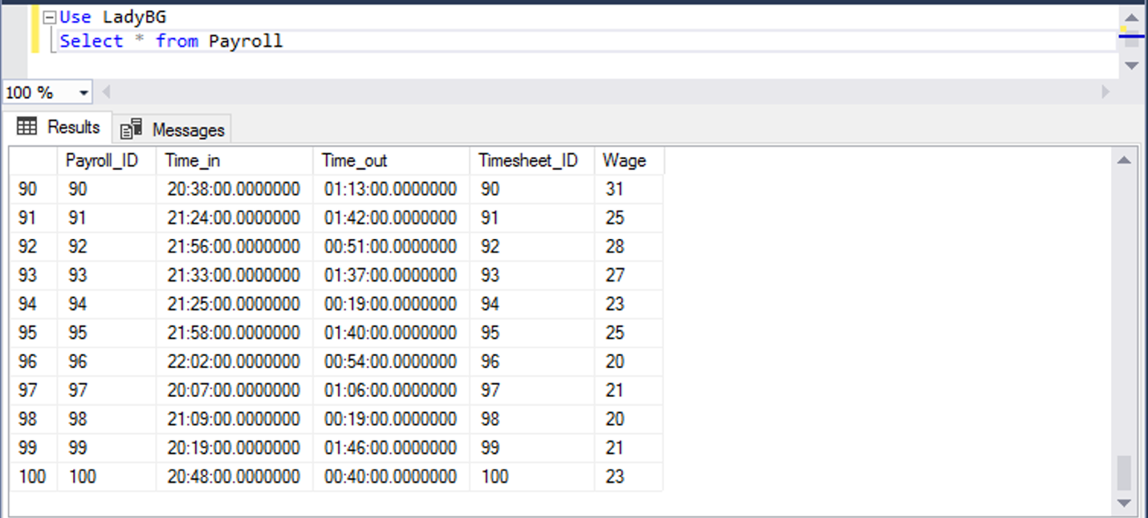

Figure 2. After *Payroll Insert*

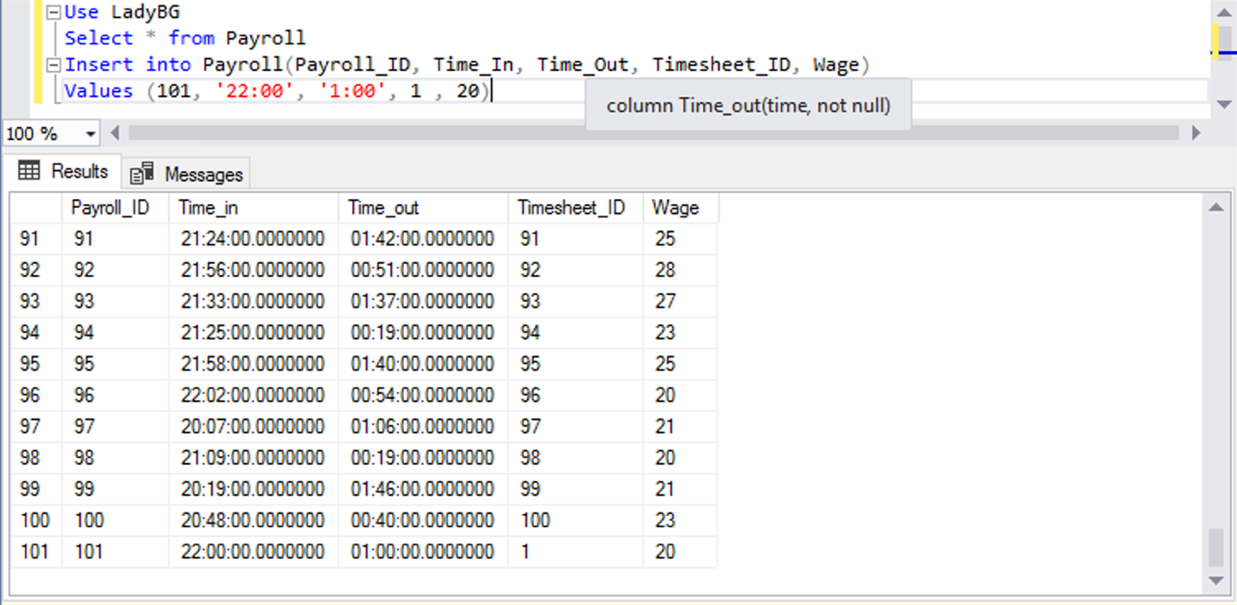

#### Insert Script 2

Insert into Timesheet(Timesheet_ID, Employee_ID, Work_Day, Time_In, Time_Out)

Values (101, 55, '2019/08/13', '20:15' , 1:40)

Figure 1. *Before Timesheet Insert*

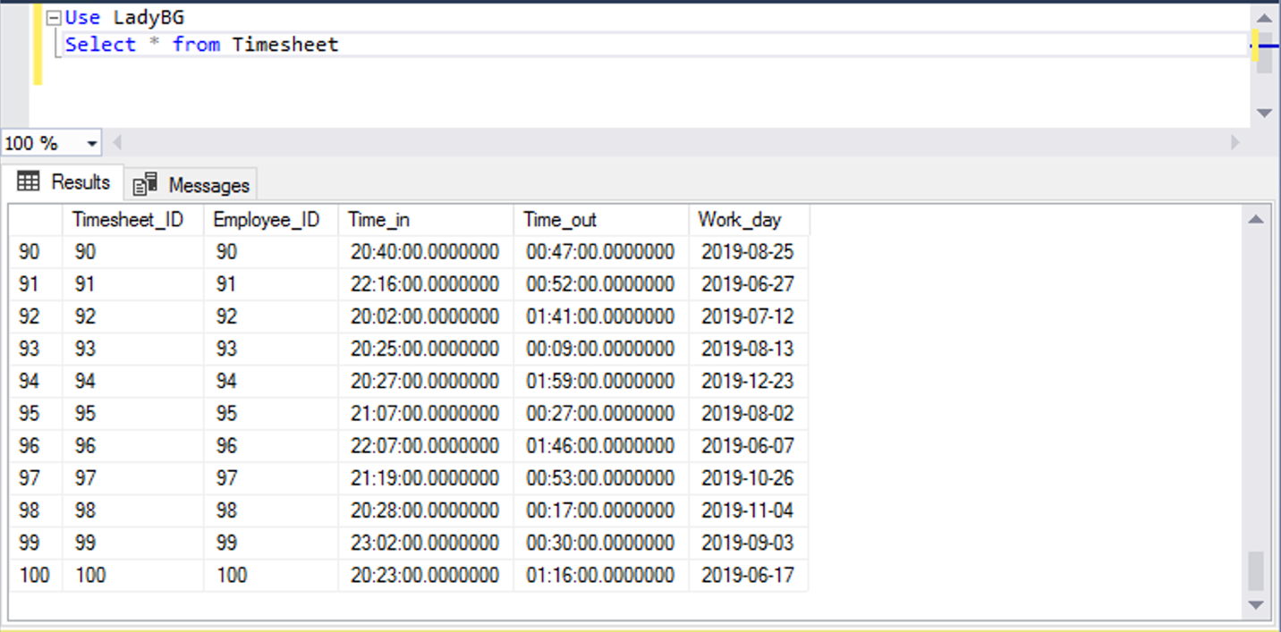

Figure 2. *After Timesheet Insert*

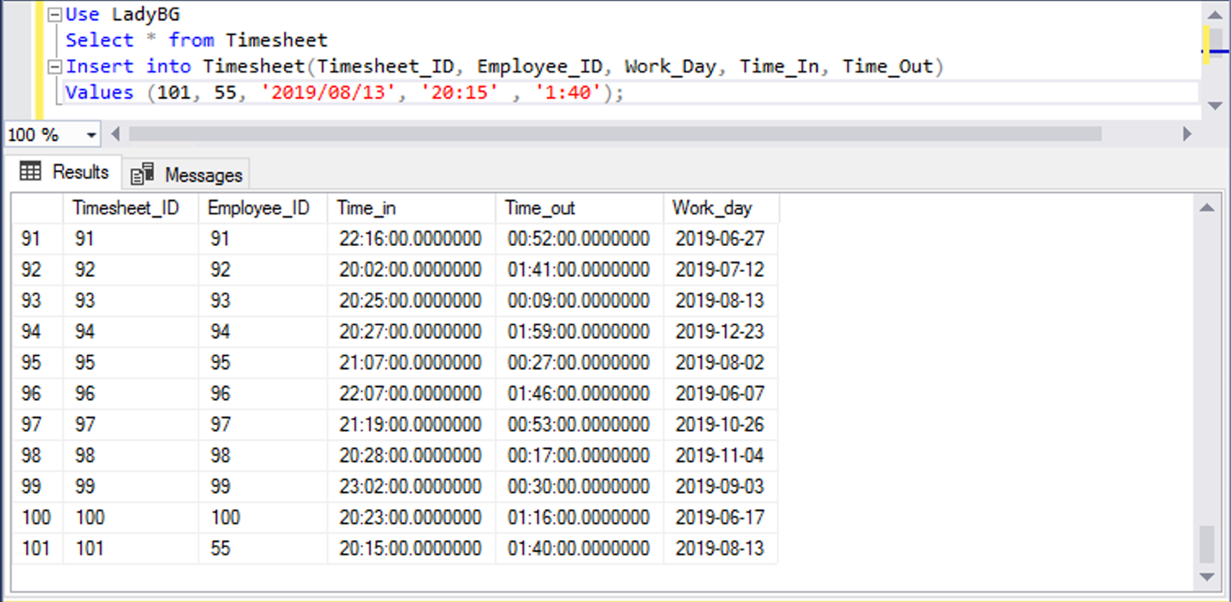

#### Update Script 1

Update Payroll

set Wage = 20

where Payroll_ID = 1;

Figure 1. *Before Payroll Update*

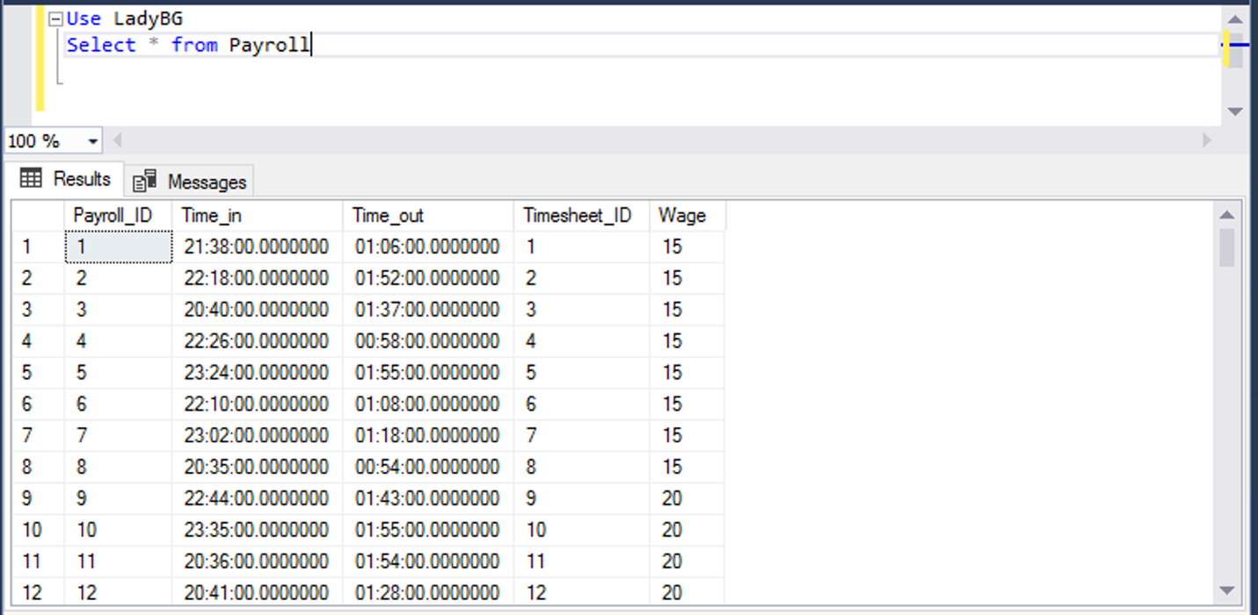

Figure 2. *After Payroll Update*

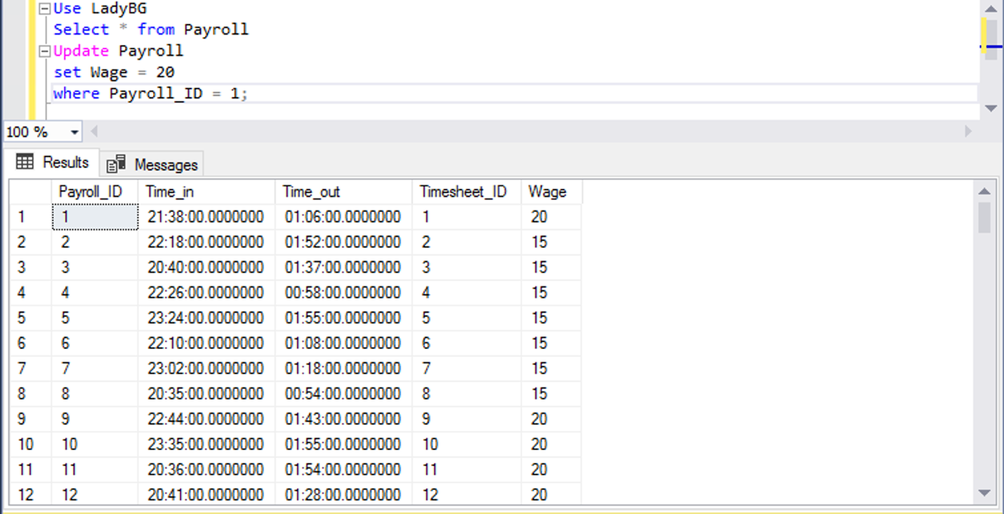

#### Update Script 2

Update Timesheet

set Time_In = 22

where Timesheet_ID = 1;

Figure 1. *Before Timesheet Update*

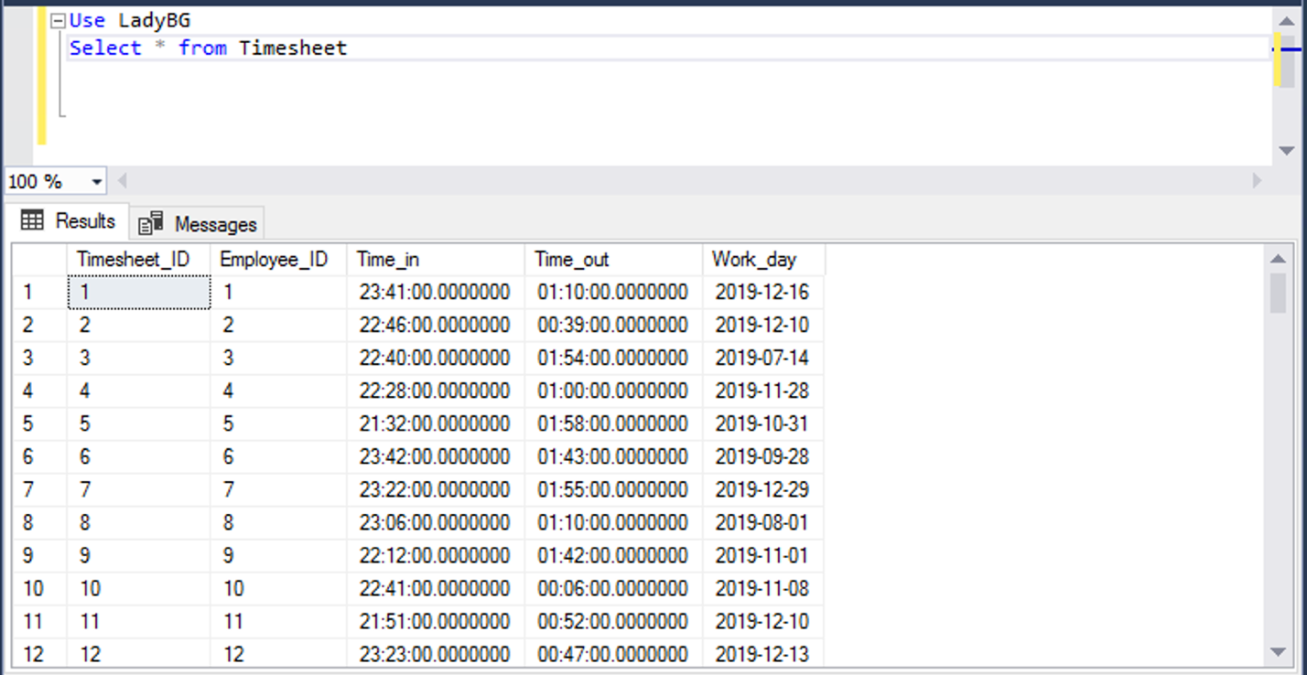

Figure 2. *After Timesheet Update*

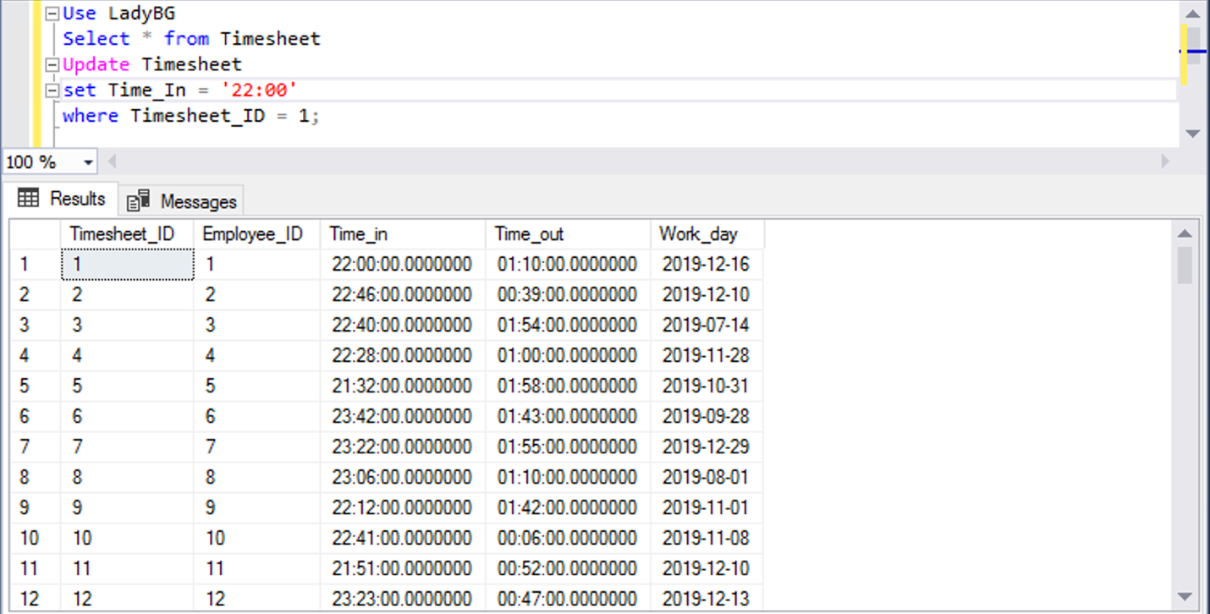

#### Delete Script 1

Delete from Payroll;

where Payroll_ID = 101;

Figure 1. *Before Payroll Delete*

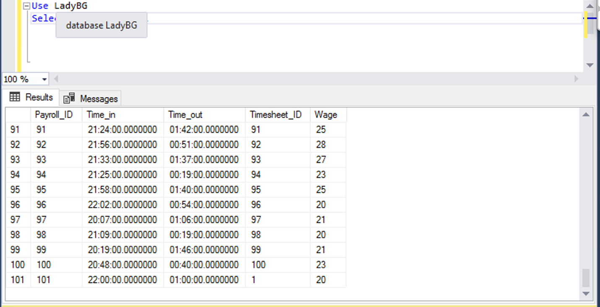

Figure 2. *After Payroll Delete*

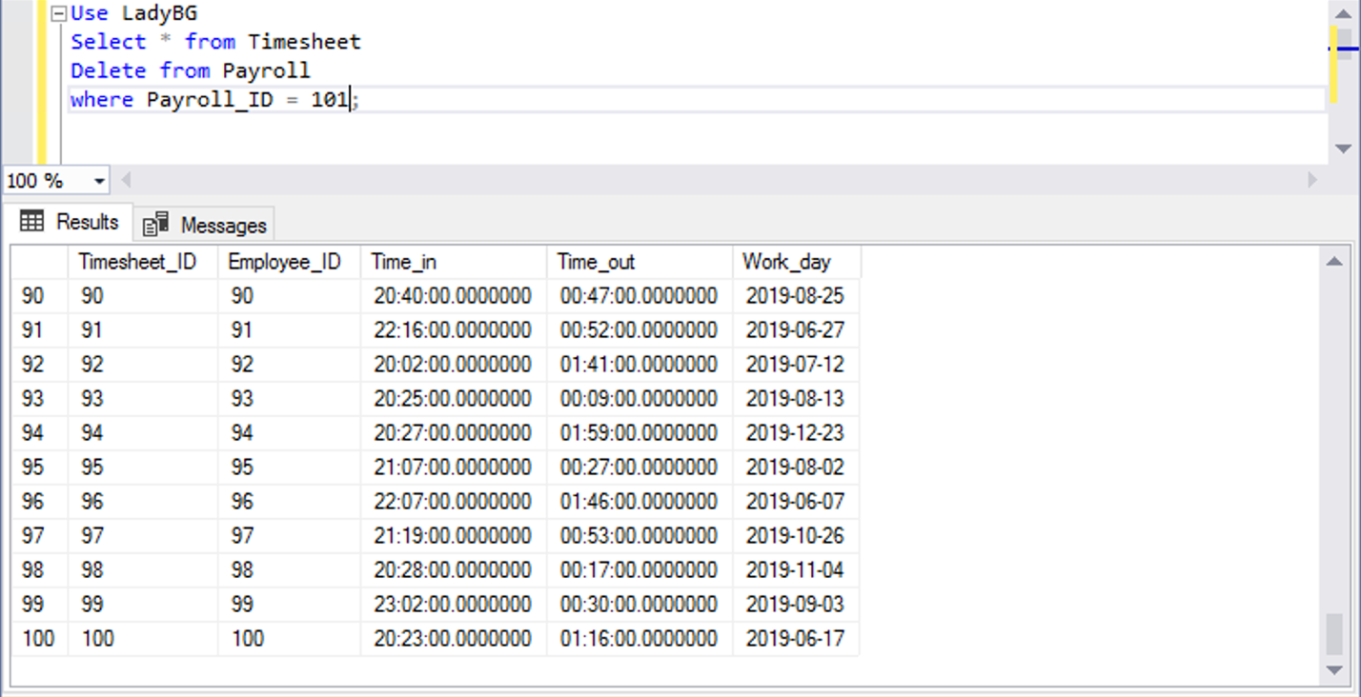

#### Delete Script 2

Delete from Timesheet;

where Timesheet_ID = 101;

Figure 1. *Before Timesheet Delete*

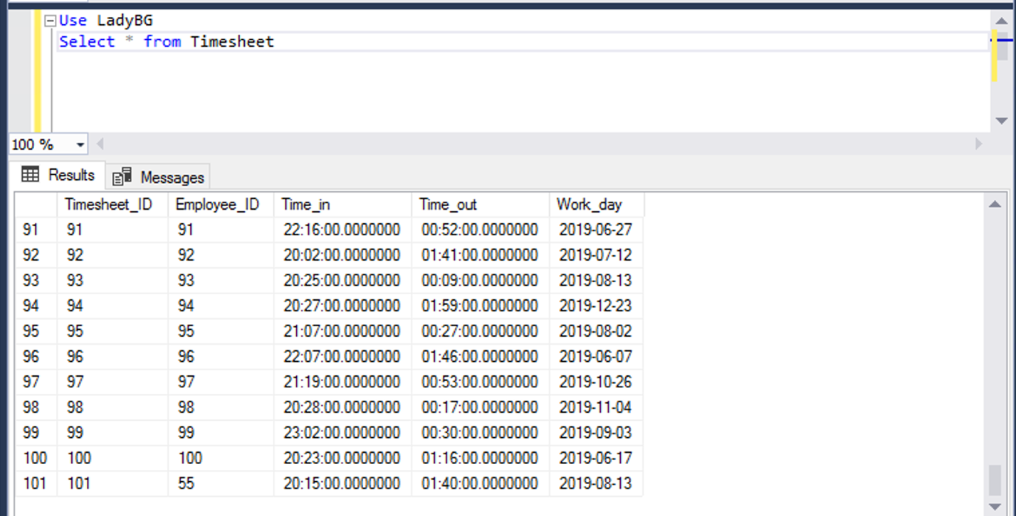

Figure 2. *After Timesheet Delete*

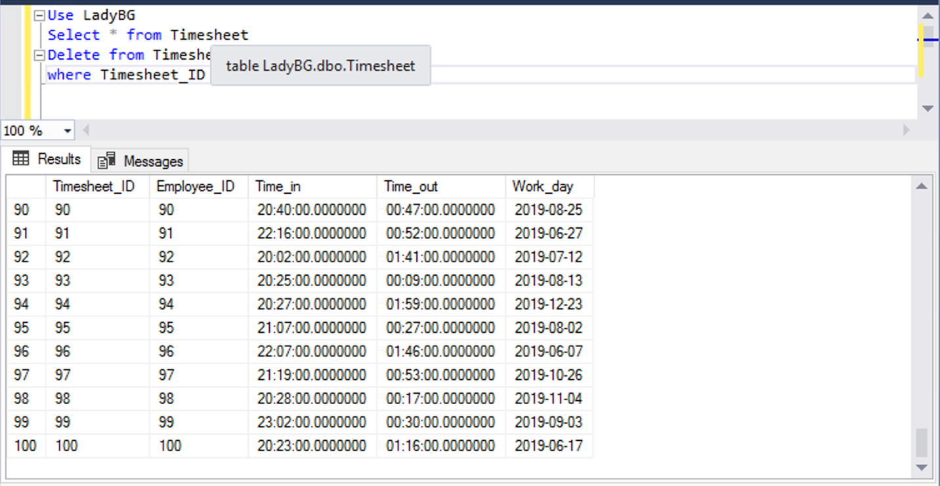

### GUI User Views

#### Manage Timesheets View

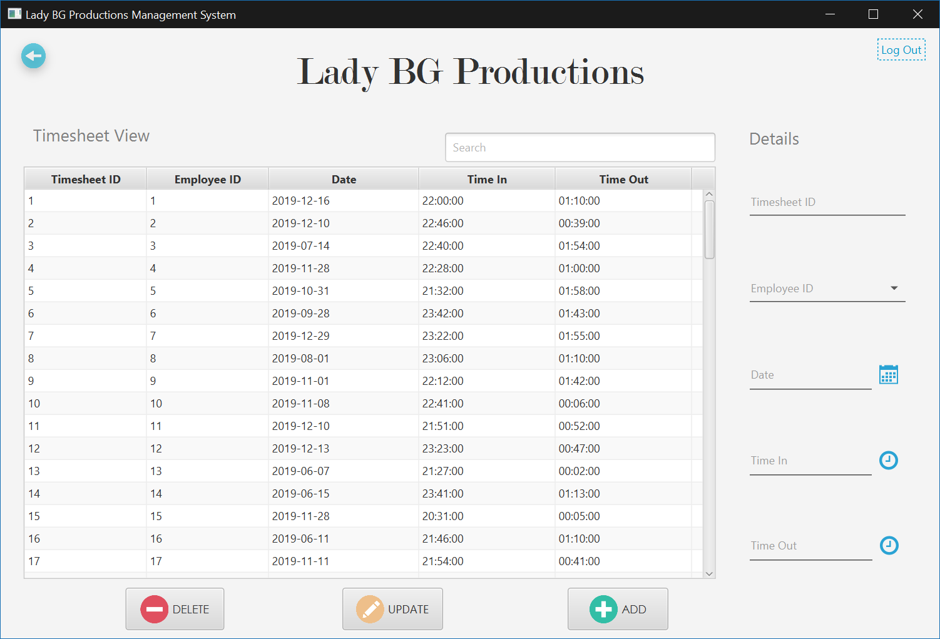

## Samuel Ekpe

### Create Scripts

#### Event Location Table

CREATE TABLE Event_Location (

LOCATION_ID int not null,

EVENT_ID int not null,

STREET_ADDRESS varchar(25),

CITY varchar(25),

STATE varchar(2),

POSTAL varchar(10),

);

#### Employee Type Table

CREATE TABLE Employee_Type (

EMPLOYEE_ID int not null,

NEW_EMP bit not null,

RETURNING_EMP bit not null,

#### Service Requested Table

CREATE TABLE Service_Requested (

REQUEST_ID int not null,

EVENT_ID int not null,

SERVICE_REQUESTED varchar(25),

);

#### Songs Table

CREATE TABLE Songs (

SONG_ID int not null,

SONG_NAME varchar(25) not null,

ARTIST_NAME varchar(25) not null,

ALBUM_NAME varchar(25) null,

GENRE_TYPE varchar(25) not null,

);

### Alter Scripts

Alter table Phone_number

 Add constraint Fk_Phone_Number

   Foreign key(Phone_Number) references Client(Client_ID);

Alter table Postal_Code

 Add constraint Fk_Postal_Code

   Foreign key(Postal_Code) references Client(Client_ID);

Alter table Location

 Add constraint Fk_Location_ID

   Foreign key(Location_ID) references Client(Client_ID);

### Bulk Inserts

#### Event Location table bulk insert

bulk insert Event_Location

from 'C:\Users\srekpe\Downloads\Event_Location.csv'

with

(

rowterminator='\n',

fieldterminator=','

)

#### Service Requested table bulk insert

bulk insert Service_Requested

from 'C:\Users\ srekpe\Downloads\Service_Requested.csv'

with

(

rowterminator='\n',

fieldterminator=','

)

#### Vacation Request table bulk insert

bulk insert Vacation_Request

from 'C:\Users\srekpe\Downloads\Vacation_Request.csv'

with

(

rowterminator='\n',

fieldterminator=','

)

#### Vacation Status table bulk insert

bulk insert Vacation_Request

from 'C:\Users\JANGO\Downloads\Vacation_Request.csv'

with

(

rowterminator='\n',

fieldterminator=','

)

### Data Records

#### Event Location table data records

1,Austin,1,78759,TX,6972 Anzinger Junction

2,Aiken,2,29805,SC,66 Memorial Court

3,Saint Joseph,3,64504,MO,02800 Chinook Pass

4,Peoria,4,61656,IL,218 Dwight Pass

5,Tulsa,5,74103,OK,36 Grim Lane

6,New Orleans,6,70142,LA,2278 Green Ridge Park

7,Clearwater,7,34629,FL,3355 Dapin Way

8,Fort Lauderdale,8,33320,FL,971 Sunnyside Avenue

9,Newark,9,7104,NJ,04 Vera Junction

10,Washington,10,20057,DC,14669 Main Court

11,Johnstown,11,15906,PA,67 Victoria Drive

12,Sacramento,12,95813,CA,67 New Castle Plaza

13,San Francisco,13,94105,CA,16612 Parkside Trail

14,Washington,14,20470,DC,3619 Vidon Road

15,Wichita,15,67210,KS,333 Magdeline Street

16,Johnson City,16,37605,TN,124 Gateway Hill

17,Tulsa,17,74108,OK,4 Katie Crossing

18,Inglewood,18,90398,CA,571 Charing Cross Point

19,New York City,19,10014,NY,776 Kings Alley

20,Omaha,20,68110,NE,411 American Ash Center

21,Houston,21,77234,TX,8981 Buena Vista Street

22,Greenville,22,29610,SC,45 Chive Park

23,New Haven,23,6538,CT,8 Pierstorff Park

24,Houston,24,77030,TX,89 Thompson Center

25,Jackson,25,38308,TN,090 Derek Road

26,Indianapolis,26,46221,IN,7656 Blackbird Street

27,San Francisco,27,94159,CA,56170 Del Sol Street

28,Dallas,28,75205,TX,2756 Stoughton Circle

29,New York City,29,10045,NY,90843 Namekagon Plaza

30,Savannah,30,31410,GA,032 Sommers Center

31,Washington,31,20078,DC,7749 Sheridan Park

32,Kansas City,32,64193,MO,3 Meadow Ridge Hill

33,Baltimore,33,21216,MD,1656 Aberg Drive

34,Syracuse,34,13205,NY,59 Londonderry Lane

35,Albany,35,31704,GA,37895 Stoughton Way

36,New York City,36,10184,NY,1062 Warner Circle

37,Colorado Springs,37,80925,CO,1 Jenifer Way

38,Vancouver,38,98687,WA,6368 Hoffman Lane

39,Fort Worth,39,76134,TX,75 Carpenter Way

40,Long Beach,40,90847,CA,777 Stang Hill

41,Louisville,41,40250,KY,802 Daystar Hill

42,Bridgeport,42,6673,CT,9186 Green Ridge Terrace

43,Springfield,43,1105,MA,6 Almo Parkway

44,Lake Worth,44,33462,FL,2 Kenwood Avenue

45,Colorado Springs,45,80930,CO,9431 David Street

46,Riverside,46,92505,CA,2 Portage Street

47,Las Vegas,47,89145,NV,850 Columbus Place

48,Nashville,48,37250,TN,6553 Miller Hill

49,Chandler,49,85246,AZ,71 Jana Pass

50,Erie,50,16534,PA,92448 Swallow Crossing

51,San Antonio,51,78291,TX,92 Scott Alley

52,Jersey City,52,7310,NJ,1939 Sachs Pass

53,Oceanside,53,92056,CA,3546 Garrison Point

54,Lincoln,54,68531,NE,032 Petterle Junction

55,Troy,55,48098,MI,93 Chive Center

56,Richmond,56,23213,VA,8 Village Green Point

57,Buffalo,57,14220,NY,4 Troy Parkway

58,Tucson,58,85732,AZ,26651 Sunbrook Road

59,Greenville,59,29615,SC,06 Meadow Valley Drive

60,Hartford,60,6152,CT,4 Forest Run Street

61,Cleveland,61,44197,OH,9 Packers Circle

62,Shreveport,62,71105,LA,756 Chinook Park

63,Gainesville,63,32627,FL,4804 Glendale Junction

64,Portland,64,97240,OR,88 Bluejay Place

65,Corona,65,92878,CA,959 Anderson Park

66,Metairie,66,70033,LA,908 Florence Lane

67,Winston Salem,67,27157,NC,629 Milwaukee Point

68,Louisville,68,40266,KY,8592 Bay Park

69,Reston,69,20195,VA,795 International Court

70,Memphis,70,38168,TN,3973 Elmside Plaza

71,Des Moines,71,50310,IA,7 Clarendon Alley

72,Austin,72,78715,TX,188 Sunfield Junction

73,Bridgeport,73,6606,CT,5 Luster Crossing

74,Phoenix,74,85040,AZ,10369 Merry Park

75,Lakeland,75,33811,FL,97 Cordelia Junction

76,Fort Lauderdale,76,33305,FL,138 Grim Lane

77,Tyler,77,75799,TX,9 Maywood Pass

78,Columbia,78,29208,SC,588 Bluejay Drive

79,Fresno,79,93704,CA,32 Crownhardt Junction

80,Houston,80,77223,TX,46741 Buhler Crossing

81,Anaheim,81,92812,CA,7696 Rowland Point

82,Bronx,82,10454,NY,63092 Muir Park

83,Ocala,83,34479,FL,65767 Sutteridge Drive

84,Washington,84,20210,DC,508 Sherman Place

85,Honolulu,85,96815,HI,1 Sundown Circle

86,Birmingham,86,35220,AL,99 Elka Circle

87,San Diego,87,92110,CA,495 Dennis Crossing

88,Paterson,88,7505,NJ,98226 Browning Street

89,Milwaukee,89,53234,WI,122 Hudson Way

90,San Antonio,90,78235,TX,733 Havey Center

91,Salt Lake City,91,84105,UT,06734 Morningstar Street

92,Pittsburgh,92,15215,PA,1 Spaight Circle

93,Winter Haven,93,33884,FL,78 Oriole Plaza

94,Lafayette,94,70505,LA,517 Fair Oaks Center

95,Baltimore,95,21216,MD,94 Daystar Drive

96,Montgomery,96,36109,AL,7187 Bartelt Terrace

97,New Orleans,97,70183,LA,81 4th Crossing

98,Orange,98,92668,CA,9 Farwell Pass

99,New York City,99,10292,NY,4976 Brentwood Point

100,San Bernardino,100,92415,CA,202 Bowman Terrace

#### Service Requested data records

1,1,Religious

2,2,Corporate

3,3,Religious

4,4,Corporate

5,5,Kid Friendly

6,6,Kid Friendly

7,7,Corporate

8,8,Corporate

9,9,Religious

10,10,Private

11,11,Private

12,12,Religious

13,13,Kid Friendly

14,14,Private

15,15,Private

16,16,Kid Friendly

17,17,Private

18,18,Corporate

19,19,Kid Friendly

20,20,Private

21,21,Private

22,22,Corporate

23,23,Private

24,24,Private

25,25,Private

26,26,Private

27,27,Corporate

28,28,Private

29,29,Corporate

30,30,Kid Friendly

31,31,Private

32,32,Corporate

33,33,Religious

34,34,Religious

35,35,Kid Friendly

36,36,Corporate

37,37,Private

38,38,Kid Friendly

39,39,Kid Friendly

40,40,Corporate

41,41,Religious

42,42,Private

43,43,Corporate

44,44,Corporate

45,45,Corporate

46,46,Private

47,47,Kid Friendly

48,48,Religious

49,49,Private

50,50,Private

51,51,Corporate

52,52,Religious

53,53,Kid Friendly

54,54,Kid Friendly

55,55,Religious

56,56,Corporate

57,57,Private

58,58,Private

59,59,Private

60,60,Corporate

61,61,Religious

62,62,Corporate

63,63,Private

64,64,Corporate

65,65,Kid Friendly

66,66,Kid Friendly

67,67,Kid Friendly

68,68,Religious

69,69,Corporate

70,70,Corporate

71,71,Religious

72,72,Private

73,73,Private

74,74,Kid Friendly

75,75,Kid Friendly

76,76,Corporate

77,77,Religious

78,78,Kid Friendly

79,79,Corporate

80,80,Corporate

81,81,Private

82,82,Private

83,83,Corporate

84,84,Private

85,85,Private

86,86,Kid Friendly

87,87,Private

88,88,Religious

89,89,Private

90,90,Private

91,91,Corporate

92,92,Private

93,93,Corporate

94,94,Religious

95,95,Corporate

96,96,Kid Friendly

97,97,Kid Friendly

98,98,Private

99,99,Religious

100,100,Private

#### Vacation Request data records

1,1,Sickness,6/26/2016,7/11/2016

2,2,Emergency,3/3/2017,3/18/2017

3,3,Leisure,1/16/2016,1/22/2016

4,4,Maternity leave,11/9/2017,11/25/2017

5,5,Leisure,8/15/2017,8/21/2017

6,6,Maternity leave,7/14/2018,7/30/2018

7,7,Leisure,4/11/2016,4/19/2016

8,8,Leisure,1/27/2017,1/31/2017

9,9,Emergency,5/28/2017,6/9/2017

10,10,Sickness,6/12/2015,6/14/2015

11,11,Maternity leave,9/17/2018,10/23/2018

12,12,Emergency,12/3/2016,12/19/2016

13,13,Sickness,6/10/2018,6/13/2018

14,14,Leisure,9/28/2017,10/7/2017

15,15,Leisure,2/19/2018,2/23/2018

16,16,Leisure,1/31/2018,2/10/2018

17,17,Leisure,2/22/2019,3/1/2019

18,18,Sickness,5/5/2016,5/8/2016

19,19,Emergency,11/30/2018,12/12/2018

20,20,Emergency,11/12/2017,11/25/2017

21,21,Leisure,11/5/2018,11/15/2018

22,22,Sickness,8/24/2018,8/26/2018

23,23,Leisure,10/5/2018,10/12/2018

24,24,Sickness,8/4/2015,8/5/2015

25,25,Leisure,12/16/2016,12/22/2016

26,26,Leisure,8/18/2016,8/25/2016

27,27,Sickness,12/18/2017,12/22/2017

28,28,Sickness,7/8/2018,7/10/2018

29,29,Leisure,5/11/2016,5/25/2016

30,30,Leisure,8/5/2018,8/12/2018

31,31,Leisure,6/30/2018,7/9/2018

32,32,Sickness,7/18/2016,7/23/2016

33,33,Leisure,4/29/2017,5/4/2017

34,34,Emergency,4/26/2017,5/9/2017

35,35,Leisure,5/13/2017,5/15/2017

36,36,Sickness,3/28/2019,4/1/2019

37,37,Leisure,6/8/2017,6/17/2017

38,38,Leisure,1/25/2018,2/2/2018

39,39,Leisure,8/16/2015,8/22/2015

40,40,Sickness,8/23/2018,8/25/2016

41,41,Leisure,5/9/2015,5/17/2015

42,42,Emergency,10/2/2018,10/19/2018

43,43,Sickness,10/14/2017,10/17/2017

44,44,Leisure,7/15/2016,7/22/2016

45,45,Leisure,12/19/2015,12/26/2015

46,46,Leisure,3/10/2016,3/18/2016

47,47,Leisure,6/3/2017,6/9/2017

48,48,Emergency,1/2/2015,1/9/2015

49,49,Sickness,7/10/2015,7/19/2015

50,50,Maternity leave,7/31/2018,8/13/2018

51,51,Sickness,8/3/2016,8/6/2016

52,52,Maternity leave,10/1/2016,10/16/2016

53,53,Leisure,4/5/2018,4/11/2018

54,54,Leisure,10/22/2017,10/29/2017

55,55,Leisure,4/5/2015,4/14/2015

56,56,Emergency,2/19/2019,2/27/2019

57,57,Emergency,3/26/2019,4/5/2016

58,58,Sickness,10/9/2017,10/11/2017

59,59,Leisure,3/26/2017,4/4/2019

60,60,Sickness,11/3/2015,11/8/2015

61,61,Leisure,11/14/2016,11/20/2016

62,62,Sickness,10/24/2018,10/25/2018

63,63,Leisure,8/11/2017,8/14/2017

64,64,Sickness,5/8/2018,5/17/2018

65,65,Sickness,11/30/2016,12/3/2016

66,66,Leisure,8/28/2018,9/2/2018

67,67,Leisure,1/24/2018,1/29/2018

68,68,Emergency,1/4/2017,1/15/2017

69,69,Leisure,2/9/2015,2/15/2018

70,70,Leisure,7/10/2015,7/18/2015

71,71,Leisure,9/3/2015,9/10/2015

72,72,Leisure,6/5/2016,6/12/2016

73,73,Sickness,3/16/2019,3/23/2019

74,74,Emergency,10/1/2016,10/9/2016

75,75,Sickness,7/8/2018,7/17/2018

76,76,Leisure,2/28/2017,3/6/2017

77,77,Sickness,5/2/2016,5/6/2016

78,78,Leisure,4/16/2015,4/23/2015

79,79,Leisure,6/25/2018,7/1/2018

80,80,Maternity leave,4/19/2016,5/2/2016

81,81,Emergency,4/3/2017,4/16/2017

82,82,Leisure,9/3/2018,9/9/2018

83,83,Sickness,5/11/2015,5/13/2015

84,84,Emergency,1/21/2016,1/24/2019

85,85,Leisure,8/24/2018,8/31/2018

86,86,Emergency,12/2/2016,12/12/2016

87,87,Leisure,9/10/2017,9/17/2017

88,88,Leisure,2/27/2019,3/6/2019

89,89,Leisure,3/24/2015,3/30/2015

90,90,Sickness,3/25/2018,4/1/2018

91,91,Leisure,1/6/2017,1/12/2017

92,92,Emergency,10/11/2016,10/20/2016

93,93,Leisure,1/11/2019,1/17/2019

94,94,Leisure,6/17/2015,6/18/2015

95,95,Sickness,2/5/2019,2/10/2019

96,96,Sickness,10/22/2017,10/27/2017

97,97,Emergency,7/18/2016,8/1/2018

98,98,Leisure,2/9/2016,2/16/2016

99,99,Leisure,8/13/2015,8/15/2015

100,100,Leisure,6/19/2016,6/22/2016

#### Vacation Status data records

1,,Finished,1

2,,Finished,2

3,,Pending,3

4,Worked overtime,Finished,4

5,,Finished,5

6,,Ongoing,6

7,Postponed time off,Cancelled,7

8,,Finished,8

9,,Pending,9

10,,Pending,10

11,,Pending,11

12,Fill in for employee,Cancelled,12

13,Will return in 3 days,Ongoing,13

14,,Finished,14

15,,Finished,15

16,Will return in 5 days,Ongoing,16

17,,Finished,17

18,,Finished,18

19,,Finished,19

20,,Finished,20

21,Will return in 7 days,Ongoing,21

22,,Finished,22

23,,Finished,23

24,Will return in 3 days,Ongoing,24

25,,Pending,25

26,,Finished,26

27,,Pending,27

28,,Finished,28

29,,Finished,29

30,,Pending,30

31,,Cancelled,31

32,,Finished,32

33,,Finished,33

34,,Cancelled,34

35,,Pending,35

36,Will return in 8 days,Ongoing,36

37,Will return in 1 day,Ongoing,37

38,,Pending,38

39,Will return in 4 days,Ongoing,39

40,,Finished,40

41,,Cancelled,41

42,,Finished,42

43,,Finished,43

44,,Finished,44

45,Will return in 7 days,Ongoing,45

46,,Pending,46

47,,Pending,47

48,,Finished,48

49,,Finished,49

50,Will return in 1 day,Ongoing,50

51,Will return in 5 days,Ongoing,51

52,Will return in 2 days,Ongoing,52

53,,Pending,53

54,,Finished,54

55,,Finished,55

56,,Pending,56

57,Will return in 7 days,Ongoing,57

58,Will return in 5 days,Ongoing,58

59,,Pending,59

60,,Finished,60

61,,Finished,61

62,,Finished,62

63,,Cancelled,63

64,,Finished,64

65,,Finished,65

66,,Finished,66

67,,Cancelled,67

68,,Finished,68

69,Will return in 1 day,Ongoing,69

70,,Pending,70

71,,Finished,71

72,,Finished,72

73,Will return in 2 days,Ongoing,73

74,,Finished,74

75,,Pending,75

76,,Finished,76

77,,Cancelled,77

78,,Finished,78

79,Will return in 1 day,Ongoing,79

80,,Pending,80

81,,Finished,81

82,,Pending,82

83,,Finished,83

84,,Finished,84

85,Will return in 10 days,Ongoing,85

86,,Pending,86

87,Will return in 1 day,Ongoing,87

88,,Finished,88

89,,Finished,89

90,,Cancelled,90

91,,Finished,91

92,,Finished,92

93,,Finished,93

94,Will return in 2 days,Ongoing,94

95,,Finished,95

96,,Finished,96

97,,Pending,97

98,,Pending,98

99,,Finished,99

100,Will return in 6 days,Ongoing,100

### SQL Report Queries

#### Query 1

SELECT        dbo.Locations.Location_ID, dbo.Client.Client_ID, dbo.Event.Event_ID, dbo.Event_Type.Event_Type

FROM            dbo.Client INNER JOIN

                        dbo.Locations ON dbo.Client.Location_ID = dbo.Locations.Location_ID INNER JOIN

                        dbo.Event ON dbo.Client.Client_ID = dbo.Event.Client_ID INNER JOIN

                        dbo.Event_Type ON dbo.Event.Event_ID = dbo.Event_Type.Event_ID

* This report query combines the following tables:
  + Location
  + Client
  + Event
  + Event Type
* The Location table shows which location the client requests their event from
* The Client table displays the information concerning the client
* The Event table allows us to see which event the client requested for and where the event will be at
* The Event Type table lets us know what kind of event the customer requested

#### Query 2

SELECT        dbo.Locations.Location_ID, dbo.Client.Client_ID, dbo.Event.Event_ID, dbo.Event_Date.Event_Start

FROM            dbo.Locations INNER JOIN

                        dbo.Client ON dbo.Locations.Location_ID = dbo.Client.Location_ID INNER JOIN

                        dbo.Event ON dbo.Client.Client_ID = dbo.Event.Client_ID INNER JOIN

                        dbo.Event_Date ON dbo.Event.Event_ID = dbo.Event_Date.Event_ID

* This report query combines the following tables:
  + Location
  + Client
  + Event
  + Event Date
* The Location table shows which location the client requests their event from
* The Client table displays the information concerning the client
* The Event table allows us to see which event the client requested for and where the event will be at
* The Event date table displays the day that the event will take place

#### Query 3

SELECT        dbo.Employee.Employee_ID, dbo.User_Info.User_ID, dbo.User_Login.Login_ID, dbo.Locations.Location_ID

FROM            dbo.Employee INNER JOIN

                        dbo.User_Info ON dbo.Employee.Employee_ID = dbo.User_Info.Employee_ID INNER JOIN

                        dbo.User_Login ON dbo.User_Info.User_ID = dbo.User_Login.User_ID INNER JOIN

                        dbo.Locations ON dbo.Employee.Location_ID = dbo.Locations.Location_ID INNER JOIN

                        dbo.Employee_Type ON dbo.Employee.Employee_ID = dbo.Employee_Type.Employee_ID

* This report query combines the following tables:
  + Employee
  + User Info
  + User Login
  + Location
* The Employee table pulls the Employee information such as the first and last name
* The User info table can check which employee is logged in at the time
* The User login table allows us to track work activity and productivity of any employee
* The Location table shows which location the client requests their event from

#### Query 4

SELECT        dbo.Employee.Employee_ID, dbo.Employee_Type.Employee_Type_ID, dbo.User_Info.User_ID, dbo.User_Login.Login_ID

FROM            dbo.Employee INNER JOIN

                        dbo.Employee_Type ON dbo.Employee.Employee_ID = dbo.Employee_Type.Employee_ID INNER JOIN

                        dbo.User_Info ON dbo.Employee.Employee_ID = dbo.User_Info.Employee_ID INNER JOIN

                        dbo.User_Login ON dbo.User_Info.User_ID = dbo.User_Login.User_ID

* This report query combines the following tables:
  + Employee
  + Employee Type
  + User Info
  + User Login
* The Employee table pulls the Employee information such as the first and last name
* The Employee Type table helps us find out what type of employee they are to see if the wage makes sense/matches up
* The User info table can check which employee is logged in at the time
* The User login table allows us to track work activity and productivity of any employee



#### Query 5

SELECT        dbo.Client.Client_ID, dbo.Event.Event_ID, dbo.Event_Status.Status_ID, dbo.Event_Date.Event_Date, dbo.Event_Expenses.Expense_ID

FROM            dbo.Client INNER JOIN

                        dbo.Event ON dbo.Client.Client_ID = dbo.Event.Client_ID INNER JOIN

                        dbo.Event_Status ON dbo.Event.Event_ID = dbo.Event_Status.Event_ID INNER JOIN

                        dbo.Event_Date ON dbo.Event.Event_ID = dbo.Event_Date.Event_ID INNER JOIN

                        dbo.Event_Expenses ON dbo.Event.Event_ID = dbo.Event_Expenses.Event_ID

* This report query combines the following tables:
  + Client
  + Event
  + Event Status
  + Event Date
  + Event Expenses
* The Client table displays the information concerning the client
* The Event table allows us to see which event the client requested for and where the event will be at
* The Event Status shows if the event is yet to occur, is currently taking place, has started, or ended
* The Event date table displays the day that the event will take place
* The Event Expenses table lets us know how much a specific event will cost

### SQL Insert, Delete, Update Scripts

#### Insert Script 1

Insert into Server_Requested(Request_ID, Event_ID, Service_Requested)

Values(101, 1, ‘Corporate’)

Before (Service Request with 100 rows):

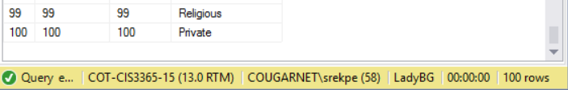

After (Service Request with 101 rows):

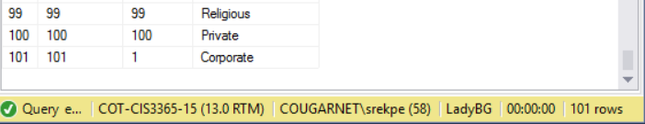

#### Insert script 2

Insert into Vacation_Status(Vacation_StatusID, Comments, Status, Vacation_ID)

Values(101, ‘’, ‘Pending’, 101)

Before (Vacation Status with 100 rows):

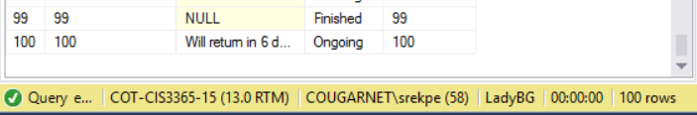

After (Vacation Request with 101 rows):

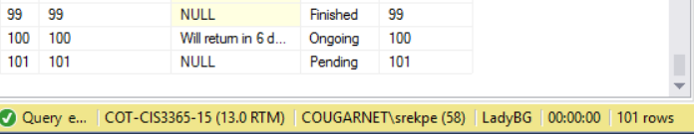

#### Delete script 1

Delete from Vacation_Request

Where Vacation_ID = 201;

Before (Vacation Request row with 201 rows):

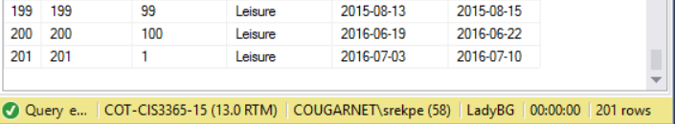

After (Vacation Request row with 200 rows):

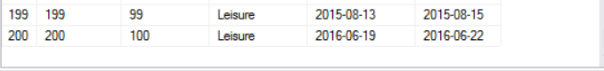

#### Delete script 2

Delete from Vacation_Status

Where Vacation_StatusID = 101;

Before (Vacation Status with 101 rows):



After (Vacation Status with 100 rows):

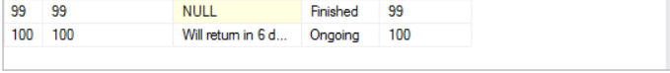

#### Update script 1

Update Event_Type

set Event_Type = ‘Corporate’

where Event_Type_ID = 101;

Before (Event Type for record 101 is currently Kid Friendly):

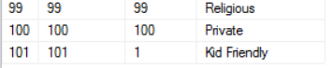

After (Event Type for record 101 is now Corporate):



#### Update script 2

Update Vacation_Request

set Reason = ‘Sickness’

where Vacation_ID = 201;

Before (Reason for record 101 is currently Leisure):



After (Reason for record 101 is now Sickness):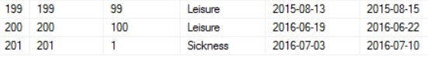

### GUI User Views

#### Manage Training Requests View

